UniPhi 15

Customer Relationship Management – Clients, Sites, and Organisations
Overview

Contents
Summary 3
Resources 4
Creating a Contact Resource 6
Creating Organisations and Site 9
Viewing External Resources 12
Viewing Internal Resources (Staff) 14
Viewing Organisations & Sites 15
Communication 17
Correspondence 18

Summary
UniPhi’s Communications module works as a fully functioning Customer Relationship Management (CRM) solution. All communications which have occurred within UniPhi are viewable in the Communications module. The aim of this manual is to provide instructions related to the creation, and the ongoing management of the CRM functionality via Organisation, Sites, and Resource Contacts.

As you read this manual you will notice the following icon recurring which will help to highlight and enable you to quickly locate activities and summary areas.
Key:
The lightbulb icon denotes a helpful hint or tip you should be aware of.

Screen shots have been used throughout the manual to demonstrate what you should be viewing as you move through the activities. They are for illustrative purposes only. Details such as dates, budget figures and other entered text/data may vary.

Resources
Within UniPhi, Resources can either be contacts (people or even just an email address) or assets. This section will focus on people as contacts. Each person’s details are entered into UniPhi via the Resource module as a Contact. Typically, a contact will also belong to a Site within an Organisation.
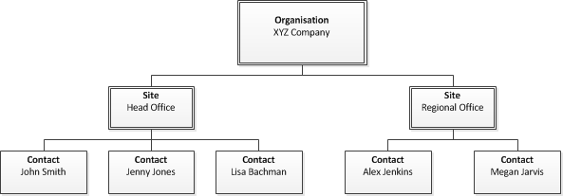
The information entered per contact can be captured to the level of detail that you have on the particular person, and can therefore be very high level (simply a name), or at a more comprehensive and detailed level with email addresses, phone numbers, and position.
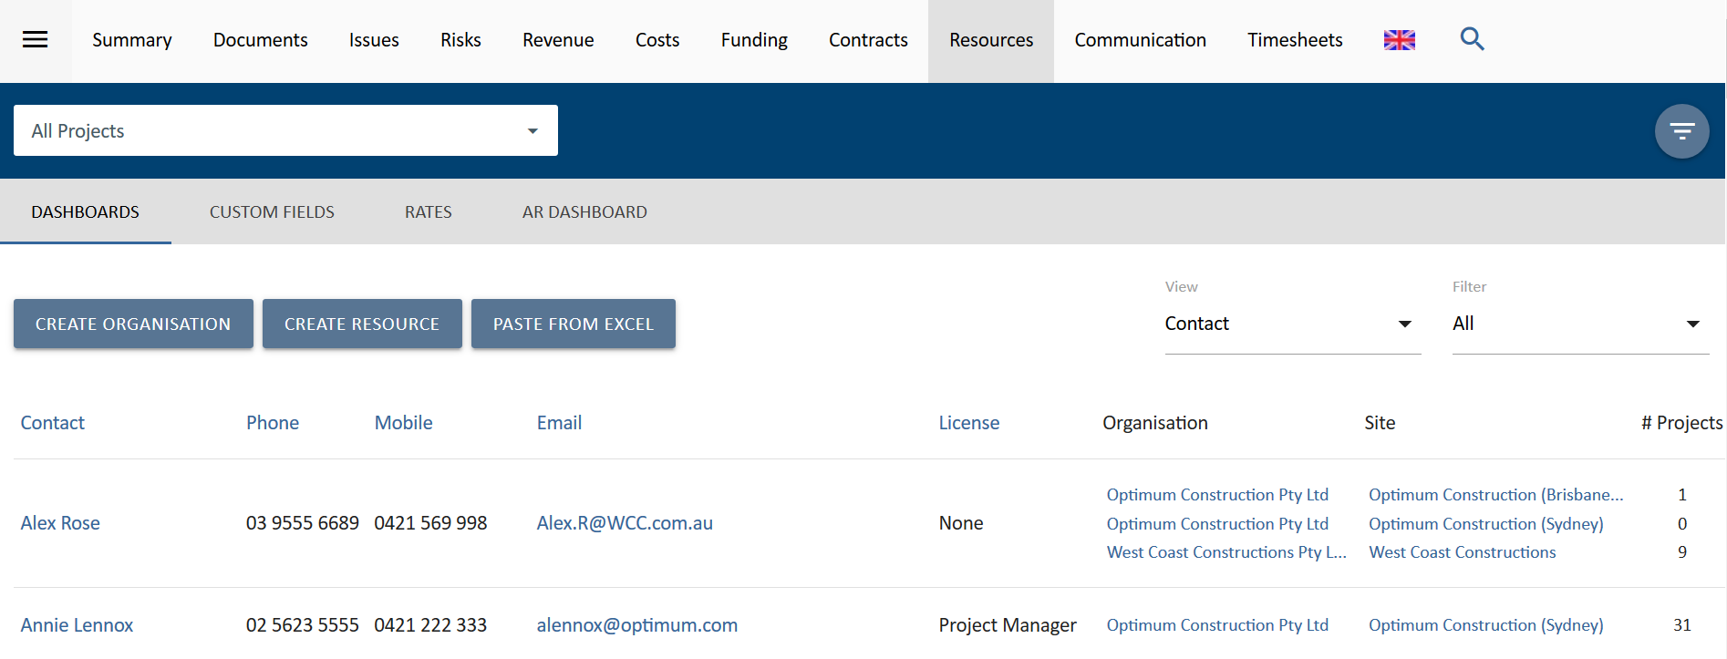
Organisations are categorised as Internal and External. An internal organisation will be your own company. Sites created within an internal company are typically physical site locations of your company. Logically, any resources associated with an internal organisation’s sites would be an employee of the internal organisation.
An external organisation may also have one or more sites, and contacts. Typically, these contacts will be people who are involved or associated with a project in UniPhi – e.g. Clients, Suppliers, Advisors, etc.
Once created, resource contacts can be assigned to UniPhi projects. Filtering for a specific project will present all resources assigned to that project.
Resources can be added or removed from a particular project, and their associated information (such as contact details) can be edited at any time.

Creating a Contact Resource
You can create a resource form within a project or from the All Projects view in the Resources module.
To create, start by pressing the Create Resource button.

There are several contact fields that you may choose to populate immediately, though the only mandatory field that requires input at this stage is the resource Name. All other fields, such as phone numbers, email address, licence type, position, etc. can be updated or amended at a later date. Remember to save your new resource details before leaving this page.

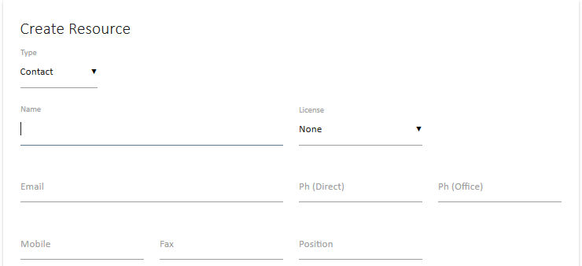

Once the basic details of the contact have been entered, you can link the contract to an organisation, scroll down to view the three options available:
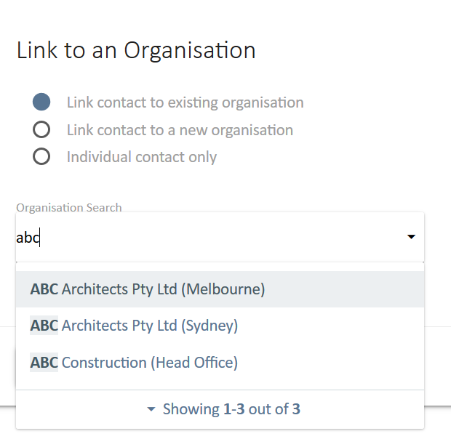
- Link contract to an existing organisation – this is a search field. Type in the organisation name and select it form the list.
- Link a contact to a new organisation – provides a data entry screen to create a new organisation (see Creating Organisations and Sites below)
- Individual contact only – use this when the contact is not associated with an organisation.

UniPhi Licenses
System Administrators will have the ability to assign a license to a contact to enable their access to UniPhi. The level of access that the resource will have to UniPhi will depend on the licence type that you select. There are four licence access levels:
- Team Member
- Project Manager
- Program Manager
- Administrator
Team Member Access
People assigned to a Team Member level role on a project can:
- Browse the organisations methodology, as defined by the program office (or System Administrator);
- Create documents (only for templates their role has edit rights to), issues, risks and change requests for the projects they are working on;
- View the portfolio of projects on the project summary view and via the reporting system;
- View their documentation issues and risks, and
- Search both for methodology content as well as project documentation/artefacts.
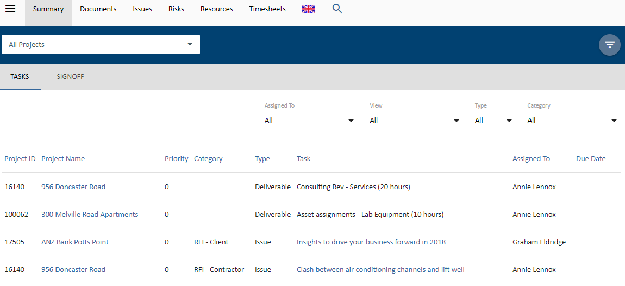
Figure 1. Team Members see these modules only

Team members cannot view
- Financial information such as budgets
- Contract information
- Reports from within the Reports module
- Documents which have been restricted to Project Manager access level or above
Project Manager Access
People assigned to a Project Manager level role on a project have all permissions of the Team Member, and can also:
- Assign team members to issues, and risk mitigation actions;
- Assign due dates to documents, issues, and risk mitigation actions;
- Complete bulk update of issues including assignments and due dates;
- Create contracts, budgets, variations and progress claims to their own projects;
- Update actuals and forecast to complete;
- Assign resources to their project;
- Close resolved issues, including those that are set to "awaiting review”

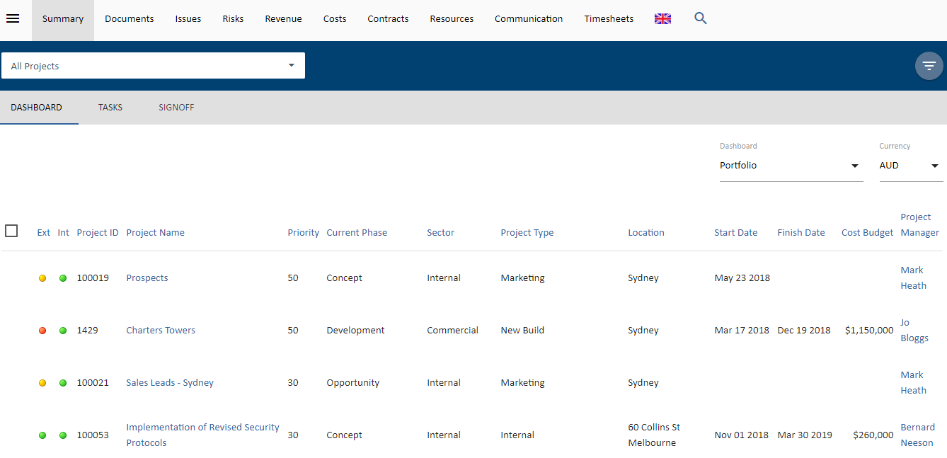
Figure 2 The Project Managers view – My Portfolio
Project Manager cannot view
- Projects with the portfolio that they are not assigned as to a resource
- Budget information for projects that they are not assigned to
- Contracts for projects that they are not assigned to
- Risks and Issues for projects that they are not assigned to
Program Manager Access
People assigned a Program Manager Licence have all permissions of the Project Manager, and can also:
- View projects, risks and financial information across the entire portfolio of the organisation.
- Assess and Analyse profitability, track backlog and burn rates and have access to contracts across the organisation.
- Access portfolio dashboard and create progress reports for all functions available in UniPhi.
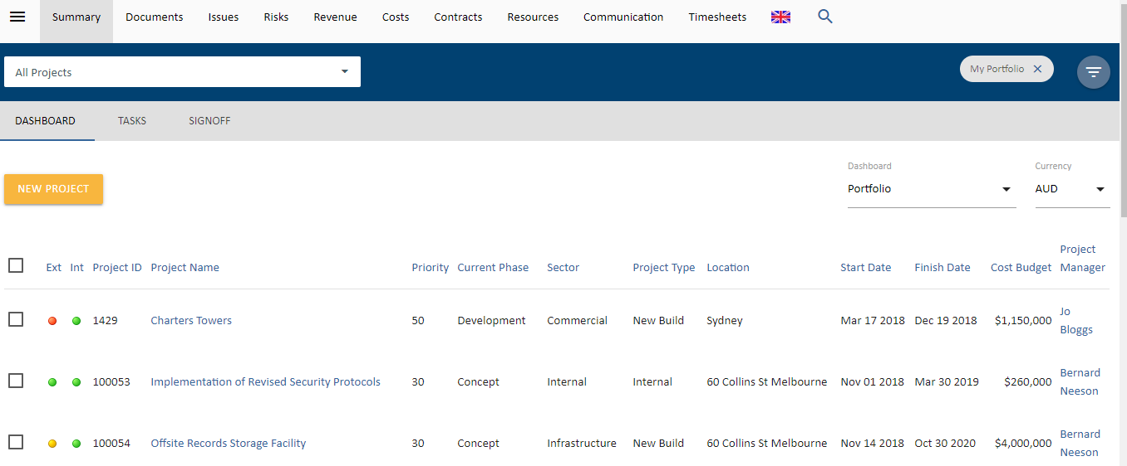
Figure 4 The Program Managers view – My Portfolio

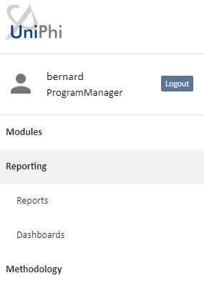
Figure 4 Program Managers view – Side Menu.

Program Manager cannot
- View or edit items within the Configuration modules
- Modify or delete document templates, or other custom fields. These tasks are performed only by the administrator.

Administrator Access
People assigned an Administrator has full permissions to every aspect of UniPhi, and can essentially make all necessary configuration changes.

Creating Organisations and Site

When creating an Organisation, it is essential that at least one site is created. Once an organisation and site have been created it is possible to create numerous sites within an organisation. Organisations and sites are usually created from within the Resources module, though they can also be created while a new resource contact is being created.

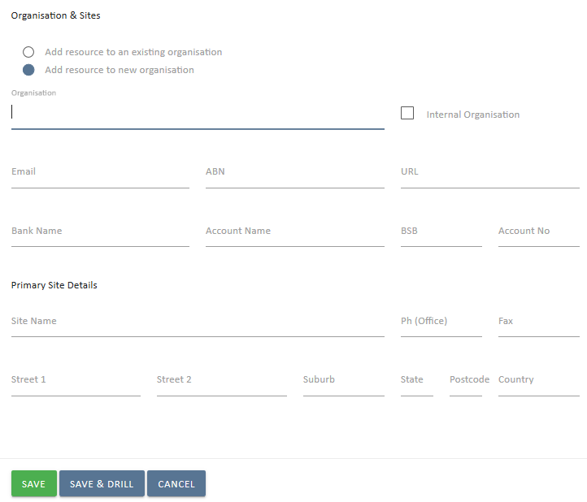
Figure 5 Creating an Organisation from within a contact

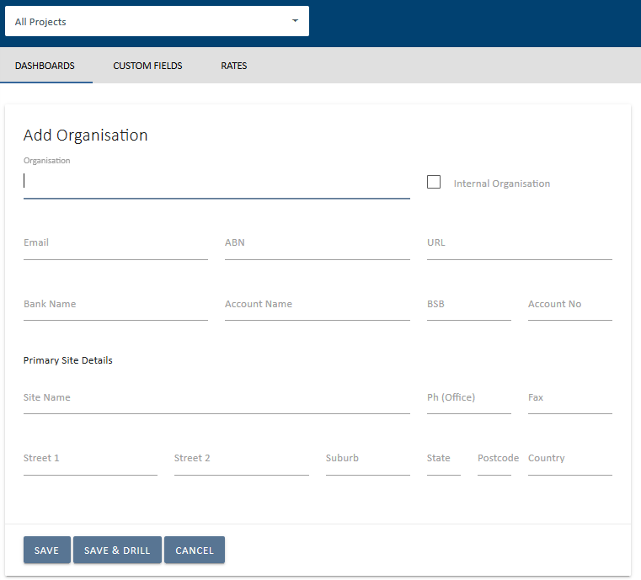
Figure 6 Add an Organisation to the pool
As is the case when creating new contact resources, you will be presented with several detail fields that can be populated with Organisation specific information. The only mandatory field at this stage is the Organisation name, and the primary site details. Obviously, the more details you have entered here, the more useful your resource information will be, particularly when performing tasks such as generating documents, or invoices, etc.

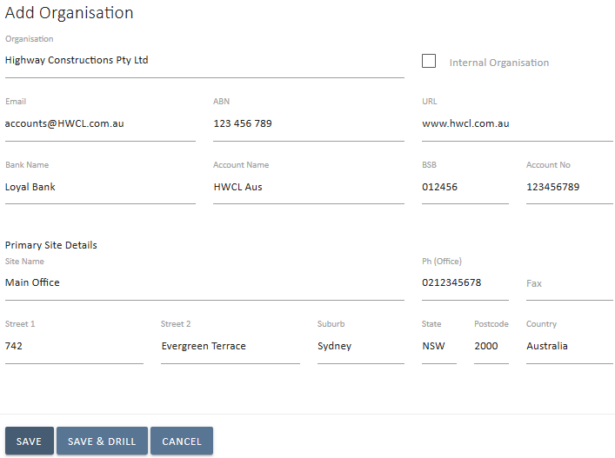
Figure 7 Organisation Details

Once you have created an Organisation and Primary Site details, you can add additional sites by pressing the Add Sites button.

The Organisation should be marked as Internal if this is your organisation, and resources assigned to your organisation are internal employees. Leaving the Internal box un-ticked will treat the organisation, and all associated sites and resources as being external (e.g. a supplier or a client).
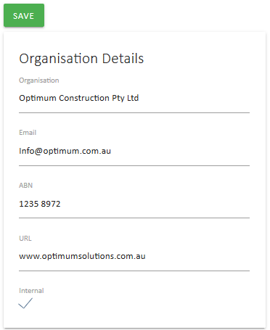

To link existing contact resources to a site, simply drill into the specific site, and press the Link Resources button.
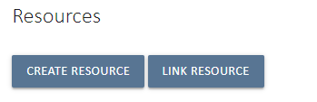
As seen above, the user also has the ability to create a new resource in this screen by pressing the Create Resource button.

Viewing External Resources
Navigating resource contact information via the Resources module is quite straight forward. Filters exist to help narrow your search so that if you are looking for a particular person (contact), you can select the View: Contact option, and you may also filter for internal or external people.

Clicking onto a resource will take you into the detail screen for that person. Here you will find more of the specific information about the person, and the company (or companies) that they belong to. It is possible to have one contact linked to numerous organisations and sites. Where a contact is linked to more than one organisation, you will need to specify their “Primary Site”.
Comments
The comments panel is designed to capture informal information that relates to a particular contact. The comments that are captured here should be those that don’t require any further activity or follow up, but may be relevant to refer to in subsequent conversations or discussion.

Note: if your conversation does require further action or follow up, you would create an issue and assign tasks and due dates

Over time your conversation thread may grow in size. If you need to locate a comment that has been made by a specific person, you can select that person from the dropdown box. This will then display only those comments made by the person selected.
Figure 8 Filter by commenter

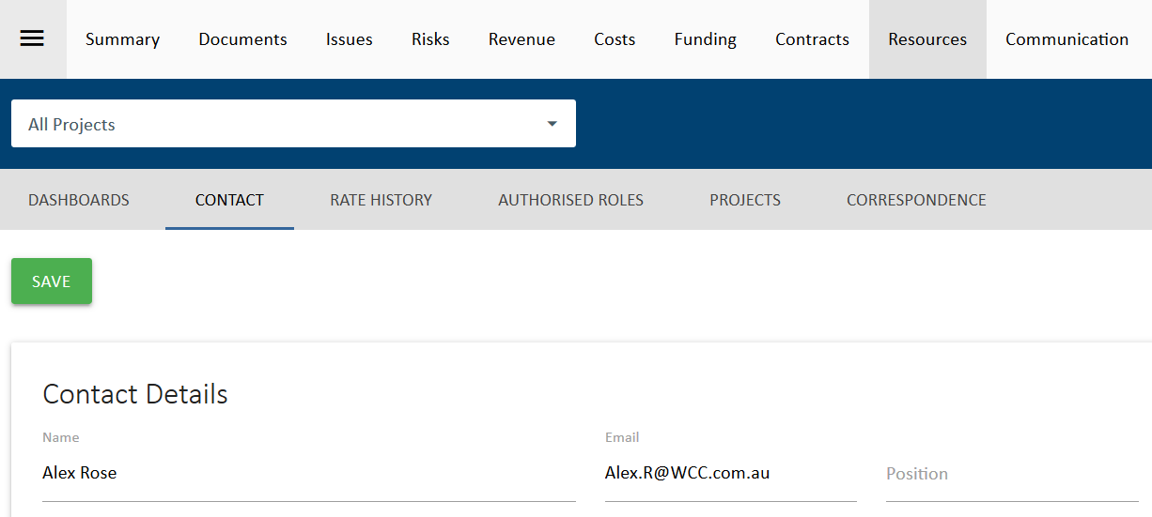
Figure 9 Sub Navigations views
The Sub navigation menu for a contact provides access to the following views:
- Dashboards – the resource pool
- Contact – edit and update contact details
- Rate History – for internal resources, review their charge and cost rate history
- Authorised Roles – for internal resources, review the roles they are authorised to be assigned to
- Projects – review the list projects and roles the contact is assigned to (see below)
- Correspondence – review any correspondence with this contact (see below)
Projects
The information displayed in this view is a useful way to observe which projects a contact resource has been assigned to, and the role that they are performing within those projects.
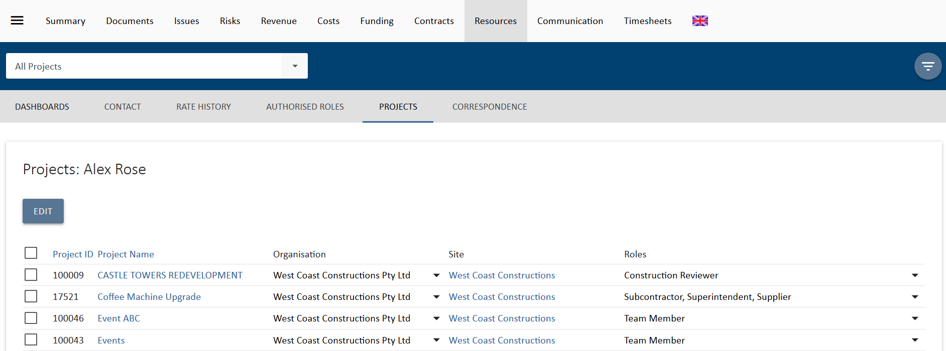
Figure 10 Projects displays allocated projects and roles per contact resource
For more information on how contacts can be assigned and updated to projects, see the detail below for internal users.

Correspondence
The correspondence panel displays all UniPhi generated interactions that have taken place involving the resource contact that you are reviewing. This correspondence includes documents, issues, comments, and emails. It’s important to note that all communications are displayed here, regardless of their status (e.g. issues are displayed even if they are closed or awaiting review). Items from closed projects are also displayed.
The benefit to using the Correspondence module to locate this information is that it brings all of the information into one place, and eliminates the need to open multiple browser tabs to locate a specific item.
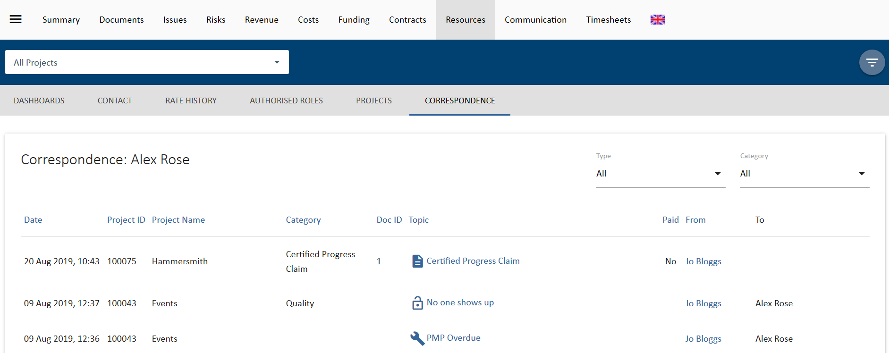
Figure 11 Resource Contact Correspondence view

Viewing Internal Resources (Staff)
The contact details for internal resource (staff) features the capability to attach a signature image, and an email signature. This information can then be used when generating and transmitting documents and emails from UniPhi.
Figure 12 Scanned copies of signatures can be attached to a resource contact
The Document Signature is a scanned image of a written signature that is uploaded into UniPhi, which can then be selected when “signing off” a document. The output document has the embedded signature attached, which saves the time and effort of printing a document, signing it, and then scanning it back as a soft copy format.
Attaching an email signature works the same way that most email programs (e.g. Outlook) allow you to attach a predefined email signature. Again, this is a time saving feature as all of your outbound emails from UniPhi will appear with your customised signature information, which may include contact details, and your company logo.
The following sub navigation views may be useful in managing internal staff access to UniPhi:
Authorised Roles
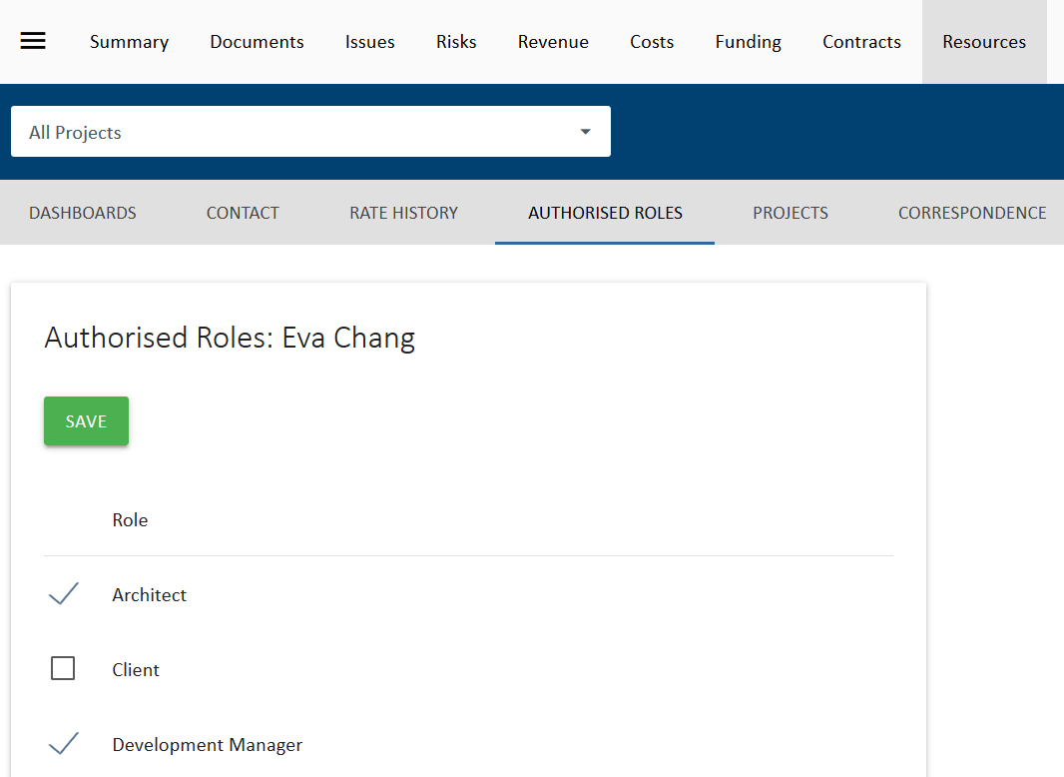
Figure 13 Authorised Roles
The Authorised Roles sub navigation view provides a list of available roles that can be assigned to a user. If any of these is checked, the user will be limited to those roles on a project. If none are checked, then the role allocation is only limited according to the user’s license.

Projects View for Internal Staff
The Projects sub navigation view provides a number of options for managing an internal user’s access to UniPhi projects.
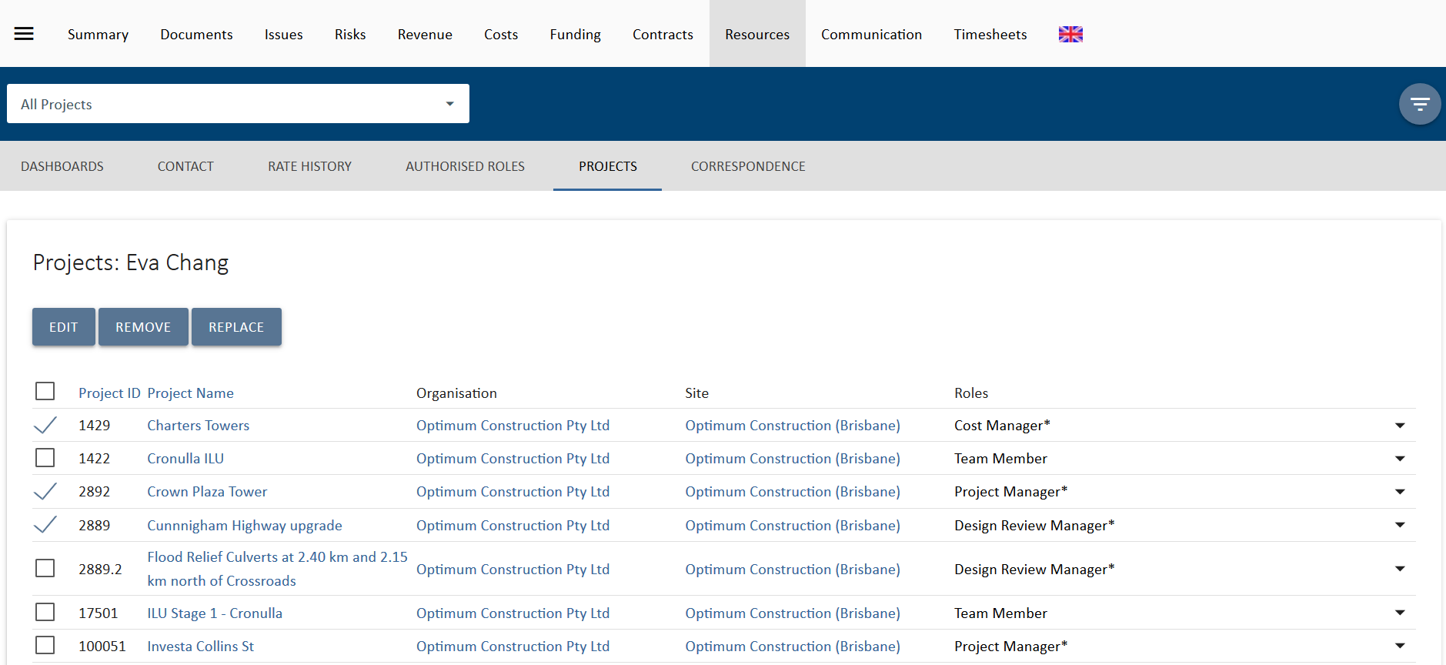
Figure 14 Projects view with selections made

Select projects from the list displayed and two additional buttons will appear, Remove 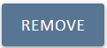 and Replace .
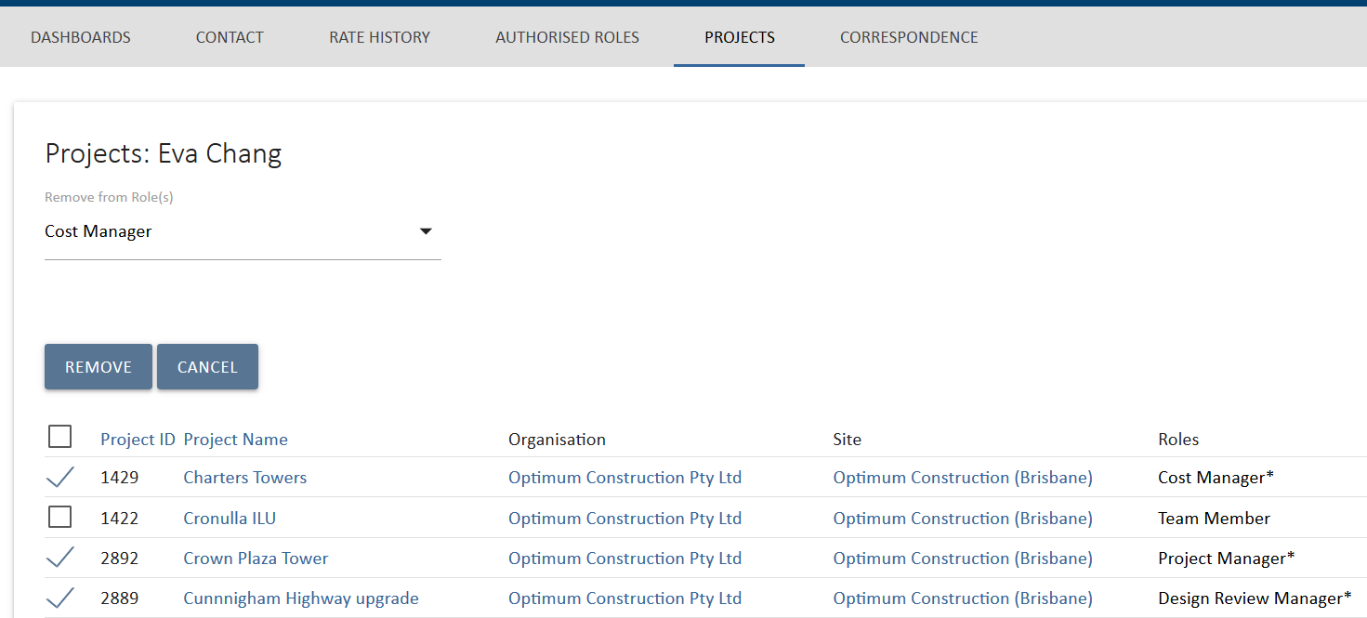
Figure 15 Projects view Remove option
The Remove options provides a drop down to select what roles you want to remove the user from. Select Remove again to complete the task. This option is useful to remove someone form projects after they have left an organisation or changed roles.

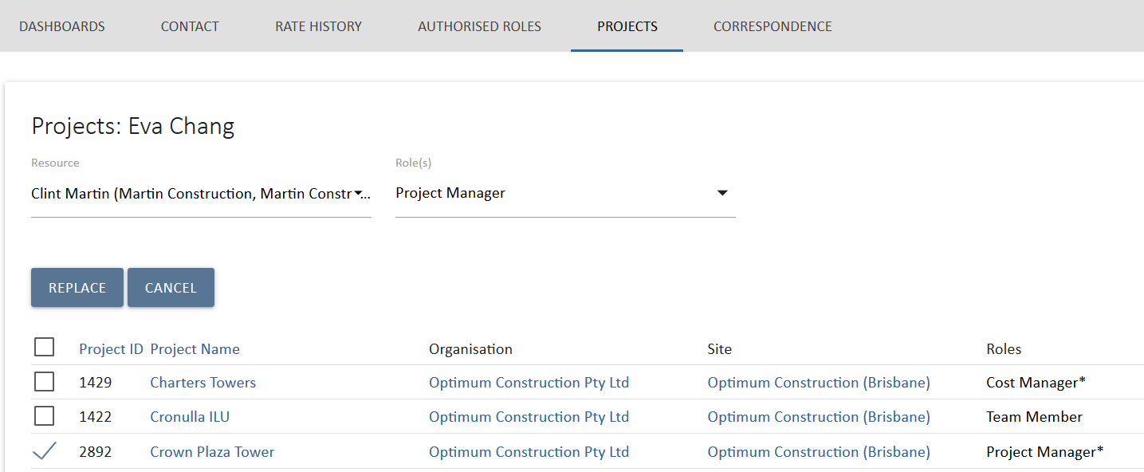
Figure 16 Projects view Replace option
The Replace option provides two drop down lists to select the resource replacing the user and the role that you will place the new user into on the select projects. Select Replace again to complete the task. In the example above, Eva Chang will be replaced by Chris Martin as Project Manager on the Crown Plaza Tower Project. This is useful to replace staff going on leave or when project roles change.
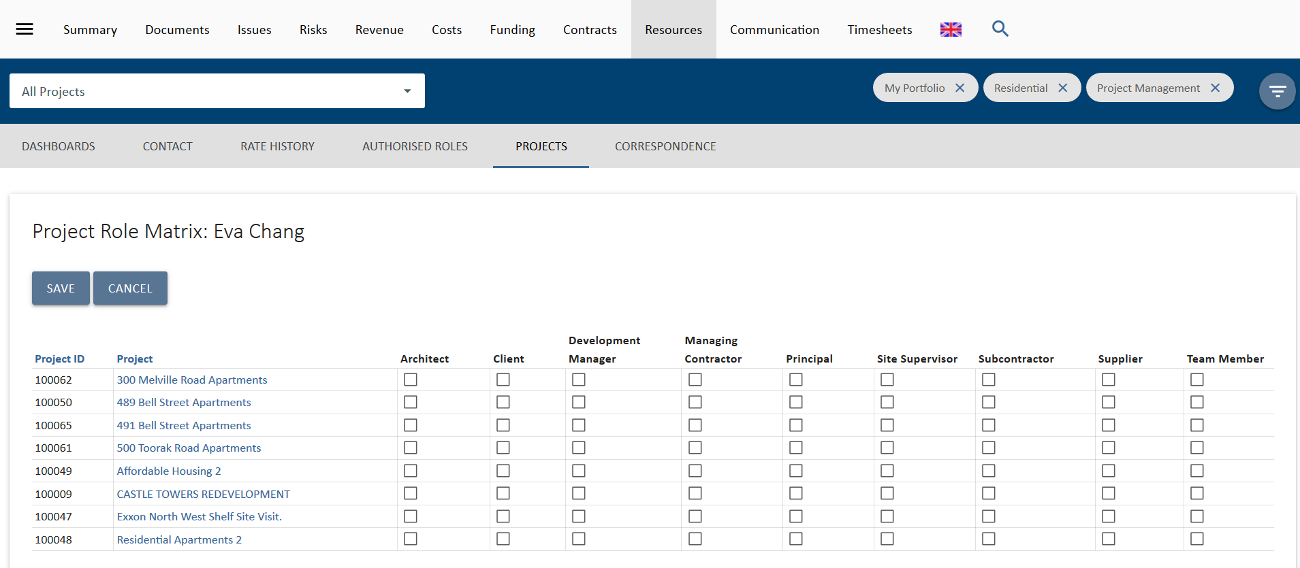
Figure 17 Projects view Edit option
The third option is to bulk edit the project and role allocations of the user. Select this and a list of all available projects and roles will display. If this list is too long, you can apply portfolio filters to it. Select the roles and the projects the user needs to be assigned to and select save. You can also deselect them form any existing roles.
This option is designed to quickly add and remove a user to a project or list of projects

Viewing Organisations & Sites
Viewing Organisations at the highest level will display information about all of the sites that you have entered into UniPhi. At this high level, you can see detail such as the name of the organisations, the number of sites related to the organisation, and the number of people assigned. Each of the headings are sortable, so you can sort organisations alphabetically, or by the number of assigned sites, or number of people assigned.
Figure 18 Organisations in the Resources module

Clicking into an organisation will display the organisation specific information, such as the company website, ABN, email address and the bank details. These details can be entered or amended at any time.
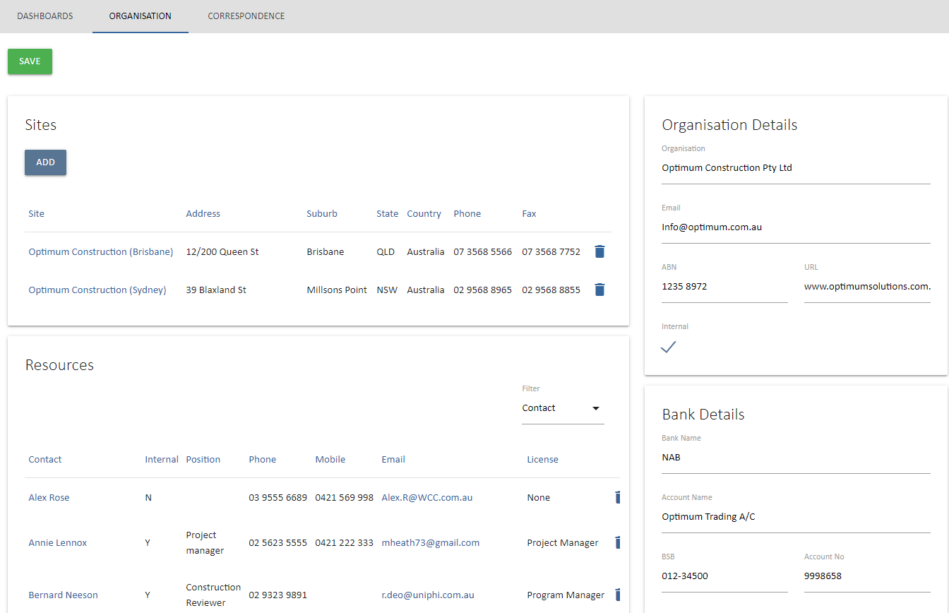
Figure 19 Drilled in to an Organisation

The Organisation view also displays the Sites and Resource section. Sites is a list of sites associated with the organisation, while Resources is a detailed list of all resources linked to that organisation.
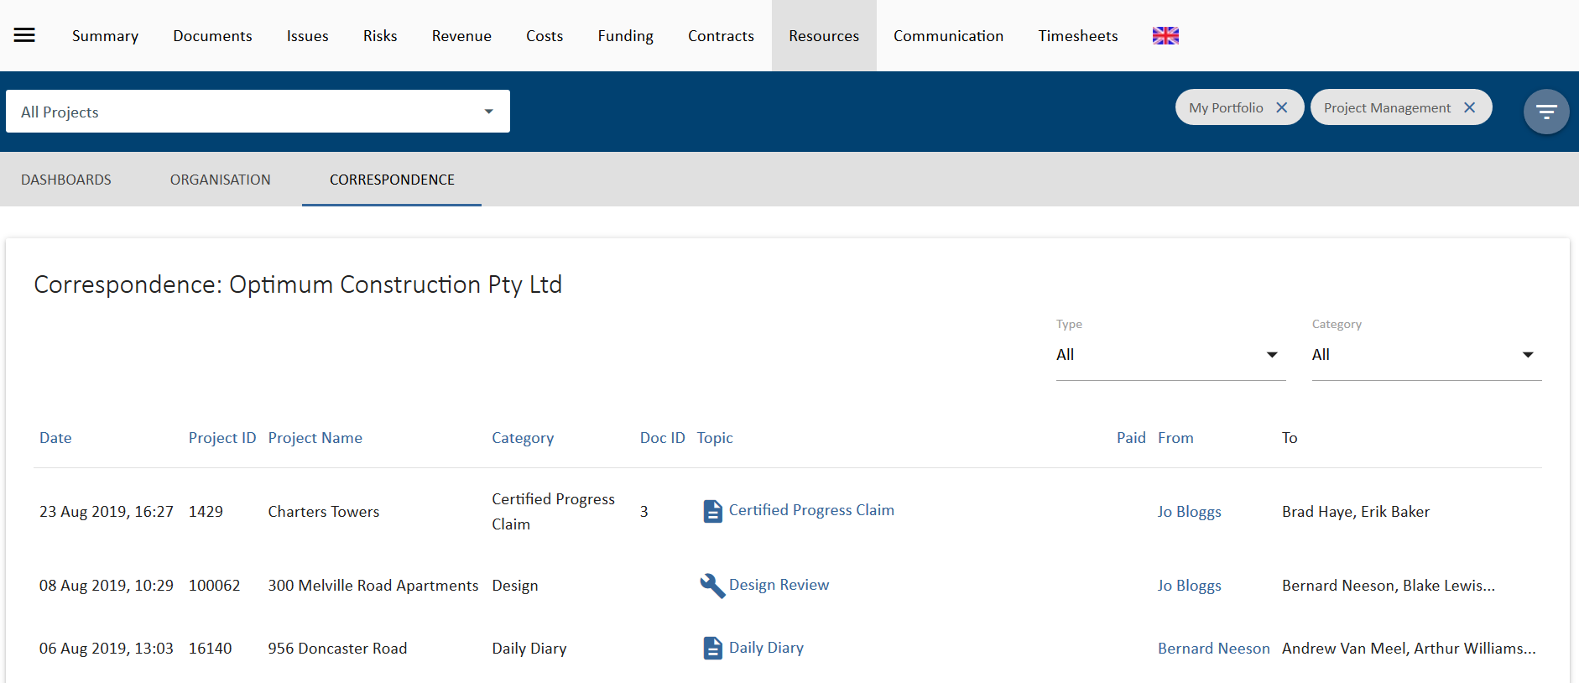
Figure 20 Correspondence view of an Organisation
The Correspondence sub navigation displays all correspondence from UniPhi linked to this organisation.

Communication
The Communication module displays all forms of interaction that have occurred across your entire portfolio of project activity. It’s a very broad, comprehensive, and powerful view of information and can be seen as a transaction log of all interactions. This interaction encompasses all Issues, actions, comments, emails (sent from UniPhi and using the Outlook Add-In) and documents. Information is displayed regardless of status, due date, or ownership status. This information can be viewed for various purposes, such as Customer Relationship Management (CRM) needs. By applying the correct filters, such as selecting particular project, it is possible to see exactly what has occurred to date. In effect this means that when you are speaking with someone associated with the particular project/organisation you are viewing, you can see all related issues, and documents, even those issues which have been previously closed.

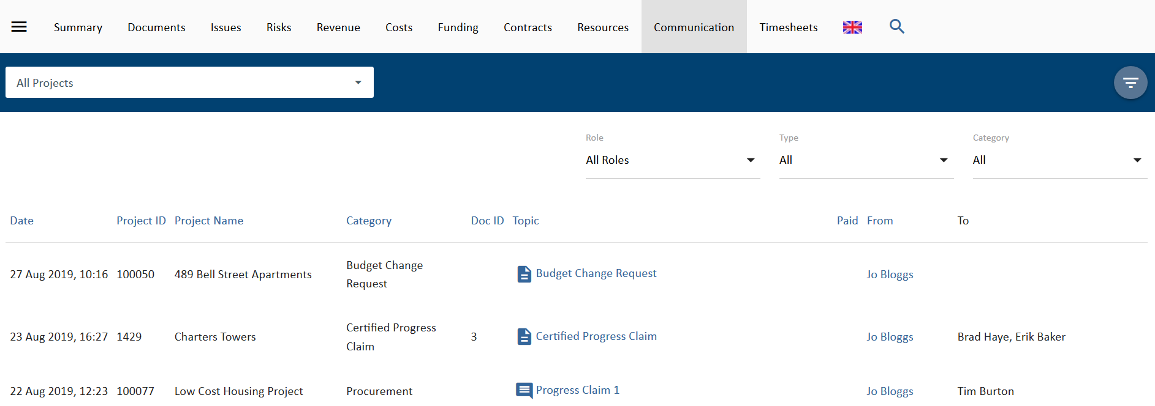
Figure 21 Communications module

Additional Use of filters:
Communications can also be narrowed down using the Role, Type, and Category filters.

Roles: These are the project roles setup in UniPhi prior to implementation. Once resources are allocated to their roles, any form of communication done by them in UniPhi can be viewed using this filter.
Type: This filter allows to choose between different forms of communication used. The range of communication present in UniPhi are Comments , Email , Issues and UniPhi Documents .
Category: The Category filter contains a list of all the document templates and issue categories that have been used. Based on the usage, this filter allows to select and display a specific category of communication.

Correspondence
The Correspondence panel is located within the Resources module, and displays all forms of direct interaction that have occurred between your company and the resource that you are viewing. You can view all correspondence which has occurred by clicking into a specific contact, site, or organisation. The correspondence list is contextualised to the resource that you have specified. This makes reviewing the correspondence items more focussed.
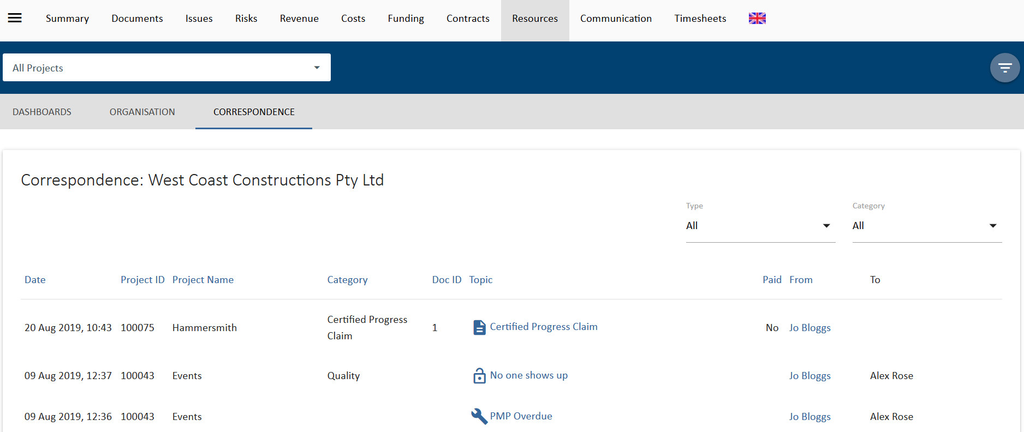
Figure 22 Correspondence for an Organisation

