UniPhi 15

Timesheet System
Manual

Contents
Timesheets for Project Managers 4
Timesheet Approval 5
Timesheets Administration 6
Timesheets 6
Timesheet As 6
Timesheets Administration 7
Standard Tasks 8
Utilisation Dashboard Chart 10
Business Rules 12
Submit Timesheets 12
Rolling Back Timesheets 13
Financial Years 14

About This Manual
The aim of this manual is to provide instructions for managing timesheet administration tasks for Project Managers and System Administrators.

How to use this Manual
As you read this manual you will notice the following icons recurring which will help to highlight and enable you to quickly locate activities and summary areas, they will also assist with tips for keeping
Puzzle Piece:
The puzzle piece appears at the beginning of each session and any major section to mark the overview of that item’s content or concept.
Cogs:
The cogs denotes a step by step activity to be completed using UniPhi by the participant relative to the section it is located in.
Light bulb:
The light bulb denotes a helpful hint or tip you should be aware of.

Screen dumps have been used throughout the manual to demonstrate what you should be viewing as you move through the activities. They are for illustrative purposes only. Details such as dates, budget figures and other entered text/data may vary.

Timesheets for Project Managers
Project Managers may have additional responsibilities in the UniPhi timesheet system. This depends on the organisations requirements for Timesheet processing.
These include configuring project options for Timesheets and approving submitted timesheets.

When creating a new project or modifying an existing project there are three options that relate to Timesheets. Go to the Summary Module and select the project from the Project filter. The Timesheet card (below) is in the Details sub navigation.
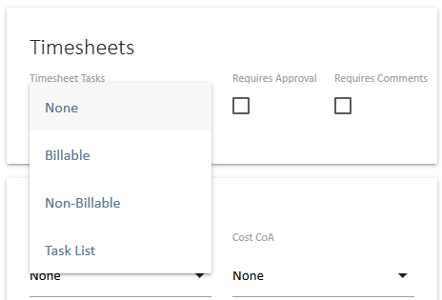
- Allocation of a Task List if appropriate.
The creation of Task Lists is an Administration function in UniPhi. The Project Manager has the option of selecting an appropriate Task list when creating a new project or as a change to an existing project.
- Requires Approval Setting
Checking this option will mean that the team members nominated in Project Manager level roles will be offered the option to Approve timesheets submitted that contain times entered for this project.
- Requires Comments Setting
Checking this option will mean that all timesheet entries for this project must have a comment entered in the Day view of the timesheet before it can be submitted.
These three options are independent of each other.
When modifying an existing project, the Save icon at the top left of the screen must be clicked to save the change.
Changing the Task List for an existing project with existing timesheet entries does not change any existing data. The previously selected tasks and hours for both saved and submitted times will remain. Only new Add Project selections will present the updated Task List for selection.
You can control the availability of the project to timesheets. If the Task list is set to ‘None’ then others users will not be able to book time to the project. This is useful if the project is not yet awarded, if it is completed or on hold and you do not want people dumping their time against the project.

Timesheet Approval
The timesheet Approval process provides the Project Manager with the opportunity to view the timesheet entries for projects that they manage.
Where timesheets are submitted with entries for a project with the Requires Approval option selected the relevant Project Manager will see a “Timesheets for Approval (1)” action icon appear in the upper right corner of their Timesheets panel.
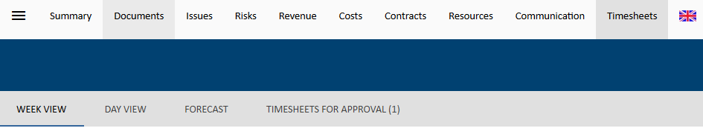
Selecting the “Timesheets for Approval” option will present a listing of all the timesheets ready for approval.
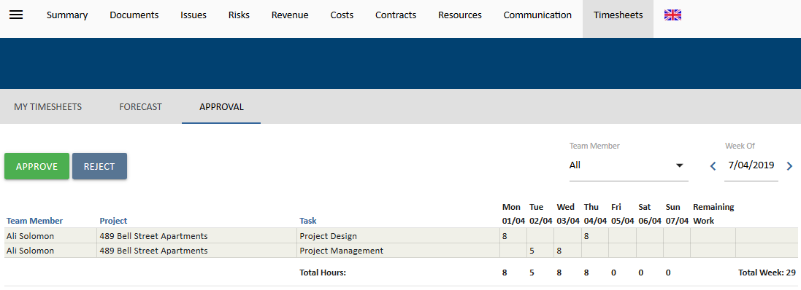
In this simple example there is only one timesheet for approval displaying 29 hours on the project for approval. To return to the normal timesheet screen select the My Timesheets icon in the upper right corner of the panel.

Select the Approve 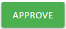 icon to complete the timesheet submission or Reject 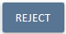 to return the timesheet to the team member.

The Approve option will only approve the project(s) that are presented. If there are other projects on the timesheet with different Project Managers to approve then the timesheet will remain as un-approved until all entries are approved.

Rejecting a timesheet moves it back to an un-submitted state for the user. The Project Manager may contact the team member directly to advise the reason for the rejection or could raise an Issue for the project and assign it to the relevant team member to address before submitting the timesheet again.

Enabling the “Requires Approval” option for an existing project with existing timesheet entries does not change any existing data. The previously submitted times will remain submitted. Only newly submitted timesheets will be held for approval. Disabling the Requires Approval option will still require approval on submitted but unapproved timesheets.

Timesheets Administration
UniPhi Administrators have a number of options to configure and controls that they need to administer to manage the UniPhi system.
There are a number of areas of UniPhi that impact on the Timesheet system.
These are the:
- Timesheets module.
- Configuration -> Timesheets (Timesheet Administration)
- Admin -> Financial Years

Timesheets
Administrators will usually have visibility of all team members’ timesheets. When an Administrator accesses the Timesheets module an additional option appears in the filter section to allow for filtering to another team members timesheet.

Timesheet As
The default selection is for the logged in user to “Timesheet As” “myself”.
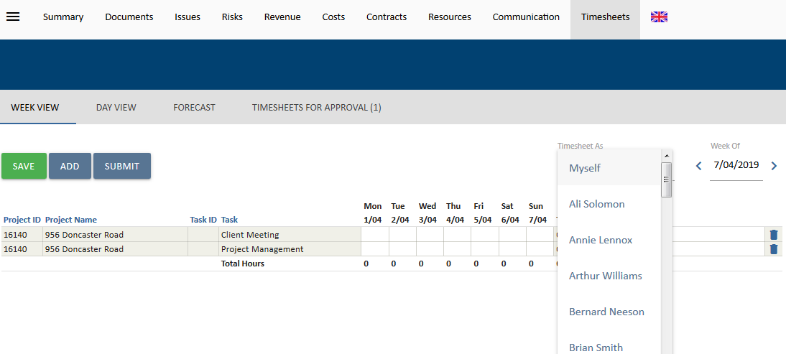
Selecting someone else from the selection box will provide for the Administrator to view and modify the selected timesheet.
Typically this facility may be used where a team member is absent and unable to complete and submit their timesheet at the appropriate time. It can also be used to review activity on timesheets, however, that this is best done with one of the many Timesheet Reports.
If a team member does not appear in the list for “Timesheet As” it will be because they are a resource assigned to a Private project.
Private Projects are covered in detail elsewhere but their purpose is to provide for projects that only assignees can view, hence even Administrators do not have access to timesheets that contain Private Project information.

Timesheets Administration
The Timesheet configuration menu provides the Administrator with access to four sub-menus.
- Admin
- Standard Tasks
- Submit
- Rollback
The default view for this screen is the Admin sub menu. This menu shows a list of all projects for which you select the task list for & whether time submitted on that project either Requires Approval or Requires Comments on submission.
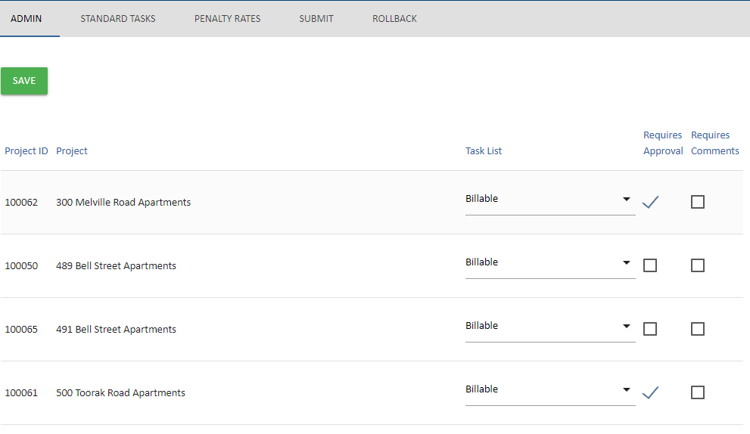
This menu provides access to the same three options that can be for an individual project in the Project Summary page. If the filter selection is for All Projects then this will be a list of all relevant projects while if a single project is selected then the screen will only reference the settings for that project.
Any modifications to the settings do require that the Save icon is clicked to commit the changes.
Projects can be changed to set the Task List and the Timesheet Requires options. Changes in this screen will be reflected in the Project Summary screen.

Standard Tasks
The creation and editing of Task Lists is an Administrative function that caters for establishing standard task lists that can be applied to a range of projects. Common uses are for Internal Projects and catering for Leave types for internal staff.
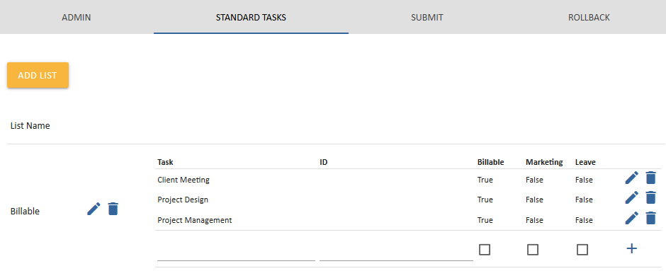
To create a new list, select the Add List icon at the top of the panel.
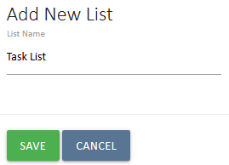
Provide the name of the list and click on the Save icon.
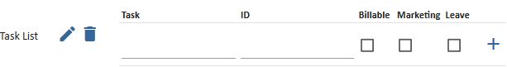
In the example the List name is Leave Types and the list is now ready for adding entries.
As each new line item for the list the Add icon must be clicked to save the new entry.
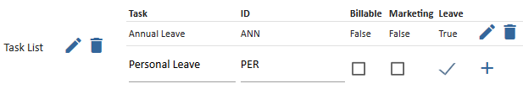
Leaving this screen without selecting Add will cancel the new line item.
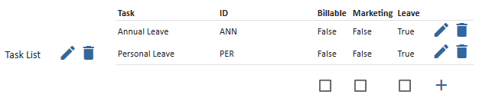
Editing an existing entry to change the Task name or ID is with the Edit icon to the right of the line. The Delete icon can also be used to remove the task from the list.
The three check boxes for Billable, Marketing and Leave specify how timesheet entries will be accounted for in utilisation calculations. Leaving all three options unchecked treats the task as Non-Billable.

The four options for Tasks are set as follows:
- Billable - check this option
- Marketing - check this option
- Leave - check this option
- Non-Billable is implied by not selecting any of the three options.
Do not select more than one option.
Adding new Task lists to the UniPhi system has no impact until the list is assigned to a project and has timesheet entries allocated to it. Deleting a Task list will only impact the system by changing what team members see when entering their timesheet for any affected project.
All recorded hours are still assigned to the relevant Task item and its’ relevant analysis.

Utilisation Dashboard Chart
Staff Utilisation analysis is driven from timesheet data and presents a split of hours in four key segments of Billable, Leave, Marketing, and Non-Billable hours.
The Staff Utilisation dashboard chart presents a summary view of utilisation for the selected period.
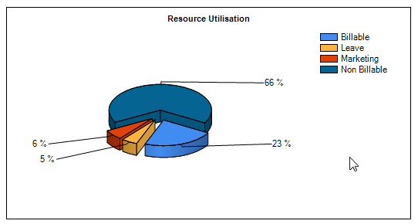
In the above example the majority of the effort is on non-billable time. This contrasts with the example below showing Billable time being the focus of effort within the organisation.
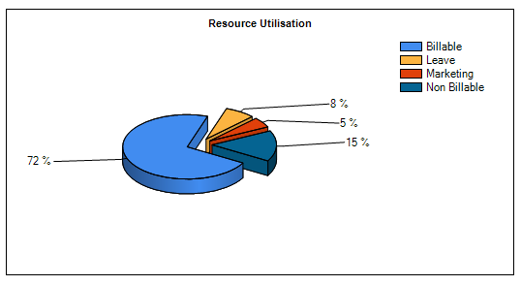
This chart is a result of activities recorded on client facing projects and against Task List items that are flagged as one of the four types.

Business Rules
The calculations are always based on submitted timesheets. Saved but un-submitted hours are not included.
Billable: Effort assigned to projects either as Billable Tasks or Contract Deliverables.
Marketing: Effort assigned to a Task flagged as Marketing
Leave: Effort assigned to a Task flagged as Leave
Non-Billable: Effort assigned to Tasks flagged as Non-Billable

Submit Timesheets
As an Administrator, you are able to submit timesheets on behalf of users across all projects for a particular week. In this sub-menu, there will be a list of users against which their submission status will be displayed, together with the total submitted and “unsubmitted” hours.
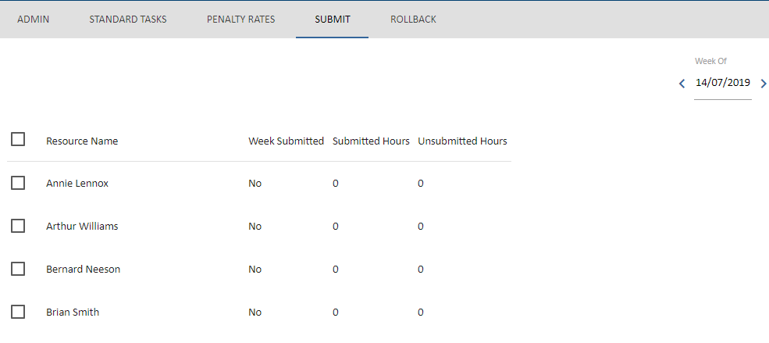
Once users are selected, then only will the Submit icon appear.
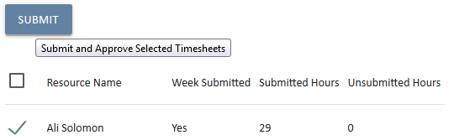

Rolling Back Timesheets
Occasionally a Timesheet may need to Rollback (the Team member may have missed a day, entered incorrect hours etc.). Only UniPhi users with Administrator Access are authorised to rollback submitted timesheets. This is done in the Rollback sub-menu.

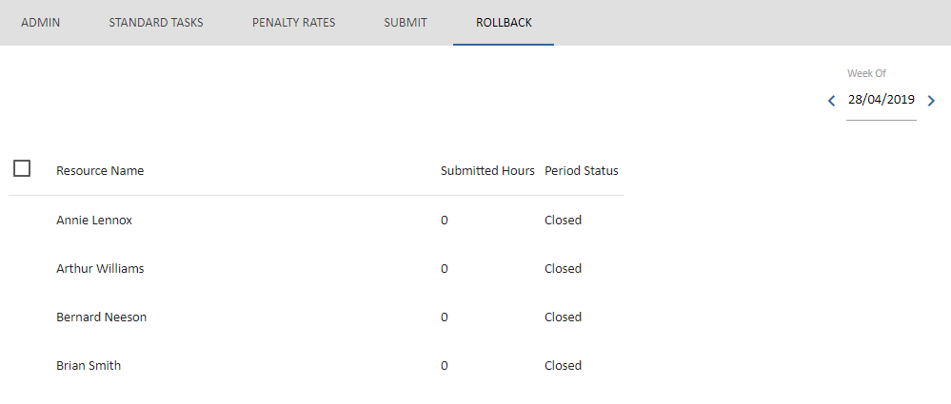
While an Administrator may be able to Roll-Back a Timesheet this can only be done within the current financial period. Once a financial period is closed the Timesheet Roll-back facility is also controlled.
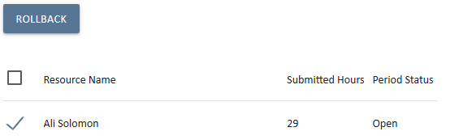
If the financial period is open then the Rollback option will allow for the selection of one or more timesheets by checking the selection box to the left of the team members name.
Click the Rollback 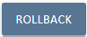 icon to “unsubmit” the timesheets. There is no confirmation message, the selected team members will simply see that their current timesheet has reverted to the selected date for editing and submission.
A Rollback of a time sheet will also re-open all subsequent timesheets.
This is because timesheets must be submitted sequentially. When this occurs not data is lost. Amend the incorrect sheet, submit it, and then re-submit the following correct sheets to return to the current period.
A suggested process is to log an Issue in UniPhi to an Administrative project and assign it to the relevant UniPhi Administrator. This maintains a record of rollbacks and will assist with debugging any errors made during the process.
Rolling back timesheets may impact on Work in Progress for a project if it is done without consideration for the flow on effects. In addition if the affected timesheets include projects that require approval then all the relevant project managers will be required to re-approve the timesheets when they are submitted again.

Financial Years
UniPhi has the ability to track the monthly actual, forecast and budgeted revenue and expenditure and report on these on a financial year basis. To be able to do this, the relevant financial years of the company need to be established. You can pre-populate as many financial years as is necessary (past and future). These financial years will be available to users via drop down boxes in the cost and fees tabs. The more financial years entered the more options in the drop down list options available. For this reason, it is common for only 3-5 financial years be available at any one point in time. More financial year periods may be required if the project runs over a number of years and the business would like to time-phase the cash flows over the entire project period.
Once a financial period is completed and the accounts signed off, the financial period is closed. Individual month periods can be closed out sequentially, or an entire financial year can be closed at one time. Once a period (month or year) is closed:
• All timesheets are marked as submitted and it submits any saved time that had not been submitted for that period
• No one can timesheet to that period.
• Cash flow phasing interfaces in the system show actual for that period instead of forecast.
• The API shows actual for that period and clears the forecast (this makes it easier for Act/fcst graphing)
Other business rules relate to accounting integration and are not relevant here including closing a financial year (won't import actuals for that year once closed for example).
The Configuration -> Financial Years section is where this is controlled.
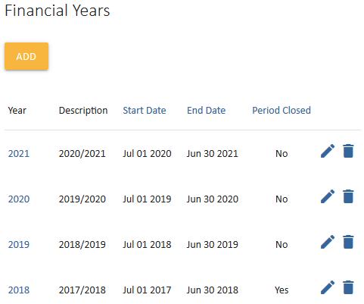
New financial periods can be added in advance at any time.
In this example the financial year for 2019-2021 has been added. The years to 2018 are all closed.
Clicking the Year on the previous screen will drill-in on the periods for that financial year.
Each year can be split into multiple financial periods. While this is typically calendar months it can also be set for any nominal date periods. 13 x 4 weeks, 52 weeks, 13 week quarters, etc.
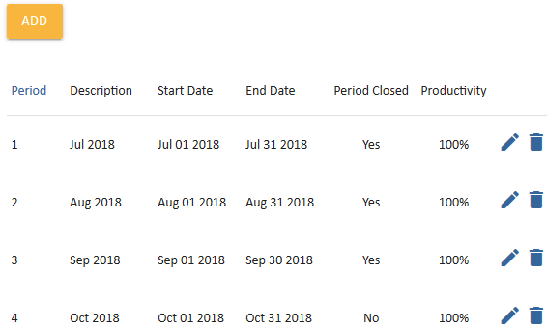
In this case it is set for financial years/months and the periods to Jul 2018 are closed.
The UniPhi Administrator closes a period by editing the relevant period and ticking the Close check box.

