System Administrator
Manual

Table of Contents
Portfolio Categories and Project Types 7
Creating and editing Project Sectors 10
Create and edit Project Types 13
Create and edit Service Line 15
Create and edit Locations/Regions 16
Project Lifecycles and Milestones 19
Create and Edit the Project Lifecycle 21
Create and Edit the Project Milestones 23
Project Governance through Roles and Access Levels 24
Create Project Roles 30
Create a Resource Custom Field 32
Programme Reporting 34
Create Project Custom Fields 34
Create and Apply Custom Lists 39
Dashboards 43
Issue and Risk Reporting through Categories 48
Create and Edit Issue Categories 48
Create and Edit Issue Escalation 50
Create and Edit Risk Categories 51
Create and Edit Risk Escalation 52
Risk Management via Risk Matrix 53
Create and Edit Risk Likelihoods 53
Create and Edit Risk Consequences 54
Add Risk Levels 55
Apply Risk Levels to the Risk Matrix 57
Contract Methodology Configuration 59
Contract Methodology through Contract Status 59
Contract Methodology through Contract Standards 62
Contract Methodology through Variation Categories 64
Workflows using the Issue system 66
Add an Issue Template 66
Financial Management 71
Chart of Accounts 71
Chart of Account Types 71
Create Chart of Accounts through Import 72
Create Chart of Accounts through Data Entry 76
Financial Years 79
Create Financial Years and Periods 80
Edit, Close, or Re-Open Financial Years 82
Non Standard Financial Periods 83
Integration through Templates 85
Template Management 86
Adding a New Category 87
Available Templates 88
Creating a Template 90
Adding a MS Word Template 90
UniPhi Templates 91
Template Configuration Details 94
Template Data Entry Details 97
Template Variables 103
Template Output Order 105
Create a Simple UniPhi Template 107
The Rich Text Editor Toolbar 117
Template Variables 129
Methodology 130
Create a Flowchart in the Library 134
Create and Map Library Pages 135
Create a Prioritisation Framework 138
Exporting Documents from UniPhi 141
APPENDIX 143
Current Document Controls 143
Accounting Costs 143
Auto Number 145
Benchmark 147
Budget 149
Cashflow 151
Contract Deliverables 152
Contract Details 154
Contract EOT 155
Contract Registers 157
Contract Variations 159
Custom Check List & Custom Drop Down List 161
Date Selector 164
Distribution List 166
Document Selector 168
Document Version History 171
Embedded Document 172
External Comments 174
File Upload / File Upload (Multi) 176
Graph Selector 179
Invoice 191
Issue Details 195
Issue Selector 198
Issue Summary 200
Metrics 202
Net Budget 203
Periodic Custom Fields 205
Periodic Issue Count 206
Progress Claim 210
Project Costs 213
Project Milestones 215
Risk Details 216
Risk Summary 218
Team Selector 220
Team Selector (Single) 221
Textbox (Multi Line) 222
Textbox (Single Line) 224
Textbox (Rich) 225

Aim
One of the unique features of UniPhi is its flexibility, and that that flexibility in configuration is made available to the Administrator(s) with each organisation. This ensures that UniPhi is configured and maintained to suit the specific requirements of your organisation. The UniPhi System Administrator needs a good understanding of both the practical application and the theory associated with managing portfolios, programmes, and projects. It is beneficial for the System Administrator to be familiar with financial concepts, in order to structure UniPhi so as to maximise the value of its finance capabilities. This manual is designed to demonstrate how UniPhi structures information to assist you, the System Administrator, and your organisation to define the way information is classified, and to demonstrate how to configure UniPhi. Further, this manual is designed to assist in understanding the portfolio, programme, and project management methods that UniPhi supports.

How to use this Admin Training Manual
The following icons are used throughout this manual to assist in highlighting and enabling you to quickly locate activities and summary areas, and to avoid potential problems.
Puzzle Piece:
The puzzle piece appears at the beginning of each session and any major section to mark the overview of that item’s content or concept.
Cogs:
The cogs denotes a step by step activity to be completed using UniPhi by the participant relative to the section it is located in.
Light bulb:
The light bulb denotes a helpful hint or tip you should be aware of.

Screen shots have been used throughout the manual to demonstrate what you should be viewing as you move through the activities. Details such as dates, budget figures, and other entered text/data will vary.

Portfolio Categories and Project Types
UniPhi classifies all projects according to portfolio categories:
- Sectors
- Service lines
- Locations
- Project Types
- Lifecycle
Each of these categories may be defined by your Administrator to match your existing categorisation, or to better manage your project data within UniPhi. In addition, the categories can be configured to only be displayed within certain criteria, so that projects in the Residential sector may display different lifecycle phases than those in Retail (see the section below for a more detailed example). Once categories have been defined, all data henceforth is captured against the project, which already has the portfolio categories associated with it. In essence, these five filters are similar to five layers of a typical network folder structure as per below:
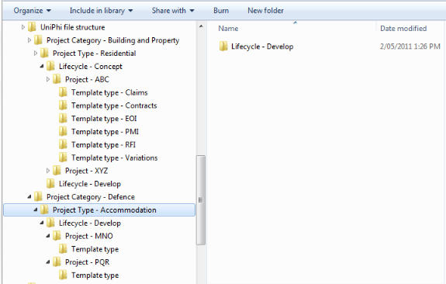

This means that document management in UniPhi is much more efficient than in other document management applications where the portfolio metadata would need to be selected and specified every time. In addition, UniPhi’s database structure enables the consolidation within a folder of all data therein (e.g. the number signed off Contract documents, versus those which are not signed off. Clearly something that is not achievable within a standard network folder structure).
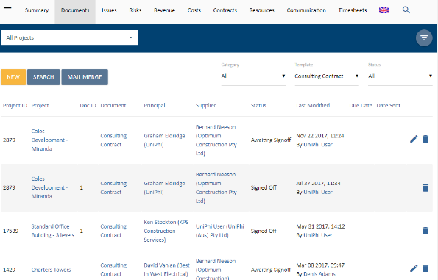

Similarly the graph below, (found at Reporting > Dashboards), tells us the number of projects being undertaken across numerous sectors. It is also possible to display comparative fee and profit information against each of these sectors.

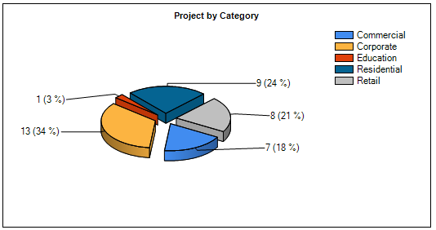

Creating and editing Project Sectors

Project sectors are generally created at the initial set up of UniPhi, though it is possible to create additional, or to edit existing categories, as outlined below:
To create new project sector:
- Click on the Side Menu (Hamburger) > Configuration > Project tab to see the project sector window:
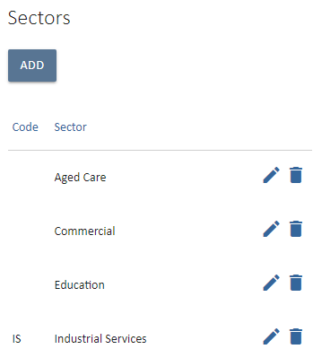
- Click on the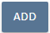 icon
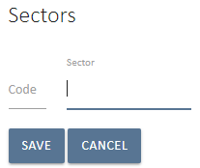
- Enter the name of the new project sector
- Click on the 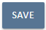 icon
- Go to Summary view and from the pop out menu . Select the Sector drop down list to see your newly created category included in the list.
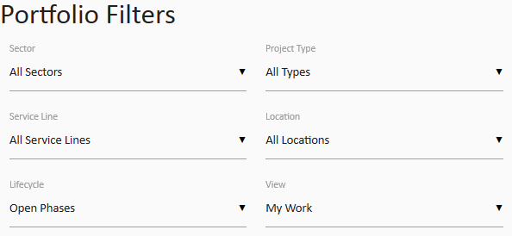
You have successfully added a sector

UniPhi has some universal icons that are consistently used throughout the system. Each data grid will have an edit and a delete icon, which is used by the appropriate users to edit that part of the system: edit and delete icons:

To edit a sector:
- Click on the edit icon
- Edit the name of the project sector
- Click on the icon to update all projects that have been assigned to this category.
You have successfully edited a sector

Create and edit Project Types

Project types are typically created upon system deployment, though they can be modified at any time. If you do need to edit or create new project types, simply follow the steps outlined below.
To create a project type:
- Click on the Configuration > Project tabs and navigate to the Project Types box:
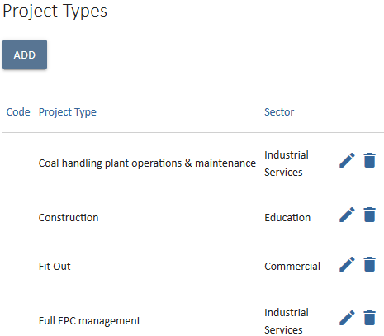
- Click on the icon
- Enter the name of the new project type. To restrict that project type to a particular sector, select the sector from the dropdown menu. Project sector and type have a one to one relationship. There only can be one sector linked to one project type.
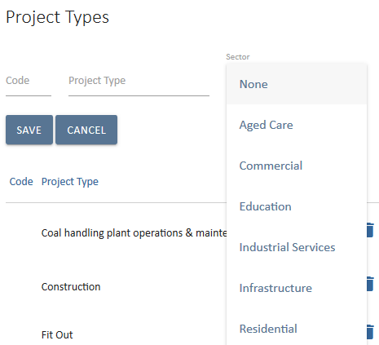
- Click on the icon
You have successfully added a project type
To edit a project type:
- From the Methodology > Project, Project Types page, click on the edit icon
- Amend the type
- Click on the icon to update all projects that have been assigned this type.
You have successfully amended a project type

Create and edit Service Line
Service lines are another way of filtering for information in UniPhi. The service line filter is generally focused on the various revenue streams of an organisation.

To create a service line
  - Click on Configuration > Project tabs and navigate to the Service Line. Click 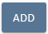
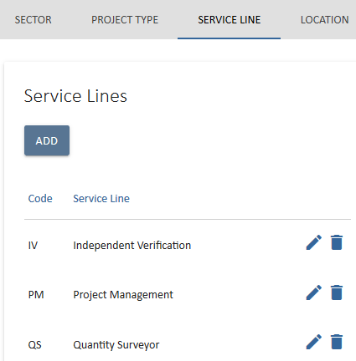
  - Enter the Name and Code for a particular service line.

  - Click on the 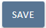 icon
You have successfully added a service line.
To edit a service line
  - Click on the edit icon
  - Amend the name of the service line
  - Click on the icon to update the service line.
You have successfully amended a service line.

Create and edit Locations/Regions

UniPhi can categorise projects into geographical locations, which allows for analysing portfolio data per specific region, or location. Locations are added as either region and the by location.

To add a region
- Navigate to Location and click the icon under Region.
- Enter the name and code of a particular region
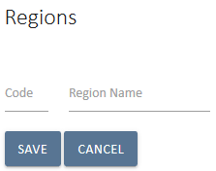
- Click the 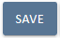 icon.
You have successfully created a region.

To edit a region
- Click on the edit icon
- Edit the name of the region, or its code
- Click on the icon to update the region
You have successfully edited a region.
To add a location
- Click on Configuration > Project > Location and click the icon under Location
- Fill out the Address Book details including the Code (if applicable)
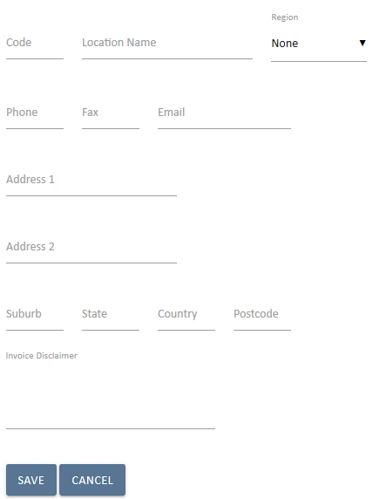
- Specify the Region that your location belongs to (if appropriate)
- Once completed, click the icon.
You have successfully created a location.
To edit a Location
- Click on the edit icon
- Amend the name of the Location
- Click on the icon to update the location
You have successfully amended a location.
Project Lifecycles and Milestones

Project lifecycle phases are used to track the stage gates of a project as it progresses from one phase to the next. These phases are broken up into Pre Award phases, which are used to track the potential sales pipeline, and Post Award phases, which represent work that has been won and is in progress. Lifecycle phases are defined and configured by an individual company’s methodologies / practices. Below is an example of lifecycle phases showing the triggers for a project’s movement from one phase to the next:

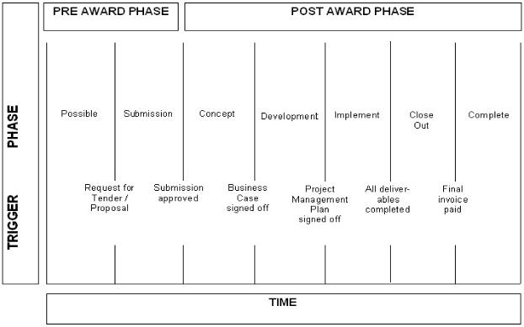

Possible projects that are tenuous, or where the fee and scope of work is unknown, can still be set up in UniPhi for tracking the pipeline of projects. Once it is known that the proposal is likely to proceed, the project is moved to the Submission phase.

Submission phase manages the proposal submission. Once the proposal is submitted and a decision has been made, it can be moved either to a post award phase, or cancelled if the proposal was unsuccessful. By cancelling lost work, UniPhi can track win/loss % for submissions and the value of the won/lost work. Comparing this to invoiced values gives UniPhi the ability to report book to burn ratios.

The post award phases track the projects, or client’s stage gates. It may be that your part of the project work is in one of these phases only.

Concept represents the creation of a business case.

Development is when project planning occurs. The project will move to Implementation when the final project management plan has been signed off.

Implementation is where implementation tasks associated with the project occur. The project will move to Close Out when all agreed deliverables have been received, and signed off.

Close Out ensures that all post practical completion work has been completed and invoices finalised. The project moves to Complete once all invoices have been paid.

Complete is a project that has been completed (typically includes key tasks such as the finalisation of accounts).

Lost/Cancelled is a project that was proposed/tendered and was unsuccessful or that may have been cancelled prior to completion.
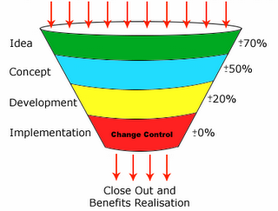

Create and Edit the Project Lifecycle

The project lifecycle phases are created by the administrator and is designed to match your existing project management methodology and associated lifecycle of phases. Depending on the size and complexity of your organisation, you may have one or more lifecycle phases that your projects will follow. UniPhi allows the administrator to define the lifecycle phases, and the categories of projects which will align with those phases. You may have a long list of lifecycle phases, but by associating each lifecycle phase to its relevant project category, the phases will be manageable and logical.

The Phase Number represents the sequential stages of your phased stage gates.
Pre-Sale Phase is only relevant if you manage projects on behalf of others (e.g. you are a consultant).
Completion State indicates that a projects phase is no longer “visible” within the main portfolio. This allows for completed, cancelled, or on-hold projects to be archived, so as to ensure the focus is on currently active projects.
To create a project lifecycle phase:
- Click on the Configuration > Project tabs and navigate to the Lifecycle box:
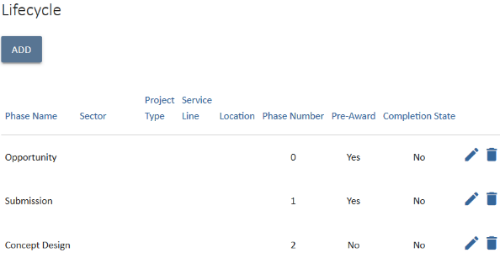
- Click on the 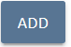 icon. The following screen will be displayed:
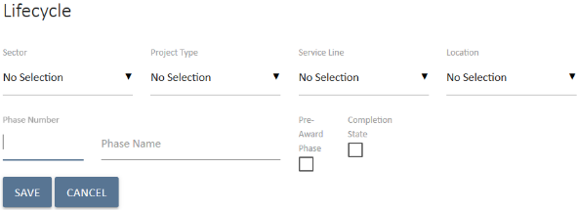

- Select the specific Sector, Project Type, Service Line and Location of the Lifecycle (if necessary)
- Enter the number that corresponds to the lifecycle phase (e.g. Concept would be phase 1, Submission would be phase 2 etc.)
- Enter the name of the Lifecycle phase
- Make sure you include Pre-Award and Completion State phases. Tick the Completion State: tick box for these two phases. This ensures that projects that are completed or cancelled can be archived out of the default view whilst maintaining the information relating to those projects for future reference.
- Click on the save icon 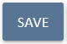
- Browse to the Portfolio tab and select the Lifecycle drop down list from the pop-up menu to see your phase is now included in the list
You have successfully added a lifecycle phase

To edit a lifecycle phase:
- From the Lifecycle page, click on the edit icon
- Amend Lifecycle changes. For example, you may need to change the name of a lifecycle phase, or change the sequential order that a phase appears within the full lifecycle.
- Click on the save 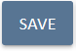 icon, to update all projects that have been assigned this phase.
You have successfully amended a lifecycle phase.

Create and Edit the Project Milestones

The project milestones can be applied to a project via two methods. Manually or using a template of predefined milestones. A resource in a role that has a minimum access level of Project Manager is able to manually create milestones from the Milestone menu of a project. However, only a System Administrator can setup Milestones templates. Milestones templates can be categorised as well. In order to set this up:
- Navigate to Configuration > Time.
- The first sub-menu allows creation of Milestone categories. Click on ADD & name the category.
- Apply any project filters for this category. The consequence of applying filters to a category impacts the projects that are able to have this category selectable. (eg, if a milestone category is for a particular project type only, then only would you apply that project type to the category).
Once the categories have been created, the Milestone templates can be developed. In order to do this, navigate to the Milestone Template sub-menu.
- Name the template. The default is “Milestone Template 1”.
- If you do not have any categories, you can apply project filters to a template so that they only appear to be selected on projects with the same project filters.
- Enter the milestone order number, the description, and the category (if created) and click the icon.

- This has create the first milestone in the template. Repeat the process until all milestones have been created for the template.

Earned Value – UniPhi has the ability to track Earned Value on milestone completion. For each milestone, a value (in %) can be entered has having been “earned” on completion. This value can be locked in place is desired.
Project Governance through Roles and Access Levels
Project governance is the method for ensuring a project can resolve issues and remains within its defined delegations of scope and outputs. Typically, governance involves defining the project roles and responsibilities, communication processes, methods, tools and approval requirements.
UniPhi manages project governance through a combination of licence levels and organisation specific roles. There are four licence access levels:
- Administrator
- Program Manager
- Project Manager
- Team Member
Discussion on these three party role levels (i.e. subscription, role and access level) needs to be broken down into read, create, update and delete and into module by module review.

Read access is controlled by the system wide subscription a person has.
Program manager subscription level can read data on every project (excluding private projects) in every module in the system regardless of whether they are on the project or not. Project manager subscription level can read data in every module for projects that they have been allocated to. Team member subscription level can read data in the documents, issues, risks and resources module for projects they have been allocated to.

Create and Update is controlled by the access level of a role on a project.
For all subscription levels other than administrator, you can only create/update information if you are on the project. What you can update on a project depends on what access level the role that you are allocated to on the project is. A role with a program manager access level has full functionality across all modules for that project. A role with a Project manager access level has full functionality across all modules except resources which is configurable at the deployment level to be either full access or read only. A role with team member access can only create documents, issues and risks, update their own documents, issues and risks but not their associated ratings or due dates

Special cases

Documents
Documents have their own party role model configurable by the system administrator. The administrator controls read rights to documents via the setting a templates view rights to an access level on the project (e.g. view only by program managers means you need to be in a role with program manager access level to view documents created from the templates). Create and update is set by selecting admin defined roles to be able to edit documents created from the template. This ignores the access level and focuses purely on the role. Sign off is set by selecting admin defined roles and ignores access level.

Risks
Program Manager Subscription can read all risks across the system and create, update and delete all risks on projects their allocated to a role with program manager or project manager access level. If they are allocated to a role with team member access level then for that project they can only create and update their own risks and cannot change ratings or due dates. Project manager subscription can read, create, update and delete all risks on projects their allocated to a role with program manager or project manager access level. If they are allocated to a role with team member access level then for that project they can only create and update their own risks and cannot change ratings or due dates. Team member subscription can read all risks on projects their allocated to and create and update their own risks. They cannot edit due dates or ratings.

Reports
The reports sub nav is configured deployment by deployment at the subscription level e.g. you can have only admin access a reports sub-nav or program manager and above or project manager and above or all.

Team Member Access
People assigned to a Team Member level role on a project can:
- Browse the organisations methodology, as defined by the program office (or System Administrator);
- Create documents (only for templates their role has edit rights to), issues, risks and change requests for the projects they are working on;
- View the portfolio of projects on the project summary view and via the reporting system;
- View their documentation issues and risks via the My Projects tab, and
- Search both for methodology content as well as project documentation/artefacts.
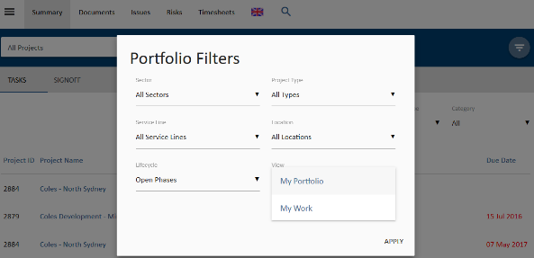
Figure 1. Team Members see these tabs only
Team members cannot view
- Financial information such as budgets
- Contract information
- Reports from within the Reports tab
- Documents which have been restricted to Project Manager access level or above
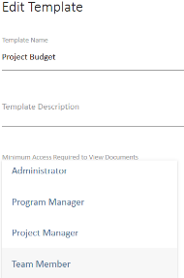
Figure 2. Team Member licenced users cannot see this document
Project Manager Access
People assigned to a Project Manager level role on a project have all permissions of the Team Member, and can also:
- Assign team members to issues, and risk mitigation actions;
- Assign due dates to documents, issues, and risk mitigation actions;
- Complete bulk update of issues including assignments and due dates;
- Create contracts, budgets, variations and progress claims to their own projects;
- Update actuals and forecast to complete;
- Assign resources to their project;
- Close resolved issues, including those that are set to "awaiting review”
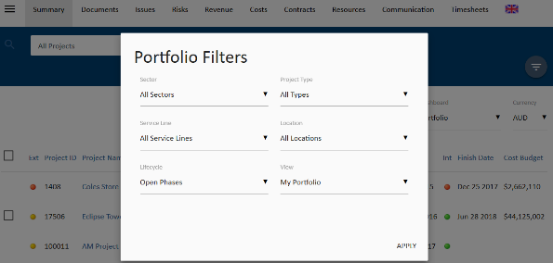
Figure 3 The Project Managers view
Project Manager cannot view
- Projects with the portfolio that they are not assigned as to a resource
- Budget information for projects that they are not assigned to
- Contracts for projects that they are not assigned to
- Risks and Issues for projects that they are not assigned to
Program Manager Access
People assigned a Program Manager licence have all permissions of the Project Manager, and can also:
- View projects, risks and financial information across the entire portfolio of the organisation.
- Assess and Analyse profitability, track backlog and burn rates and have access to contracts across the organisation.
- Access portfolio dashboard and create progress reports for all functions available in UniPhi.
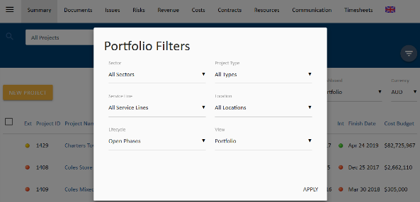
Figure 4 Program Managers view

Program Manager cannot
- View or edit items within the Admin tab
- Modify or delete document templates, or other custom fields. These tasks are performed only by the administrator.

Create Project Roles

A standard set of project roles will be deployed by default however, as organisations become more familiar with the functionality of UniPhi, they will typically create new roles.
To create a project role:
- Click on the Side menu and select Configuration> Roles
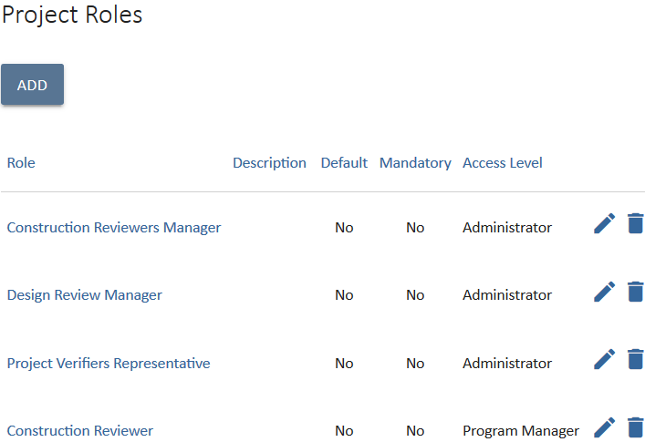
- Click on the 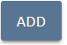 icon to display the following screen:
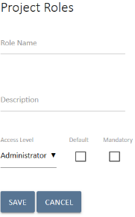

- Enter the role name
- Enter a job description in the larger description text box
The description should clarify the responsibilities and accountabilities of the role that you are creating. The access level of the role depends on what the role needs to do on the project.

- Select the access level this role has. These roles will appear as shown below
- Click the icon.
You have successfully added a role
To edit a role:
- Click on the editicon
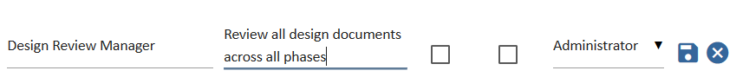
- Amend the role, description or access level
- Click to update all resources that have been assigned this role
You have successfully amended a role

Create a Resource Custom Field
Resources within UniPhi are categorised as being
- Organisation – The trading entity or “brand” that you are dealing with. The organisation must have at least one site associated with it, and in some cases it may have multiple sites
- Site – The physical location of an organisation. The site will have a physical address, and will have one or more resources associated with it.
- Contact – A person. Each contact is created in UniPhi and can be a licenced user or can have no access and simply be stored in UniPhi for contact and CRM purposes. Each contact can be linked to one or more sites and organisations
- Asset – Broadly speaking assets are materials that relate to your project. Asset may be resources which have been procured in bulk quantities, which are then allocated to projects within your organisation. For example, your organisation may purchase a block of land, which it hopes to develop and sell off as individual units. In order to track and monitor the land asset, and the units which are built upon that land, UniPhi uses the Asset category

UniPhi’s flexible design allows an organisation to create custom fields per resource type. In practice this means a contact person may have specific details recorded against them, and this is also possible for an organisation, site, or an asset.

Create a resource Category
- From the side menu, select Methodology > Resources and navigate to the Custom Fields tab.
- Press the Add+ button under Resource Custom Field Categories.
- 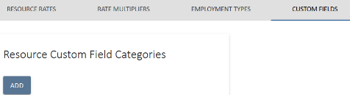
- Enter the name of the resource category
- Save your entry.

Create a Resource Custom Field
In order to create your resource custom field:
- Scroll down to the Custom Field panel and select the type of resource custom filed that you wish to create from the drop-down section menu.
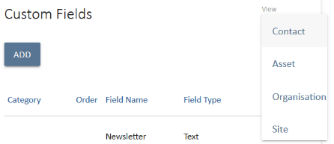
- Press the Add button and select the category that your field belongs to, provide a name for your custom field, and select the type of information that your custom field will capture.
- Save your entry.

Once created, the resource custom fields will appear within the resource details for that particular resource type.

Programme Reporting

Key to UniPhi’s unique features is its flexibility in the way that an organisations administrator user can configure much of the structure that other users will adhere to. The UniPhi administrator can create custom lists and fields throughout the various modules in the system so that the terms used, and the fields of information and meta-data captured are relevant to the particular organisation. The resulting fields describe the project and can be used to gain business intelligence on a single project, or across the entire portfolio. Once configured within UniPhi, managers and reviewers (e.g. Project and Program Managers) can view reports based on this specific data. For example, a consulting or sales company may wish to add a postcode or location project custom field to determine and report on where most of their business is coming from, or which locations generate projects with the most income. Alternatively a construction company may be interested in the metrics associated with their buildings and hance may wish to capture measurments such as gross floor area.

UniPhi allows for the addition of numerous organisation specific customisations. Instructions below explain how to create these customisations via the creation of project custom fields, drop down lists, categories, and project custom lists.

Create Project Custom Fields
To create a project custom field:
- From the side menu select Configuration > Project, navigate to the Custom Fields tab and scroll down to Custom Fields:
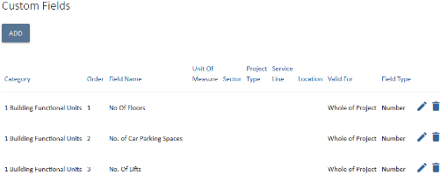
- Click the 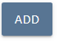 icon to display the following screen:
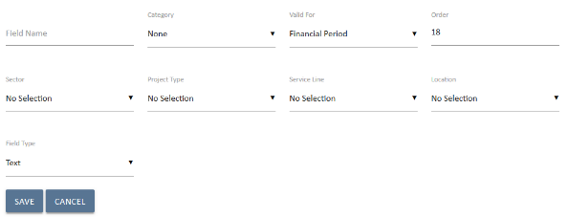
- Select the relevant project custom field Category (if relevant).
It is possible to allocate project custom field to specific project categories, effectively links your custom fields to a particular project category. Larger or more complex UniPhi deployments may need a greater number of custom fields to be added in order that reporting requirements can be satisfied. Adding categories allows the company to report on a selection of project custom field data more easily. For example, a project may require multiple fields to be added regarding safety (i.e. number of lost time injuries, number of medical treatment injuries, number of first aid injuries, and number of working days lost etc.) If all of these custom fields have been assigned to the safety category then it is easy for Project Managers to report on all safety data by simply selecting the safety category when generating a report.
To add project custom field categories simply go to Methodology > Project Custom Field Categories
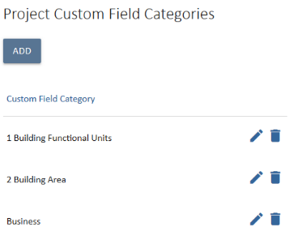
Click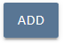 in the, enter the name of your new category, and then click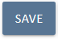. Repeat until you have added all required categories.
- Enter the order number that you wish your custom field to appear in the Project Details box (1 for first, 2 for second, etc.).
- Select the relevant project categories (Sector, Project Type, Service Line and Location) that your new custom filed relates to. Leaving each of the category fields blank means your custom field will appear in every project.
- Enter the name of your custom field in the Field Name
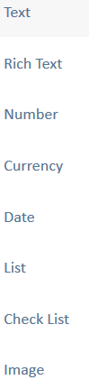
- Select the type of custom field you wish to add by selecting the Field Type dropdown.
Custom Field Types: There are eight (8) different types of project custom fields.
Text: Allows the user to enter in limited text.
Number: Allows the user to enter in numeral digits when adding a new project
Currency: Captures financial information
Date: Allows the user to select or manually enter a date against the project.
List: Allows the end user to make a selection from a pre-defined drop-down list. This will be demonstrated in the following exercise.
Check List: Allows the end user to make multiple selections form a pre-defined check list.
- Select the period of time that the custom field is valid for. For this example select Whole of Project.
Valid For: By indicating the period the custom field is valid for, you enable users to report on the information based on these periods - either the value is specified for the life of the project or is set every financial period.
Whole of Project: may be an extra level of project categorisation for reporting purposes over the entire project.
Financial Period: Used when you want to report on something (e.g. an occurrence such as the number of OH&S incidents) over a financial period.
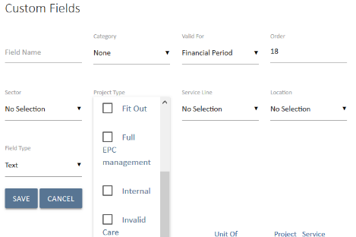
- Click the save icon 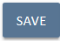 to save your custom field
- To view your new custom field, go to Portfolio > Summary and click the 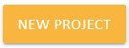 icon to display the Project Details screen. Note the new custom field appears at the bottom of the Project Details box.

Create and Apply Custom Lists

To create a new Custom List:
- Click Configuration > Custom Lists to display the Custom Dropdown Lists box:
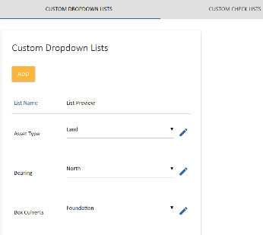
- Click the 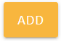 icon to display the following screen:
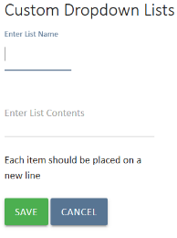
- Enter the name of your custom list and the list contents. Each item should be placed on a new line. This is done by pressing the enter key after each item.
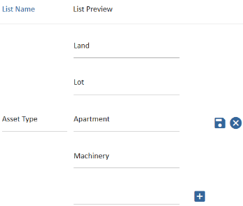
- Click the icon to save your list. Your new list should now appear in the Custom Dropdown Lists along with other lists that have been created.
To apply your custom list to projects:
- To add your new custom list to projects go to the Configuration > Project view.
- Click the 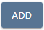 icon in the Custom Fields box
- Give your project custom field a name (this does not have to match the name of list you created) and select list from the Field Type: dropdown.
- The Custom List dropdown will appear. Select the list you created earlier.
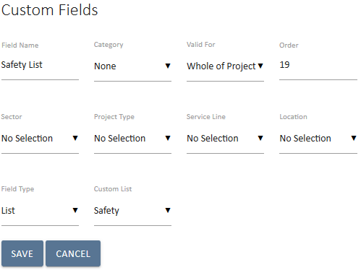
- Save your entry.
View your project custom list by going to Portfolio > Summary and drill into a project. This will display the Project Details screen, and as you scroll down through the project information you will notice that your custom list has been added.
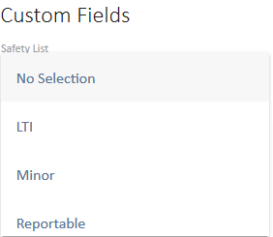
You now know how to create and apply custom lists

Custom lists are a very powerful and useful way to capture project specific information. Custom lists can be used in numerous places within UniPhi such as project summary, issues, and even document templates.
To apply your custom list to an issue category:
- Ensure the issue category exists.
- Click on Configuration > Issue > Issue Custom Fields and click 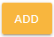
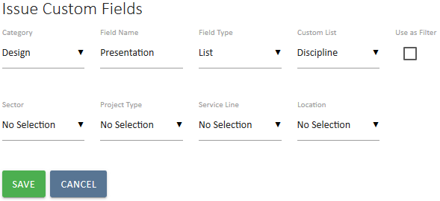
- From the drop down menu, select the custom list to be linked. You will now see this custom list in the Issues screen if the issue category is selected.
You now know how to create and apply custom lists to an issue category.

Dashboards

Within the Dashboards tab you will find a number of high level but powerful dashboard summaries. The dashboard merely present information which has been drawn from various information sources in UniPhi. It is not possible to create or modify content within these tabs, but rather to review and act on any information that you see summarised thin them.
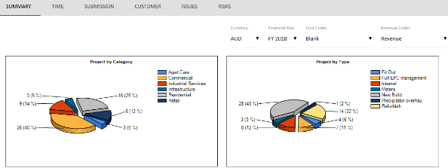
Dashboard reports present information according to the following categories:

Summary Dashboard
Present s summary of your entire organisations portfolio of project. Panels have been designed to display the number and % of projects according to your defined Sectors and Project Types. You will also see a summary of your project Issues by rating (high, medium, or low), and Risk rating trends over time. The risk rating is useful for understanding the trends in your risk management as it will show graphically how the count of high, medium and low level risks have changed over time.
Financial information is displayed as Fee and Cost tables which present budget, forecast, and actual values. You will also find a summary table that displays cost and revenue information according to the lifecycle phases that your projects are in. This table provides insights into the amount and value of new projects versus those that are heading into completion phase
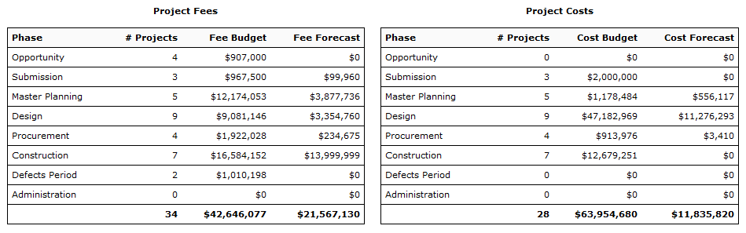

Time Dashboard
The Time dashboard is designed to provide an overview on the progress of each project according to baseline dates, and current forecast dates. There is also a filter option which allows you to hone in on the projects which are slipping against their baseline dates, and those which have actually slipped.
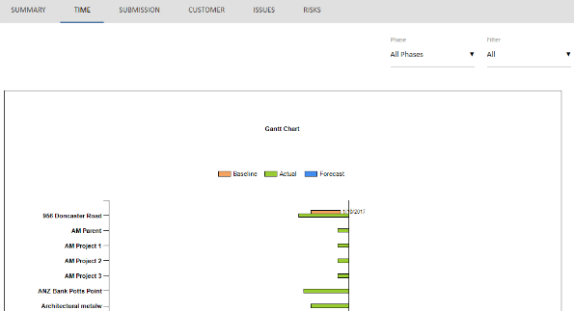

Slipping projects, where a phase of the project is forecast to end later than originally planned, but the end date of the overall project is still forecast to be on-time. Slipping should flag that there is potential that the overall project may be impacted if the slippage is not made up for in later stages of the project.
Slipped projects have an expected project end date later than the baseline end date, i.e. the project was originally planned or baselined to finish at a date, but the current forecast end date is later.
For clarity, baseline dates are those dates that were set and saved at the commencement of a project as the 'target dates'. Actual dates are the dates that are in the past for the start or end of a particular stage or phase of a project, while forecast dates are the dates in the future for the start or end of stages or phases.
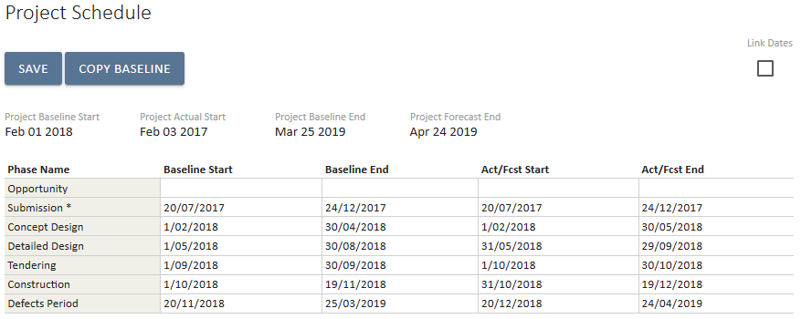
Setting and editing project stage or lifecycle phase dates is prepared in the Project Schedule page accessed from either of the Portfolio views -> Summary or Resources for a specific project.

Submissions Dashboard
Submissions dashboard draws information for your projects as they move from pre-award phases to post award phases. At a glance you can see the number of and value of projects which have been won, and those lost. Data is displayed according to the revenue being existing revenue and new revenue. Win/Loss rations are also shown in the submissions tab.
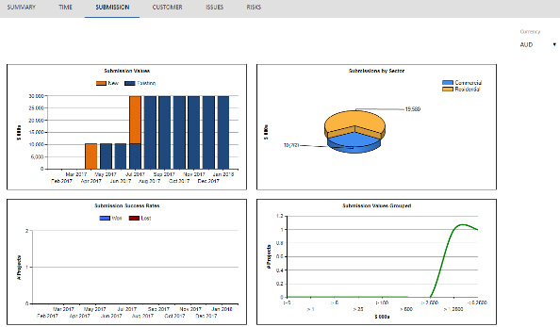

Customer Dashboard
The Customer Dashboard presents the "Top 5" customers in terms of revenue and profit across your organisation. The dashboard contains 4 graphs which display your present top 5 customers for the quarter and over the past year with a comparison to the same time last year.
The graphs each show:
- Top 5 Revenue in the Quarter
- Top 5 Profit in the Quarter
- Revenue by Customer
- Profit by Customer
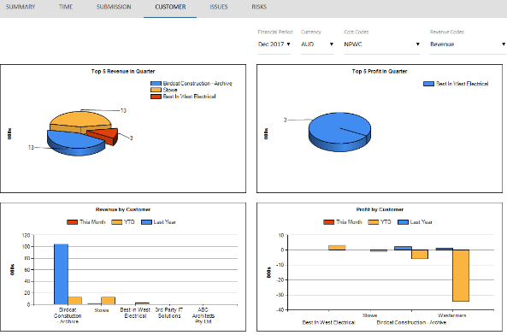
UniPhi dashboards adhere to UniPhi’s core design principles whereby data entered once is made available in numerous places, and in real time. This means that each time a revenue contract is created anywhere in your UniPhi deployment, the value of that contract will immediately update the customer dashboard, so you always see your top 5 as of right now. Having this information available dynamically means that you no longer need to wait for a report to be compiled, consolidated, and distributed to understand how your business its tracking today, and not last year, last month, or last week.

Issues Dashboard
The Issues dashboard presents two graphs. These graphs show the number and percentage of issues according to their rating of high, medium and low. And the number and percentage of issues allocated to the defined issue categories.
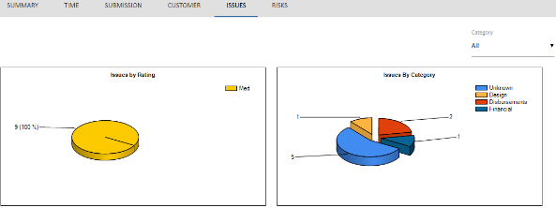

Issue and Risk Reporting through Categories
Managing issues and risks is important to reduce negative impacts on projects, and to generally collaborate and track progress towards intended outcomes. Within UniPhi, users can add issues and risks (through the relevant tabs), assign due dates, track actions & resolutions, or mitigation steps & triggers, and generate various reports to relevant stakeholders. In order to be able to view and analyse your risks and issues it is important to establish the categories as they relate to your organisation.

Create and Edit Issue Categories

Issue categories are used to identify issues according to their specific type, as well as to group issue information for use in documents and reports. When users log issues they can select the type of issue by specifying the issue according to the pre-defined list of categories.
To create an issue category:
- Go to Configuration > Issue to display the Issue Categories box:
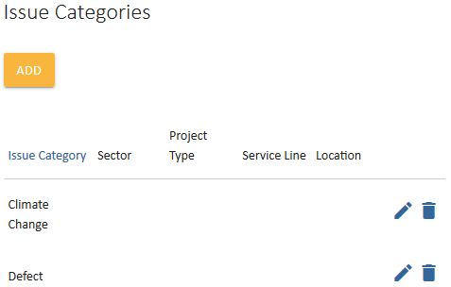
- Click 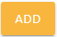
- Enter the name of your new issue category and select the Sector, Project Type, Service Line and Location.
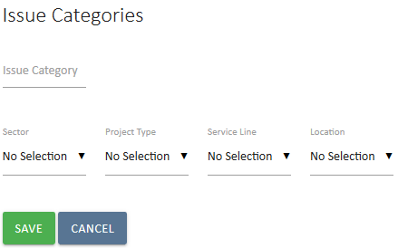
- Save your entry.
You have completed adding an issue category.
To edit an issue category:
- Go to Configuration > Issues to display the Issue Categories box
- Click the edit icon to the right of the category you wish to edit.
- Amend the category name:
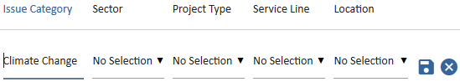
- Save your entry.
You have completed editing an issue category

Create and Edit Issue Escalation

Issue escalation levels are designed to prioritise issues by ranking them against user specified levels. Escalation levels are a useful way to add an extra layer of escalation to the standard High, Medium, and Low issue levels. These levels of escalation can be named and ordered in any way desired.

  - Go to Configuration > Issues > Issue Escalation Levels.
2. Click the 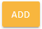 icon

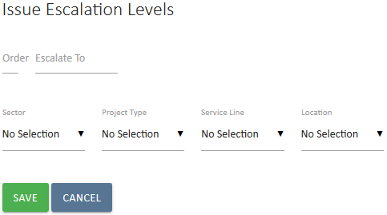

  - Order and name the escalation level
  - Select the Sector, Project Type, Service Line and Location as deemed appropriate.
  - Save your selection.
Note that issue escalation works from a top-down hierarchy level so that the level 1 escalation will only see items which have been escalated to that level, while those viewing escalation level 2 will see both level2 and level one escalations. This is by design and ensures that a person filtering for a level 1 issue is not distracted by a lower level of issue.

Create and Edit Risk Categories

Risk categories serve much the same purpose as Issue categories, and the process for creating and modifying them is largely the same.
To create a risk category:
- Go to Configuration > Risks to display the Risk Categories box:
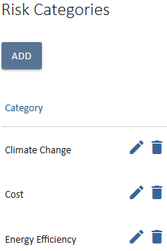
- Click and enter a category. Save your entry.
You have completed adding a risk category.
To edit a risk category:
- Go to Configuration > Risks to display the Risks Categories box
- Click the edit icon to the right of the category you wish to edit.
- Amend the category name and save your entry.
You have completed editing a risk category

Create and Edit Risk Escalation
Risk escalation levels are designed to prioritise risks by ranking them against user specified levels. These levels of escalation can be named and ordered in any way desired.

- Go to Configuration > Risks > scroll down to Risk Escalation Levels.
- Click the icon
- Order and name the escalation level. Save your entry.
You have now created a risk escalation

Risk Management via Risk Matrix

Risks are events or actions that, if they occur, have the potential to hinder the progress of a project and impact negatively on a project. Identifying risks to a project, determining the probability or likelihood that the risk will occur, and what impact or consequence the occurred event will have on the outcomes of a project is essential analysis, and is the responsibility of the Project Manager.

Establishing and configuring a risk matrix aids this process. A risk matrix multiplies a risk’s likelihood rank by its consequence rank to produce a risk level. UniPhi allows for these rankings and level to be established and applied to all identified project risks.

Create and Edit Risk Likelihoods

To add risk likelihoods:
- Go to Configuration > Risks and scroll to the Risk Likelihood box
- Click the button to display the following fields:
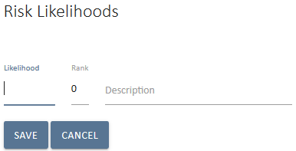
- Enter the likelihood of an event occurring
Likelihood: There are numerous ways to measure a risk’s likelihood, and the values you use are determined by your organisation or by a project’s risk management plan. Example likelihoods could include quantitative or numeral values, from 0 to 10, with 0 being the least likely and 10 being the most likely. Some qualitative values commonly used are rare, unlikely, possible, likely, certain.
- Assign a rank to each likelihood:
- Add a description of the risk likelihood. This will ensure consistency of understanding when people create and assess risks. Save your entry.
- Repeat the process to complete adding all risk likelihoods:
You now know how to add risk likelihoods

To edit risk likelihoods:
- Go to Configuration > Risks and scroll to the Risk Likelihood box
- Click the button to the right of the likelihood you wish to edit:
- Amend the likelihood and/or rank
- Save your entry.
You now know how to edit risk likelihoods
Create and Edit Risk Consequences
To add new, and edit existing risk consequences, follow the same steps that you used to create and edit risk likelihoods.
Consequences: As with risk likelihoods, there are numerous of ways to measure a risk’s impact and the terms or values you use will be determined by your organisation or by a project’s risk management plan.

Some example consequences could be:
- Quantitative or numeric values: 0 to 10 with 0 being insignificant and 10 being extremely serious.
- Qualitative values: negligible, marginal, critical, and catastrophic.
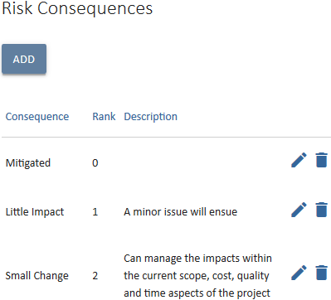

Add Risk Levels

To Add Risk Levels:
- Go to Configuration > Risks and scroll to the Risk Levels box
- Click on the button. The below fields will be displayed:
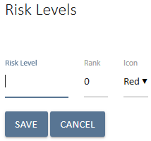
- Enter in the Risk Level and Rank, and select an icon colour to represent the level you are creating.

Risk levels and icons in UniPhi: UniPhi allows for creation of 5 risk levels, graphically represented by 5 Icons. These icons are based on typical RAG (red, amber, green) traffic light indicators, but to allow users to define risk levels in greater detail, red, orange, yellow, blue and green icons can be selected.
See the two examples below, which illustrate risk level options in UniPhi:
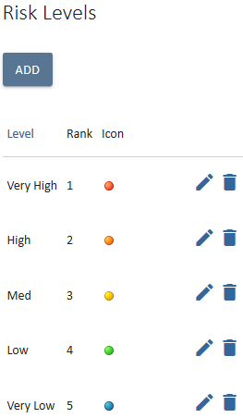
Organisations must determine their own risk levels within the risk matrix functionality.
- Save your entry.
- Repeat the process to complete adding all risk levels
You now know how to add risk levels in UniPhi

Apply Risk Levels to the Risk Matrix

Once you have entered your organisation or project risk likelihoods, consequences and levels, you are able to use this information to construct the risk matrix. The risk matrix “multiplies” the risk likelihood by the risk consequence, resulting in a calculated risk level. Managers use this information to prioritise and manage project risks.

UniPhi automatically populates the risk matrix using the likelihoods and consequences already created. The next step required to complete the matrix is for levels to be applied to each of these combinations.

Once you have created your matrix, and go to add actual risks to a project, you will be asked to select the likelihood and consequence for each risk. Based on the matrix, a risk level and traffic light icon will be applied to the risk automatically.

To create a risk matrix:
- Go to Configuration > Risks and scroll to the Risk Matrix box:
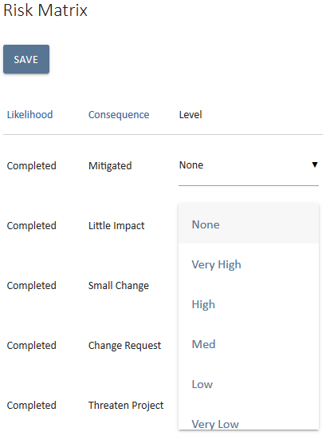
- Use the Level dropdown to select the appropriate level, based on the likelihood and consequence of the risk.
- Repeat the process until all combinations have a level applied.
- Save all your entries.
You now know how to create a risk matrix in UniPhi.

Contract Methodology Configuration

Contract Methodology through Contract Status
Managing contracts is simplified in UniPhi with the ability for administrators to establish contract statuses. By indicating which contracts statuses are committed users are aware that they intend to raise progress claims, variations, EOTs and a variety of other post contract documentation against contracts that have not yet been committed or have been completed / cancelled.
Contract statuses are usually established during UniPhi deployment but can be added to or amend to align with current contract methodology:
To create, edit and delete Contract Status:
- Go to the Configuration > Contract status tab:
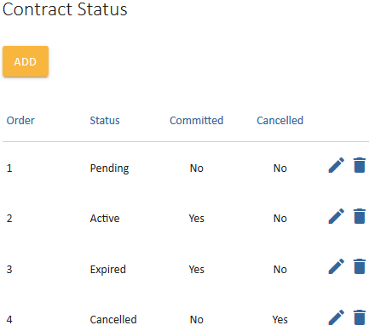
- Click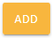and the following fields will be displayed:
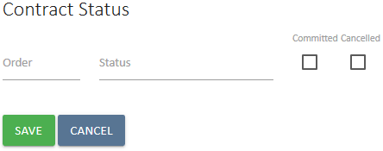
- Enter in the name of your new Status
- Enter in the Order of your new status (this is the order it will appear in the status dropdown)
- Indicate if the status is a committed contract status or not.
Committed: project cost reports will only display committed contract values so unless a contract status is committed it will not appear in reports.
- Indicate if the contract status has a cancelled property.
Cancelled: This flag is used in reports both from an internal submission basis and an external tender analysis basis. Information can be used to report on ratios of contracts won and lost, manage tenders and collate benchmark data on $ ranges for competitive versus not so competitive tenders.
In the example displayed below a number of cancelled statuses have been added to align with the organisation’s own methodology and allows users to report in more detail why the contract was cancelled:
- Save your entry.
You now know how to add a new contract status
To view your new contract status go to the Portfolio > Contracts tab and select a project from the Project filter. Click 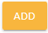 in the Contract Summary box and fields will be displayed that allow you to add a new contract to your project. Note that the status dropdown now includes the status you just added:
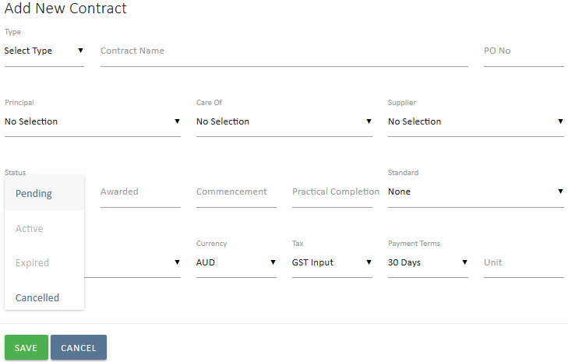
If you were to select withdrawn your contract will contain the properties associated with that status.
To edit a Contract Status:
- From the Configuration > Contract status tab, Contract Status box click on the edit icon to the right of the status you wish to amend:
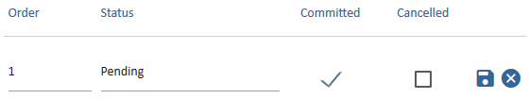
- Edit the order, name or committed / cancelled properties of the contract status
- Click the save icon to complete editing your contract status
- Click the cancel icon if you want to cancel editing your contract status.
You now know how to edit a contract status

To delete a Contract Status:
- Click the delete icon to the right of the contract status you wish to remove
- You will be asked to confirm that you really want to delete the item:
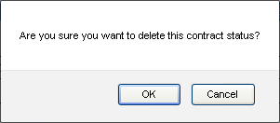
- Click
You now know how to delete a contract status
Contract Methodology through Contract Standards
UniPhi allows for the addition of contract standards so that the user can specify the relevant Australian Standard when adding a new contract.
To add, edit and delete Contract Standards:
- Go to the Configuration> Contract and navigate to the Contract Standards box:
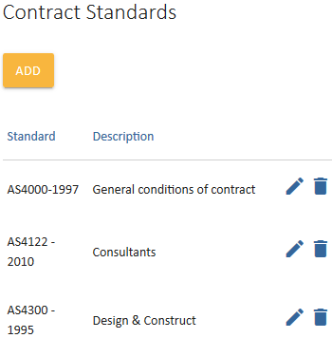
- Click the 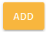 button. Enter in the Standard and a brief description:
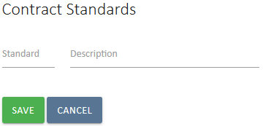
- Save your entry.
- To edit or delete an existing contract standard, use the edit delete icons to the right of the relevant standard.
You now know how to add, edit and delete Contract Standards.

Contract Methodology through Variation Categories
As contracts are let and the project progresses, it may be necessary to work with variations to the agreed contract. Variations are raised within the contract classified as being potential, pending, approved and rejected. As an additional level of management for variations, an organisation can specify the category of variations that are available to the end user.

Creating Variation Categories
- From the Configuration > Contract tab, navigate to Variation Categories.
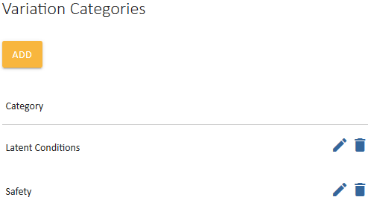
- Press the 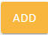 button
- Enter a description to your variation category and save your entry.

Specifying a Contract Variation Category
Once variation categories have been created, they can be specified within a contract where a variation has occurred.
Notice that the contract variation panel will display a drop down menu of available variation categories.
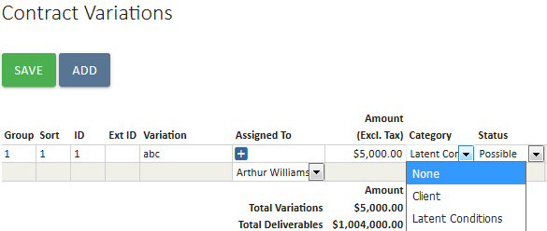

Workflows using the Issue system

The Issues tab is designed to log, track, and report on issues relating to a project. Often issues are common to many projects and the same steps or actions need to be carried out to resolve it, and in some cases actioned by the same roles. Further, if the time taken to complete the actions is the same it can be determined using the issue template functionality, automatically calculating a due date for the common isssue once the template is applied.

This functionality can be used for common issues and also common tasks. For example, a template can be created to facilitate the workflow required to carry out a progress claim.

Add an Issue Template

- Go to Configuration > Issues tab and navigate to the Issue Templates tab
- Click the 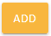 button
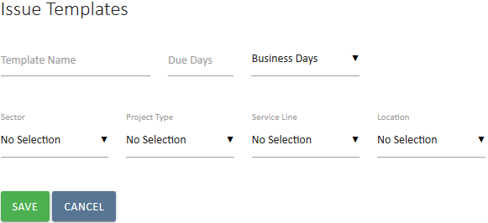

- Enter in the name of your issue template
- Determine if the Due Days field is to be calculated using business days or elapsed days
- Select the relating Sector, Project Type, Service Line and Location for the issue template.

Due Days: Due days refers to the number of days required to complete all actions and close out the task/issue. The System Administrator is able to use the drop down list to specify how the due date is calculated, based on the number of days entered. Where business days is selected, UniPhi will ignore weekends and calculate a due date further in the future. Where elapsed days is selected, UniPhi will include Saturday and Sunday and the resulting due date will be sooner that if business days was selected. UniPhi defaults to business days.

- Save your entry.
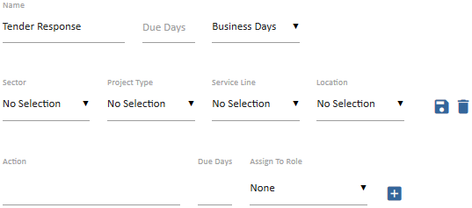

Note that the Due Date field has automatically defaulted to 0. As actions and the number of days after the issue or action was triggered that the action is due are entered, UniPhi will automatically update the final Due Date field. For example, if an issue is triggered on a Tuesday and the first action is required to be completed 3 days later, UniPhi will calculate the due date as being Thursday, (i.e. Tuesday, Wednesday and Thursday allocated to complete the first action). System Administrators must enter in the due days based on when the issue or action was triggered, NOT based on when the previous action was completed.

- Enter the first action, the number of days after the issue or task was triggered that the action is due, and select the relevant role that will carry out the work:
- Click the icon to add the first action and all subsequent actions:
Note that the Due Days field has increased to 10 days, with the first action due 1 day after initiation, and the second action due 5 days after the first action.

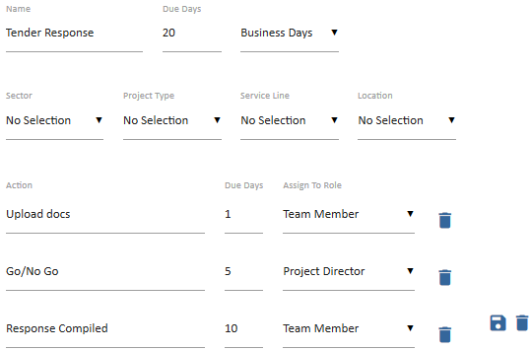

- Amendments can be made at any time and are saved by clicking the button
You have successfully created an issue template
Issue Templates in action
- To test your new template, go to Portfolio > Issues tab and select a project from the Project dropdown.
- Click 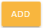 to add a test issue
- Enter in the name of your issue, select the resource that is responsible for the issue or task, and select the template you created from the Template dropdown. Next, select a rating for the issue (if nothing selected UniPhi defaults to a medium rating).
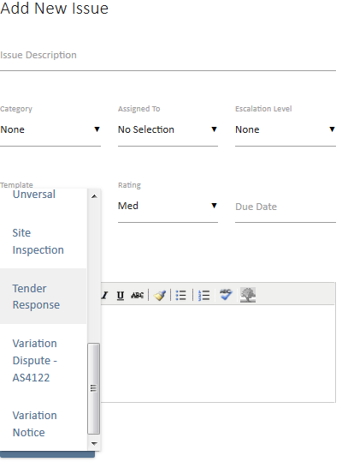

- Click 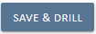 to save and view your issue actions:
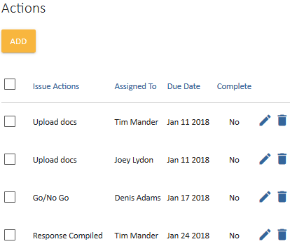
Note that Actions, Resources and Due Dates have been automatically generated based on your template and the day the issue was created.

Financial Management

Chart of Accounts
Budgets, actual and forecast, fees and costs, are managed through UniPhi according to the chart of accounts (CoA). The CoA will typically match your company accounting system structure, however, if you are managing projects on behalf of clients, then the CoA may include both your company accounts and a project CoA for project budgeting. Hence, it is possible to develop multiple CoA’s.
There is a tight integration between cost and revenue modules, and the contracts module. For example, once a budget is established in the costs system, cost contracts are apportioned to that budget, allowing the project manager to check committed versus budget, and forecast to complete costs.
The chart of accounts (or charts, if you have multiple) allows for multiple levels of detail to be defined as a hierarchy structure. There are two ways to set up cost codes in UniPhi: a file upload, or a user interface for data entry.

Chart of Account Types
There are three types of chart of accounts:
- Project costs - Use project cost if you are managing project costs on behalf of a client. You or your organisation are NOT actually paying these costs
- Internal revenue - Use internal revenue if you are tracking fees received for goods or services. You or your organisation are receiving money for these items
- Internal costs - Use if you are tracking internal company or project costs. You or your organisation ARE paying these costs.

Project costs charts are used for project cost reports. These charts can be linked to internal cost charts if the deployment is for internal project management. The cost elements set up in this chart determine how budget information will be reported on a project.

Internal revenue and internal cost charts are for tracking either project profitability from a professional services practice management perspective, or cost benefit analysis from an internal project business case perspective. Default reports in UniPhi use these two chart types to define revenue and expense, as well as benefits and costs. Example reports include portfolio profitability, project profitability, free cash flow, and cost benefit analysis reports.

Create Chart of Accounts through Import

There are two methods for creating a chart of accounts. If your chart is large and comes from an accounting system then you may like to import the list. You will need to export your finance system fields to match the sample Excel file provided, for this to work.
To view a sample Excel file:
- Access the account codes section by browsing to the Configuration > Chart of Accounts
- Select the 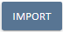 icon:
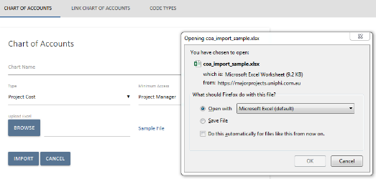
- Click on the link. A pop up will ask if you wish to open or save the sample file:
- Open the file in Excel by clicking OK. The Excel sample will be launched:
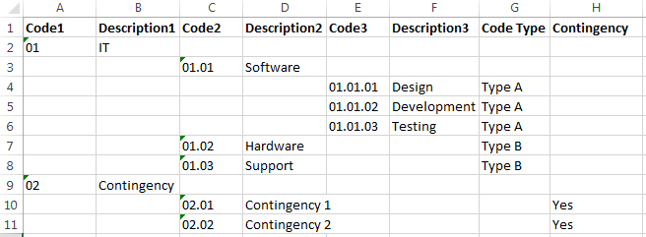

To create a chart of accounts by importing an Excel file:

Structure: The first row of the sample file contains the data structure that must be followed for a successful import.
Chart of Account levels: Your chart of accounts can be defined to the level of granular detail that suits your organisation. For example you may have a high level COA structure which simply classes all income as “Revenue” or “Sales”. Alternatively you may have a cost COA that breaks down Contractors, Consultants, Marketing and Materials; and then within Marketing for example you have a second level that breaks down the categories of marketing that you purchase. You may even categories the types of marketing types specified down to a third or even fourth level.
- To create a secondary level for marketing, enter the first sub-code in column D with an appropriate code in column C.
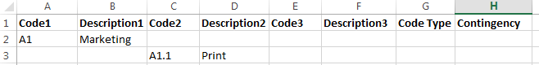
- If your secondary level item (A1.1 Print) needs to have more codes on the next level, enter these code in column F with the appropriate code in column E.
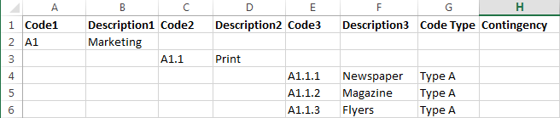

You may keep adding additional levels to your COA structure by following the logic within the sample file – where CodeX and DescriptionX are mapped along your excel columns

Code types can be specified in the next column after specifying all the different levels required in the chart of account.
Code types: are yet another way of categorising the type of COA item that you are entering. As an example you may have code types specified for Opex and Capex, or Site Costs and Building Costs.

Contingency codes can be specified by typing “Yes” in the cell. You may have multiple forms of contingency specified at any level of your CoA structure.

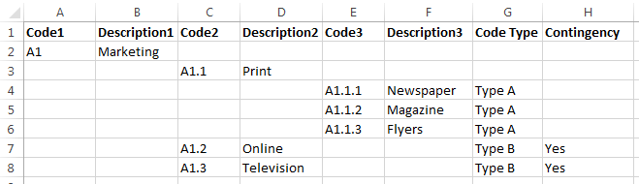

Once the chart of account has been entered into your excel sheet, the range name needs to be specified. The range name “CoA” can be edited via the Name Manager by either modifying the range of the existing CoA name, or deleting and recreating the CoA name range.

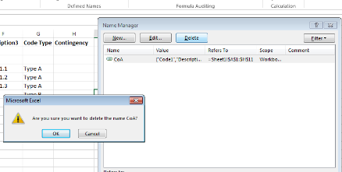
Figure 5 Deleting a defined name range
Once deleted, the new range name can be specified by highlighting the range and naming it “CoA”
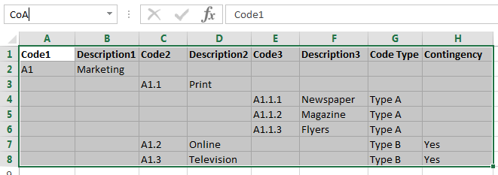
Figure 6 Creating a new name range called CoA (case sensitive)
Once this is done, save the Excel file.

To import the Excel format chart of account into UniPhi:

- Select Browse, select the saved Excel file and click the Import button.
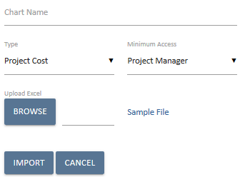

Project Costs: Select project cost if you are managing project costs on behalf of a client.
Internal Revenue: Select internal revenue if you are tracking fees received for goods or services
Internal Costs: Select if you are tracking internal company or project costs.
You now know how to import cost codes

Create Chart of Accounts through Data Entry
To create a new chart of accounts manually:
- Go to the Admin > Chart of Accounts tabs, click on the 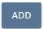 button. Enter the name that describes your new CoA and select the type:
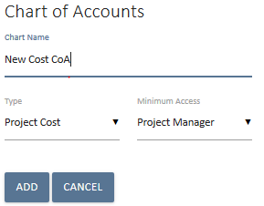
- Your new chart of accounts entry will appear in the list of charts:
- Click on the hyperlinked labale “New Cost CoA” in order to add each of the relevant header categories:
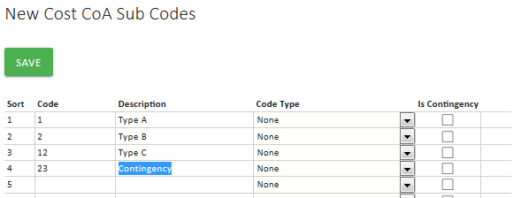
- Save your entry. You will notice aicon. To enter a new secondary level code, click into it and enter the relevant code details:
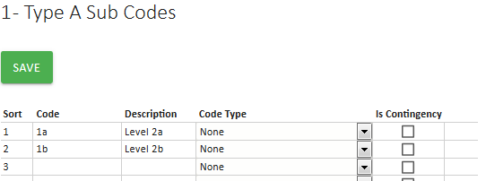
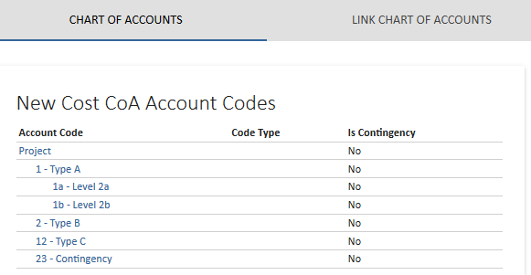
- UniPhi will let you map your chart accounts to multiple (n level) levels of detail. In order to add a new sub-level to your chart of accounts you simply need to save and then click into the code that you have created. Alternatively you may click on the icon.
Cost versus Revenue CoAs and Contingency Codes: In the example above a Cost chart was created. When creating a cost chart of accounts the Is Contingency column will be displayed (highlighted in red). Revenue CoA will not have a contingency value option:

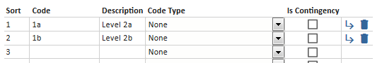
To indicate contingency, codes for variations to be mapped against the Is Contingency box must be ticked. Codes that have been selected as a contingency code will appear in the Funding Code dropdown when adding a variation to a contract:
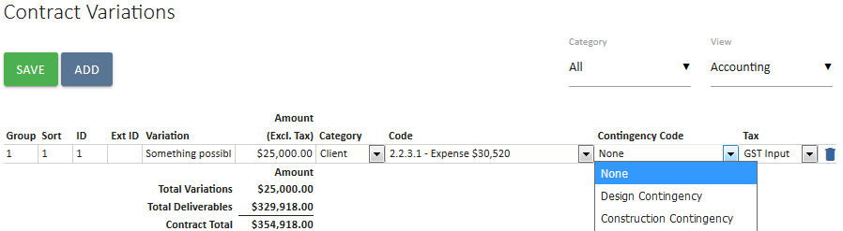
Deleting CoAs: To delete a chart of accounts, select the relevant chart from the Chart dropdown and then click the delete icon to the right of the chart name, then click OK to confirm that you wish to delete that chart.

To edit account codes; click in the code you wish to edit and amend as necessary then save. To remove a code, click the icon and save.
You have successfully added account codes to an existing chart of accounts

Financial Years
UniPhi has the ability to track the monthly actual, forecast and budgeted revenue and expenditure and report on these on a financial year basis. To be able to do this, the relevant financial years of the company need to be established. You can pre-populate as many financial years as is necessary (past and future). These financial years will be available to users via drop down boxes in the cost and fees tabs. The more financial years entered the more options in the drop down list options available. For this reason, it is common for only 3-5 financial years be available at any one point in time. More financial year periods may be required if the project runs over a number of years and the business would like to time-phase the cash flows over the entire project period.
Once a financial period is completed and the accounts signed off, the financial period is closed. Individual month periods can be closed out sequentially, or an entire financial year can be closed at one time. Once a period (month or year) is closed:
- All timesheets are marked as submitted and it submits any saved time that had not been submitted for that period
- No one can timesheet to that period.
- Cash flow phasing interfaces in the system show actual for that period instead of forecast.
- The API shows actual for that period and clears the forecast (this makes it easier for Act/fcst graphing)
Other business rules relate to accounting integration and are not relevant here including closing a financial year (won't import actuals for that year once closed for example).

Create Financial Years and Periods
To create a financial year:
- Click on the Configuration > Financial Years tabs
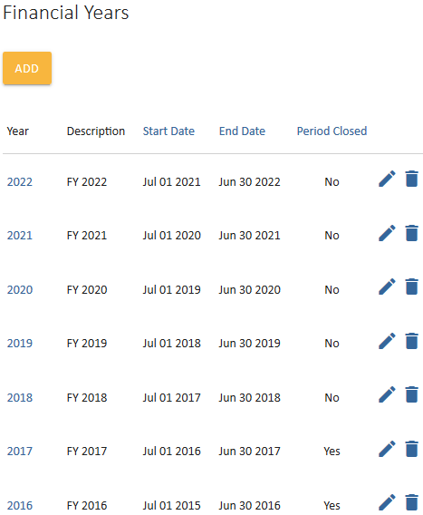
- Click on the 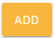 icon to display the following:
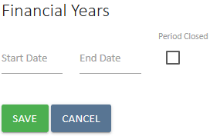
- Enter the start and end dates for a financial year and indicate if the financial year has been closed:
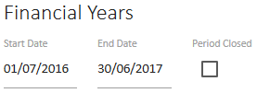
Note it is possible to enter a shortened financial year if for example UniPhi is deployed a portion of the way through a financial year, or a company changes its financial year period. The Period Closed tick box allows you to indicate single period or entire financial years where accounts have been finalised, which prevents data being entered against that year.
- Save your entry
You have successfully added a financial year

Edit, Close, or Re-Open Financial Years

To edit or close a financial year:
- Click on the Configuration > Financial Years tab
- Click on the edit icon to the right of the year you wish edit:
- Amend the financial year dates or tick the Period Closed tick box if you wish to close it, or un-tick if you wish to re-open it.
- Click on the save icon.
Note the financial year is a filter. Data entered against a particular month is captured at that point in time. If that month is no longer within a financial year period it will no longer be displayed in the accounting costs for that project. However, if this period becomes within a financial year period again, it will be re-displayed. In other words, the data is not lost, it is simply filtered out.
You have successfully amended a financial year

Non Standard Financial Periods

UniPhi allows you to create financial periods within a financial year to align with your company’s accounting periods. Though most organisations use monthly financial periods within financial years, UniPhi can be configured for non-standard periods such as quarterly. As with financial years, closing periods means that accounts have been finalised for that period, which prevents data being entered against it.
To amend to quarterly financial periods:
- From the Configuration > Financial Years tabs, click on the financial year that you would like to change. The Financial Periods box will be displayed:
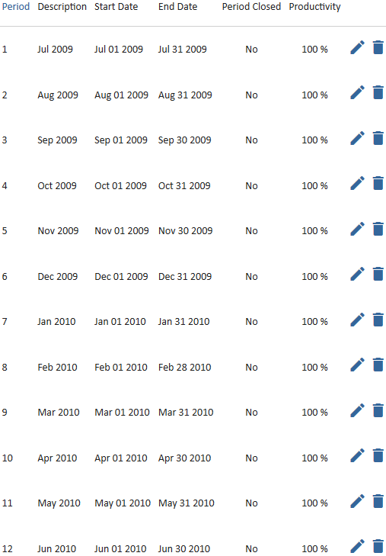
As periods cannot overlap, you will need to initially delete months that will be included in your first quarter.
- Click the icon next to the monthly periods that you wish to include in your quarter. In this case August and September.
- Click the edit icon next to the July quarter and enter in the correct description and start & end dates for your period. Indicate if the period is open or closed:
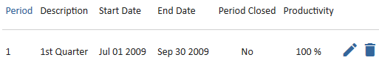
- Click the icon and repeat the above process to complete amending / adding your organisation’s quarterly financial periods:
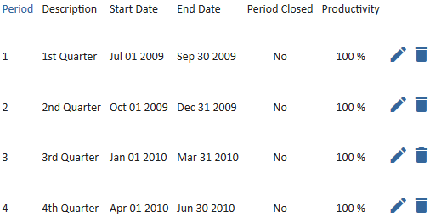
- As with closing financial years, click the edit icon to indicate that the financial period has been closed. Save by clicking the save icon:
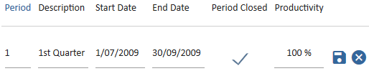
You now know how to create, amend and close off financial periods.

Integration through Templates

UniPhi documents are conveniently stored and available “online” as HTML web-based documents via the web application, and offline via the OnSite mobile app. Each document is created from templates that have been built using the UniPhi template system.

UniPhi documents are used for four purposes:
- To integrate information that exists across the tabs (e.g. risk, issues, and contract information into one document)
- To share information with people who do not have access to UniPhi
- To provide quality control around the information stored in UniPhi
- As a method of capturing information (e.g. inspections conducted on the OnSite mobile app)

UniPhi achieves the first point through the use of document controls and template variables. Document Controls are the template design objects that query the data in the UniPhi database and display this information in pre-defined views. Each document controls is designed to present data which already exists in UniPhi, thus reducing the risk of copy/paste errors and manual data entry. In some cases these controls are fully pre-determined and cannot be changed by the user, while other steps allow the end user to show or hid component of the information. The data cannot be edited within the document and must be edited at its source (i.e. the relevant section in UniPhi that it was originally created e.g. the risks, issues and contracts tabs). Template variables ensure that necessary data is automatically populated when templates are used to create documents.

Template Management
The Templates management system is found under the UniPhi Methodology system.
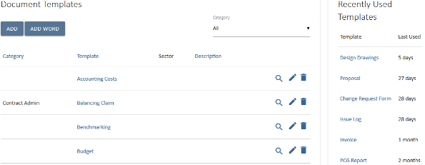

When you click onto the Templates tab you will notice that in the upper right side there is a panel that highlights Recently Used Templates.
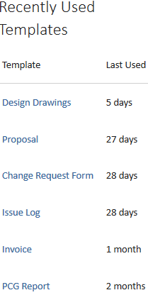
This panel is designed to inform a UniPhi user of the templates that they have recently used. Theoretically the user will use similar templates when creating documents on a regular basis, hence they don’t need to search for a specific template from a potentially long list of templates, as then can simply select the template they need from those that have been recently used.

At the very bottom of the screen below the Templates panel is the Template Categories panel.
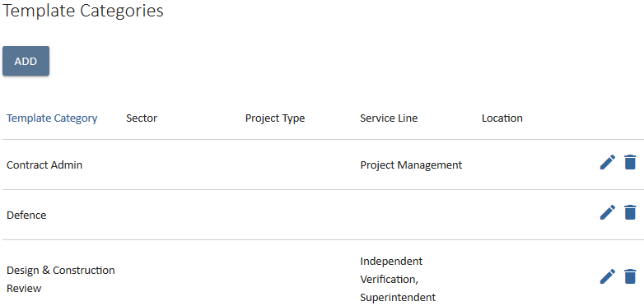

Template categories are a useful way to limit, or contextualise the templates that your users will be presented with in UniPhi. In the example above you can see that several template categories have been associated with defined sectors, project types, service lines, and locations.

Adding a New Category

- In the Template Categories panel click the 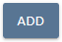icon. The new Category field will appear
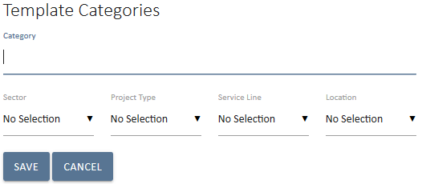
- Type the name of the new category. If the templates that will be assigned to this template category are intended for use by all users, then you can leave all project specific information blank. No selection means the category is available to all users. Alternatively, if you wish to limit the category of templates to a specific group, you may make a selection at each of the project specific drop down selections.
- Click on the 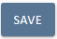 icon to save your changes or click the 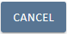icon if you make a mistake.

- The new category will appear in the Template Category list.
At the far right hand of the Template Category list are the icons to Edit or Delete an existing category. Pressing the edit icon will open up all of the selectable fields and allow you to make your changes. Pressing the delete icon will allow you delete any unwanted categories.

Available Templates
The Methodology Templates panel provides a list of all the templates which have been created in UniPhi. The defaults that are included with a new installation or UniPhi are designed to simply provide examples of template concepts that may be created.
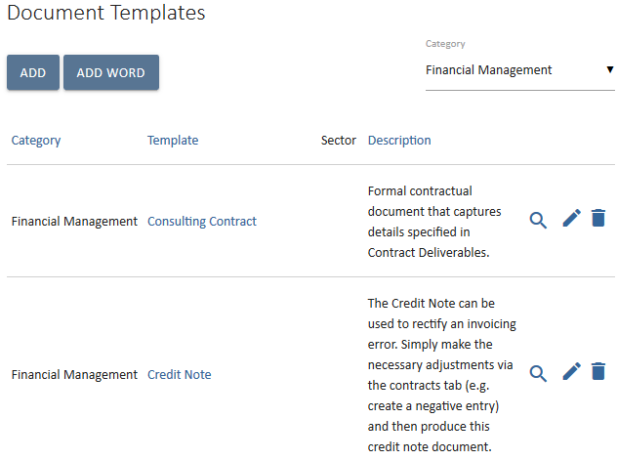
The listing shows all the Templates in the system according to the selected Financial Management category filter.
The 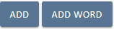icons in the upper left corner of the panel allow you to create a new templates.
The icons to the right of each template in the list provide you to View, Edit, and Delete your templates. The View icon loads a summary of the steps or sections of the template as an overview of what it includes.
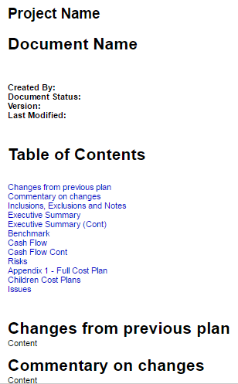
This is opened in a new browser tab or window and can be closed to return to the template list.

A deleted Template is not recoverable although any documents created using the template will remain intact.

Creating a Template
UniPhi features two types of template. The first and most valuable in terms of efficiencies and traceability is the UniPhi template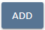. UniPhi templates make use of the predefined and configurable template controls which have been designed to draw information that is stored within UniPhi, into a document format.

The second type of template available through UniPhi is the MS Word template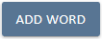. MS Word templates are basically formatted documents that have been saved into UniPhi’s documents module, which are then available to users of UniPhi. MS Word templates do not have any functionality to allow for information to be drawn from data stored in UniPhi. Documents produced using MS Word templates are also not able to be searched or filtered through the Documents tab. For these reasons, templates using the MS Word format are best suited to reference materials, or standard text documents where the contents have been defined and does not change.

Adding a MS Word Template

- From the Methodology / Templates tab, press the Add MS Word Template button.
- Enter a title for your template, add a description that will assist your users to understand when and why the document will be used, and specify the template category (if necessary)
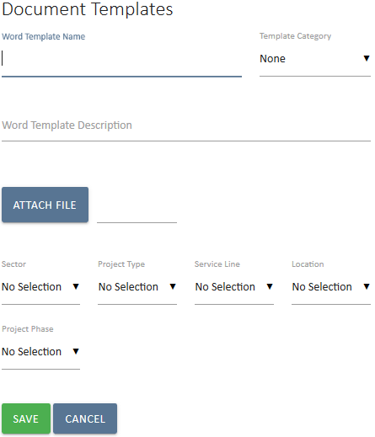

- Finally, attach the required file and then save your changes.

UniPhi Templates
UniPhi templates are a much more efficient way to create documents based on information stored within UniPhi. UniPhi template settings are found in the Methodology / Templates tab. Here you may press the Add icon to create a new template of the edit icon to edit an existing template

Note that the screen consists of three panels:
- New Template
- Document Edit Roles
- Document Signoff Roles
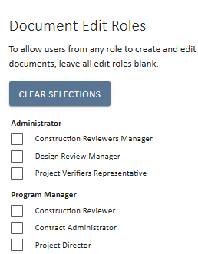
Document Edit Roles
The Document Edit roles in the upper right side provides for controlling which team members in a project can Create a new document using this template.
As noted at the top of the panel
“To allow users from any role to create and edit documents, leave all edit roles blank.”
The purpose is to assist with managing documentation on projects by ensuring that members of the team only see templates that are relevant to their role on the project. This method is useful where restrictions need to be placed on access to certain documents.
Tick the role or roles as appropriate.

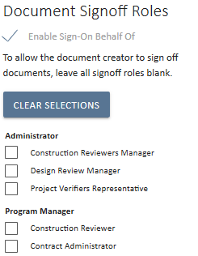
Document Sign off Roles
The Document Sign-Off Roles panel allows for setting the desired authorisation or workflow for documents that will be created with this template.
The option to “Enable Sign-On Behalf Of” is enabled by default and allows for anyone to authorise a document in the absence of the preferred role.
The Roles are grouped by the Licence group allocated in the Methodology Roles section of UniPhi.

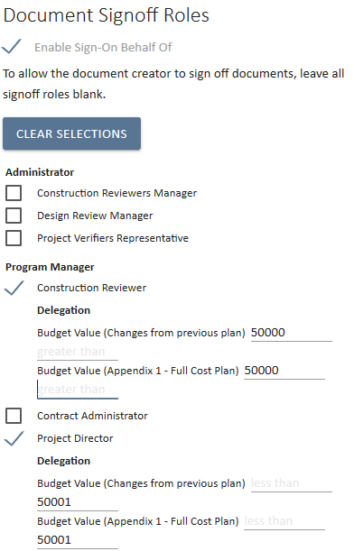
Delegation
Found at the end of the template creation wizard. This feature enables specific Roles to be selected as the sign-off roles. UniPhi also allows delegation sign-off based on specified monetary values.
In the scenario below, the Construction Reviewer is only authorised to sign-off on documents which have a budget value of up to $50,000.
The Project Director however, will be required to sign-off all documents that have a value greater than $50,001.

New Template
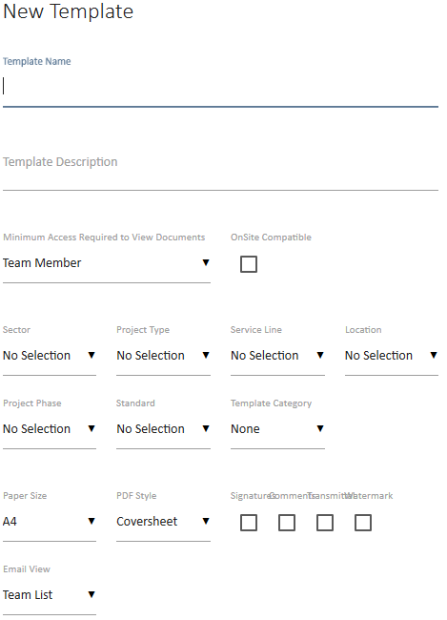

The template creation process consists of three primary stages. This first stage of the template creation process generates the control and meta functions of the template. The second stage is to create the data entry steps in the template and the final stage provides for modifying the output order of the steps.

Template Configuration Details
The template configuration panel provides for the meta data and control characteristics of the template and its resulting documents.

Template Name
The template name field should be descriptive and concise. This value will be displayed in the drop down list for template selection in the Create New Document wizard. It will be the default document title for any document created using the template. Some special characters cannot be used within a in template name.
Special characters commonly include: \ / : * ? ” < > |
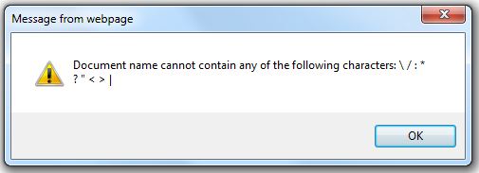
The above error is generated when trying to create a document with special characters in the name.

Template Description
The template description is a longer description which provides the opportunity to instruct users on the appropriate use of the template. This description only appears in the Template Listing.

Minimum Access Requirements to View Documents
The licence level of a user is distinct from their role allocation levels in UniPhi. The primary purpose of this setting is to restrict Team Member access to documents that contain information that would not be accessible to them on screen, i.e. Costs, Fees, Contracts, etc. This defaults to Team Member.

OnSite Compatible
“OnSite” is the UniPhi mobile app (for iOS tablets, and Android devices). The OnSite compatible controls are a subset of the UniPhi controls. It is important to note that not all template controls are compatible with the mobile devices. If you are creating a new template specifically for use on a mobile device, you must tick the OnSite Compatible button. If you would like to use an existing template on your mobile devices, ticking the OnSite Compatible box will perform a quick test and inform you of any incompatible steps.
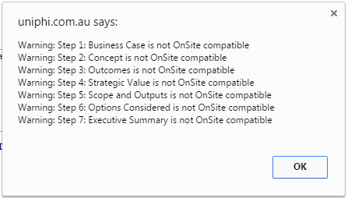

Project Specifics
As administrator you may choose to define the various project specific information filters. Defining your organisations Sector, Project Type, Service Line, Location, and Project Phases will allow you to allocate particular templates to specific organisational or according to project criteria. By default, your template will be available across all projects.

Project phase
This field is used to assign a template to a specific phase of a project. The purpose is to assist the user in understanding when a template would be used.

Template Category
The template category selection includes the template in that category. Leave this as “None” unless a specific category is required. The template will appear in the template selection lists or the document creation wizard by default in the “All” category selection or the specific category if the list is filtered.

Default Style sheet
The default style sheet sets the selection as the default format for the output all documents created with the template. This can be overridden at document creation or when preparing document output.

Email View
The Email View option selects the default setting when email a document based on the template.
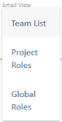
The View list options are:
- Team List: The Resources associated with the project listed by Name
- Project Roles: The Resources associated with the project grouped by Role
- Global Roles: All Resources from all projects in UniPhi grouped by Role.

Template Data Entry Details
Once the Template configuration details are completed the next stage is the addition of the data entry steps for the template.
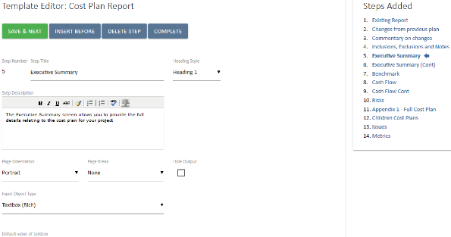
The screen consists of two panels that mimic the format of the document preparation screens with the main Template Editor panel to the left and the Steps Added listing to the right.

The four main controls provide the following functions:
- Insert Before: Inserts a new step before the current step.
- Save & Next: Saves the current step
- Delete Step: Allows a single step to be deleted
- Complete: Finishes with the current step and moves to the final stage of a template.

Steps can be added at any time and will appear in the sequence that is nominated by using the Insert Before or Save & Next controls within the sequence of existing steps.

The main panel presents the following controls:

Step Number
This is a display only value that just confirms which is the currently edited step within the template.

Step Title
The Step Title is a single line field that will be presented as the step heading in the resulting documents. The title can be edited or overridden in the resulting output document.

The presentation format of the title is controlled by the Heading Style option.

Step Description
The purpose of the step description is to assist the document author using this template with an explanation of what is expected in terms of data or action.
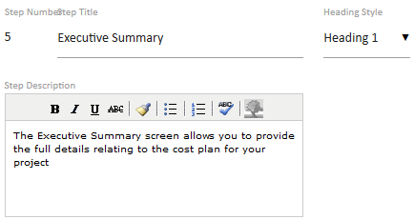
In this example the recommendation is that the rest of the document is completed and understood before the Executive Summary is prepared.
In a resulting document this appears as un-editable text to prompt the author with this instruction.
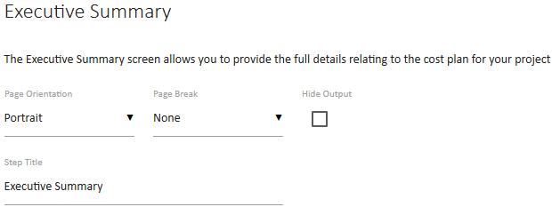
Note that the Step Title is an editable field so it can be modified for the resulting output document.

Page Orientation
This sets the default page orientation as either Portrait or Landscape. However, it is not until preparing the data with the document that the page width will be known. Select either Portrait or Landscape orientation.
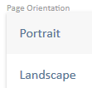
As a result this can be overridden during document preparation but is useful to select landscape if the content of the step is expected to be wider than a portrait page.

Page Break
Controlling the pages of a document will vary depending on the content. This control allows for default settings, which can also be overridden during document preparation.
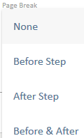
Select a page break Before, After, or both ‘Before & After’ the document step. Adding a Page Break After a step and adding a Page Break Before the next step will insert two breaks and therefore a blank page is inserted into the resulting document.
Page Breaks will also occur automatically in documents depending on the volume of data in a particular step. For example a long Issues list may split across multiple pages. Also the Rich Text Editor provides for inserting Page Breaks directly into text based information.

Heading Style
The heading style selection allows for three heading formats, a paragraph, and an option for no heading to be displayed. The output format of each of these options will be set in the style sheet according to the style guide information. The defined heading is not editable by your document authors, and the purpose is to ensure consistency in document presentation standards.
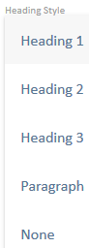
Select:
- Heading 1, Heading 2, or Heading 3 for special text formatting according to the style guide.
- Paragraph to use the same font and style as the normal text except that the ‘heading’ will appear on its’ own line with a separate line before and after the heading text.
- None to have no heading appear for the step.

Hide Output
Hiding the output of a step relates to the output document not to the editing process. The step is still active and presented during the document editing sequence.
The purpose is to allow for a default setting that can be overridden during document preparation.

As an example ‘Related Attachments’ steps may be used within a template where there is requirements to add a related file (or files) to the document.
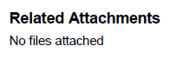
Selecting the hide output option will remove the entire step from your output document, This may be useful where you don’t wish to attach a document. If however you do attach a file you can untick the hide output option, and your files will appear within your output document.

Input Object Types
The array of input object types is broad and they are designed to cater for a flexible and versatile process integrating any project or portfolio information that is accessible within the UniPhi system.

The Appendix of this manual covers each of the Input Object types and describes in detail and expands on the source of the data and control of the presentation to a document author using the template.

The following page provides a simple example of a template input object for the purpose of explaining how a template is created.

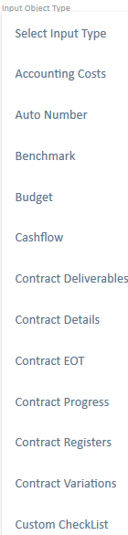
Clicking on the selector option for the Input Object Type presents a list of available options.

The Rich Text Editor is commonly used as it has the ability to link, or import specific database details into the boilerplate text as well as images and tables.

When that is loaded it will display an empty text box which can then be populated with required text that will appear in the resulting document where it can be edited or changed as required for the document output.

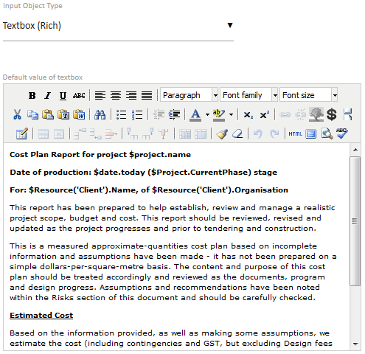

Once completed this step can be saved with the 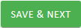icon or 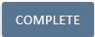to save and move to the finish step.

When using copy and paste from Microsoft Word or other systems, it is best to use the “paste from” icons for normal paste, paste text only, or paste from Word. The paste from Word will strip all the Word specific formatting from the pasted information so that it does not conflict with the styles in the output document.

Template Variables
Template Variables can be inserted from the toolbar control or by manually typing or copy and paste from the Admin -> Template Variables list.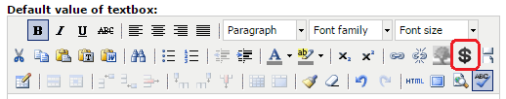
Selecting the toolbar icon will present a pop-up dialog
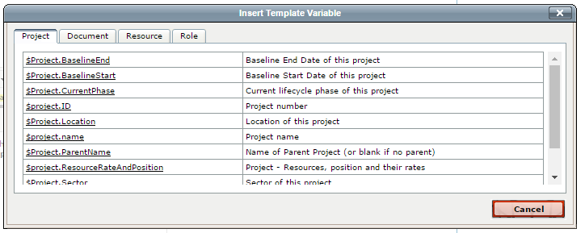The popup screen allows for selecting template variables. By default Project, Document, Resource, and Role are displayed. If specific template input objects are included in the template, then additional template variables will be made available. For example the Contract variables are not relevant unless a contract input object is a step in the template as the system would not know which contract to reference.
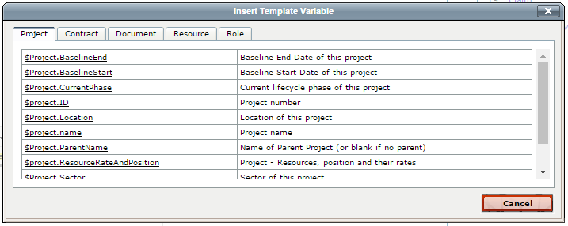
In the second screen the Contract variables are included.
Once a variable is selected from the pop-up window the $variable will appear in the text box.
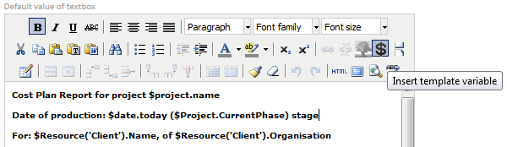
In this example several template variables; $date.today, and $project.name have been inserted into the text.
When this Rich Text object is used in the template the details are pulled from the relevant project in UniPhi and inserted as text, or numbers.
Administrators of UniPhi can access the Template Variables listing in UniPhi under the Configuration > Template Variables module.
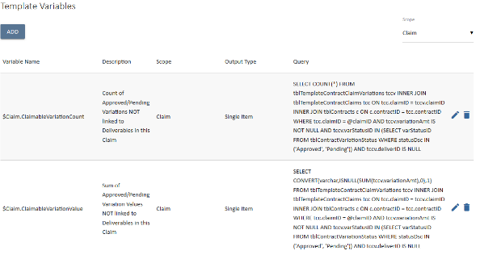

A Template Variable is a standard piece of SQL code that extracts information from the UniPhi database according to the relevant project.

Template Output Order

The final stage of creating a template is to sequence the output order of the document. If your template features numerous steps, it is possible to re-order the output so that it appears in a different sequence to the input order.

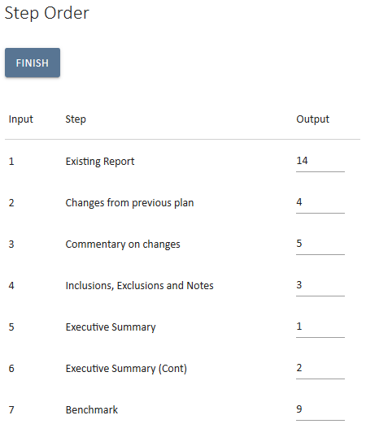
To modify the output order, edit the Output column fields with the appropriate numbers. The output order does not need to be the same as the input order. There is the possibility to prepare information like a value in a step that is then used in a later step in the input sequence.

Save your entry once you have sorted the Output order.

Create a Simple UniPhi Template
To create a basic template:
- Click in the Methodology > Templates tab. The Document Templates view will be displayed. This lists any templates already created and gives a brief description:
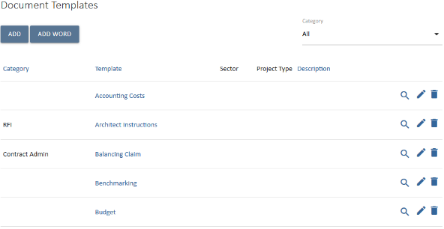
- Click on the 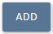 icon. The New Template view will be displayed:
- Enter a descriptive name for the new template. The template name field should be descriptive and concise. This value will be displayed in the drop down list for template selection in the Create New Document wizard. It will be the default document title for any document created using the template. Some special characters cannot be used within a in template name. Special characters commonly include: \ / : * ? ” < > |
- Enter a more detailed description for the template. This information will be displayed in the Document Templates view and will assist users to understand the templates intended usage and purpose.
- Select the accessibility of this template by choosing from the drop down menu. This is a restrictive hierarchy control. Where a team member is specified as the minimum level, then every licenced user may use the template and view the output documents. While a minimum access level of Administrator would restrict use of the template and visibility of output document to Admin licenced users only.
- If this template is to be used remotely on mobile devices via the OnSite app, tick the OnSite compatibility checkbox.
- Choose from the dropdown menus the Sector, Project Type, Service Line, Location and Project Phase. Adding a tickbox next to any of these organisational custom categories will restrict the use of your template to only those projects which fit into your specified criteria. This is intended to reduce the number of templates that are presented to your end users (e.g. if your organisation spans various regions, you may establish regional templates and link each one to a particular location)
- The Default Stylesheet filter allows you to specify what style the output document will adopt. Your deployment may have several defined style sheets such as coversheet, or letterhead.
Stylesheets: UniPhi programmers can apply customised stylesheets, which are specific to your organisations requirements. This may include adding your organisation’s standard letterhead, or coversheet design, for example.

- Tick or un-tick the Signatures, Comments, Transmittal and Watermark boxes depending on whether you do or do not want these features to appear on output documents.
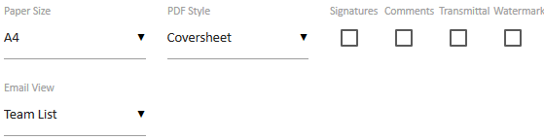
Signatures: displays who has signed the document off
Comments: displays comments made regarding the document – usually while in draft format
Transmittal: displays who the document has been emailed to, and when
Watermark: displays a “DRAFT” watermark on the document when rendered.
- Select the Email View List. This is a list of resources on the project that will appear when the document email view is selected.
- Select the required paper size from the dropdown menu.
- After indicating the phase, stylesheet, edit and signoff roles, click the icon:
- Enter a Step Title for the first step of your template:
Template Steps and the Checklist: UniPhi templates are made up of Steps that the user must complete (called the Checklist) to create the final document. Each step in the checklist represents a document control (see below) and needs to be selected in order to import the data and to save the information. This information will then be displayed within the final document .
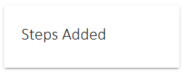
Note that the Steps Added box is empty as no steps have been added to the template yet. As steps are added and saved, each step title will appear in the Steps Added panel. This is a useful reference when creating your template, but also as a navigation aid when you are creating a document from the template, as you can jump straight to a specific step as opposed to having to save and continue through the whole document.

Document Controls / Input Objects are created by UniPhi software developers as an integral part of the document management system. They enable quick creation of documentation based on information that has already been entered into UniPhi.
Example Document Controls:
The Textbox (Rich) document control appears in most templates. By using this control the user can enter unlimited text, tables and graphics into their document. Default text can also be entered by the template creator / administrator and will be displayed, and can be edited or deleted by the user.
A Contract Details control can be configured to let the user specify which contract the document refers to as projects can have multiple contracts. This method is used to make information from the selected contract available for use in the document you are creating. Information from that contract can be populated throughout the document by using Template Variables. Template variables will be outlined in more detail later in this manual.
A full list of document controls can be found in the appendix of this document.
- Enter a description for the template step. This is where you can add instructions to your end users on how to fill a template in:
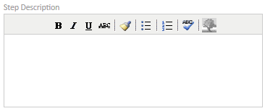
- The Page Break drop down allows you to indicate if you want the following/previous step to appear on a different page. This is useful when the output orientation of a page differs from those that precede or follow (e.g. a landscape page that follows a portrait page):
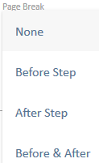
- The Heading Style: drop down allows you to select the format of the step. Select Heading 1, 2 or 3 for the Step Title to appear as a heading in the document or select Paragraph for it to appear as normal text. Select None if you do not wish the Step Title to appear in the final document.
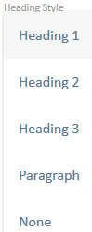
- Tick or un-tick the Hide Output tick box if you do or do not want the step hidden:
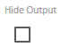
Hide Output: When setting up a template it may be necessary to include steps that you wish to be hidden in the final document. For example, you may want to include a Date Selector input object so that you can insert that date throughout the document (through the use of template variables) but do not want the date to appear where that step appears in the checklist. Users of the template have the option to unhide steps and hide steps.
When setting up templates, System Administrators are establishing default settings that the user can amend if required. Users also have the option to change page breaks set by the administrator and standard text entered into text boxes.
- Next select the Input Object Type (or Document Control) for this step of your template:
There is an ever growing list of Objects you can choose from. Scroll through the list and select the required object for this step of your template:
For this example, select the Date Selector Input Object Type:
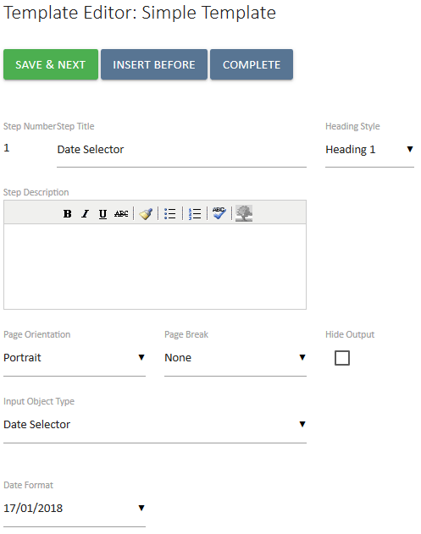
- This object requires that you indicate the format of the date, as it will appear in the final document. Use the drop down to select the appropriate format:
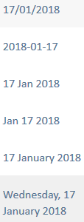
- Click 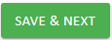 to save your step and move Step number: 2:
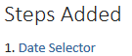
Note: The first step you added is now displayed in the Steps Added box.

- Repeat the process (enter a step title, step description, indicate if you require a page break, select how or if you want the title displayed, if you wish to hide the step):
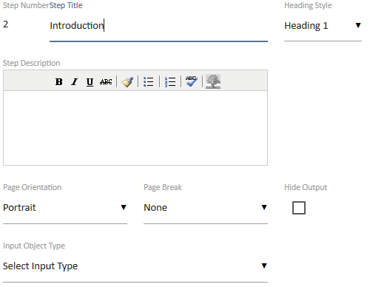
For this step, add a Textbox (Rich) Input Object Type. The following textbox will appear:
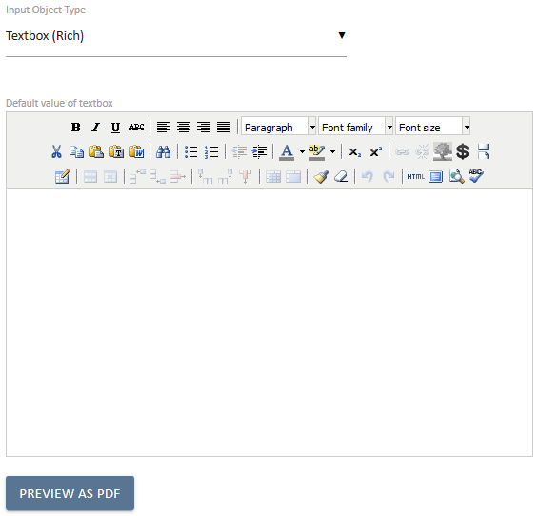
You can leave the textbox empty, ready for the user to enter text, tables, graphics etc. or you can enter default text, format it using the rich text editor toolbar, so that it is there ready for the user to use and edit when creating a document from this template.
The Rich Text Editor Toolbar
The rich text toolbar, displayed below, is available to use with a rich text box and provides functionality for the HTML environment.

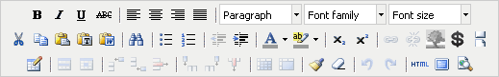

The multi line text editor toolbar uses a cut down version of this editor. Hover over an icon and a label will appear to tell you what the icon is. The Ctrl key and relevant letter on the keyboard can be used to activate some of the controls exactly the same as you would use in MS Word.
For example: Ctrl+C for copy, Ctrl+V for paste and Ctrl+Z for undo.
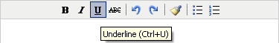

The common commands you will use are as follows:

- highlight text to make formatting changes B – to bold , I to turn to italic or U for underline. Select the letter to either add or remove the formatting type. You can also use the common keyboard commands that you would use in MS Word such as Ctrl+B, Ctrl+I or Ctrl+U. The ABC enables you to strike through the text.

- enables you to position text in the document to the left, right, centre or justfied.

- select the heading style you wish to use if required, these have all been predefined for you. The heading styles and paragraph are Calibri. You can manually select font family and font size from the drop down if you wish.

- the cut, copy and paste icons enable you to add or remove text into the rich text box from external documents or sources.

- the paste as plain text icon is used when copying text from MS Word. This is because MS Word has its own markup language which does not match exactly with HTML. When copying text from
MS Word the rich text editor does its best to convert from word to HTML, however it is not perfect since the two do not match up exactly. The paste as plain text option will remove the word formatting and allow the user to have more control with formatting.

- provides the options to create or remove a bulleted or numbered list. When you remove these a space will be entered between each line of text . If you wish to remove these spaces place your cursor in front of the first letter of the word you wish to move and select your backspace key. The word will be inline with the word previously above, now select Shift+Enter. The word will be placed back on the line immediatley below with no bullets and the space is removed.Alternatively, if you are familiar with HTML you can view the code and make your changes there. (See explanation further on in this section).
- enables you to change the colour of the font by highlighting the text and selecting the drop dowm menu to pick your colour.
- enables you to highlight the background of the text, this is particulary useful if you want to note where you have made changes in a document so the author or readers can see what you have amended in the text. UniPhi does not have a track changes option.
- Used to insert a picture and enables you to select the image you want to insert. This can be used for inserting a photo into CV or logos etc . The best method is to create a table and insert the graphic into one cell, that way you can control the positioning.

- The first icon inserts a table into a rich text box and you can enter the number of rows and columns required.

The middle icon displays the table properties and where you modify the amount of rows and columns and set width and height properties. (Table width is suggested to be fixed to 650 pixels so when document is rendered to PDF it will fit on an A4 page. Creating tables will be outlined in greater detail further on).

The last icon is the cell properties. It is suggested that you modify the cell/column using pixels with a total of all columns across the table equalling the table wide, usually the suggested 650 pixels. For example a table with 5 columns may have a width of 130 pixels each, if you change one of the cells in a column you will need to update the remaining columns to maintain the table width

- Inserts a column in a table to the right or left or the last icon deletes a column. Place the cursor in the column you wish to insert next to or delete and select the relevant icon.

- Inserts a row in a table below or above the row you are in. Place the the cursor in the row you wish to insert a new row above or below or delete and select the relevent icon.

- redo/undo the last action(s) done. You can also use Ctrl+Z to undo or Ctrl+Y to redo.

- select this icon to access the HTML code for the step. If you are familiar with HTML you may find it easier to use the HTML view and make changes to the code to create your information, amend formatting.

- enables you to view the full screen for the step you are in.

- enables you to indent text to the right or outdent to the left. You can use this method as well to remove bullets or numbers by selecting all the relevant text and then outdenting until gone.
- Enter in text into the rich textbox, formatting as required using the editor buttons:
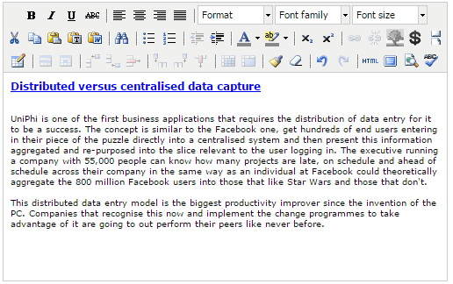
- Save your entry.
You can use the 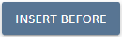 icon to amend the order of your steps and include a step you may have missed.

- Repeat the process (enter a step title, step description, indicate if you require a page break, select how or if you want the title displayed, if you wish to hide the step):
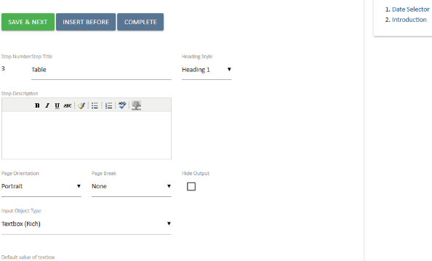
For this step, add another Textbox (Rich) Input Object Type but this time, add a table and template variables. Template Variables will be explained further on when you go to add them to the table.
- Insert a table by selecting the insert table icon. Select 4 columns, 4 rows, 2 Cellpadding and a width of 650 in the dialog box that is displayed:
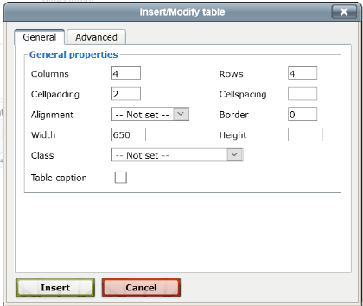
Cellpadding sets the amount of space between the contents of the cell and the cell wall. Cellspacing controls the space between table cells. Cellpadding is usually more effective than cellspacing for spreading out the contents of tables.

Example:
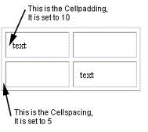
(Source: http://www.conservapedia.com/HTML_table_formatting)
- Select to insert the table into the rich textbox:
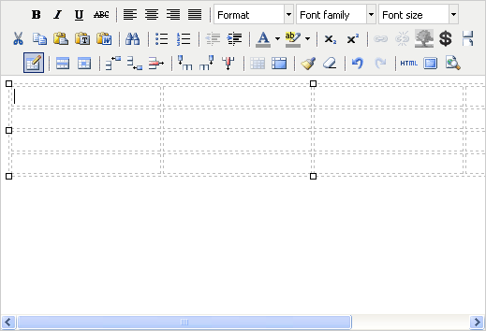
- Format the column width by selecting the top cell in the column and clicking on the Cell Properties icon:
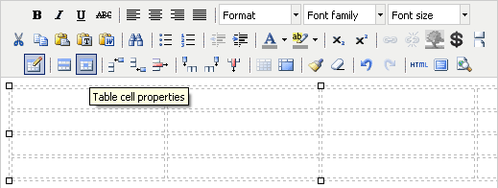
This will launch the Table cell properties dialogue box. Set the column width to 100, which is 100 pixels.
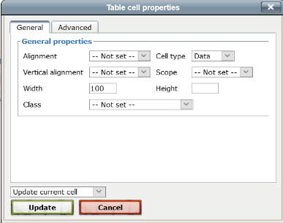

Colum Widths: When setting the column widths, be sure to note the total tabled width in pixels and make each column a subset of this totalling the width of the table.
For example, in the table we are creating the first column will be 100 pixels, the second 225 pixels, the third 100 pixels and the fourth 225 pixels totalling the table width of 650 pixels.
- Repeat above steps to complete setting your column widths:
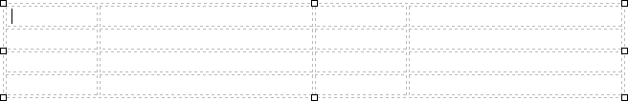
- You can use the table as it is to space out the text ad not have it appear as a tale in the output document. Have your table format to your standard style, right mouse click and select table properties:
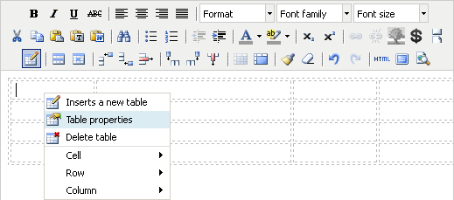
This will launch the Insert/Modify table window:
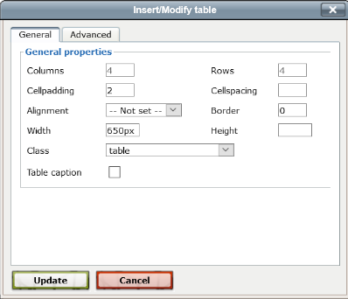
- In the Class drop down list, select “table”. This will apply your table style to the document when it is saves as a PDF.
- Click button:
Table Class means that you do not have to use advanced table setting to make your tables look consistent. Instead Let UniPhi apply the required formatting when the PDF is generated. This will ensure all the tables in your documents are consistent.

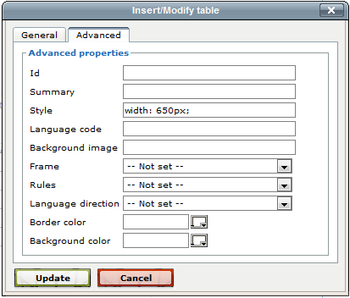
- Click on the icon to move onto the next user control
- Click on the icon to finish adding steps to your template.
- You will be presented with the Step Order box:
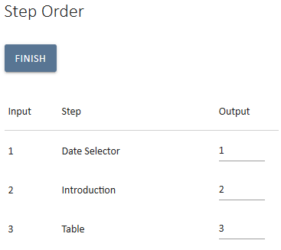
This enables you to sort the order in which inputs are displayed, or output, in a document. For example, if you were stepping someone through how to enter a business case, you would get them to complete a variety of analysis first (e.g. situation analysis, SWOT analysis etc.), then they would enter the main document information and lastly they would write the executive summary. However, we would want this order reversed when displaying the document.
- Decide which order you would like to display the document by amending the output order.
- In Document Autoname use text and template variables to apply rules to generate the document name.
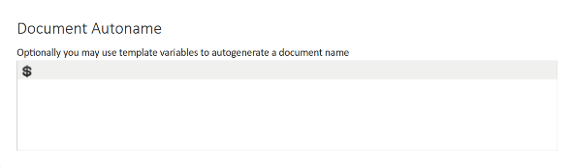
- Specify any sign off roles, including any financial delegations of authority for your financial document (e.g. progress payment, or contracts)
Found at the end of the template creation wizard. This feature enables specific Roles to be selected as the sign-off roles. UniPhi also allows delegation sign-off based on specified monetary values.
In the scenario below, the Construction Reviewer is only authorised to sign-off on documents which have a budget value of up to $50,000. The Project Director however, will be required to sign-off all documents that have a value greater than $50,001.
- Click on the 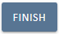 icon
You have successfully created a template

Template Variables
A template variable allows information that already exists within UniPhi to be automatically inserted into a document when it is created. For example, the name of a project may be inserted by using a variable such as $Project.Name, or the phone number of the project manager may be inserted by using a variable such as $Resource('Project Manager').Phone
Template variables are available when adding a rich text step to a template by clicking on the icon. Certain variables that are project specific are always available, however others such as contract specific variables can only be inserted into a template if a contract had been selected in an earlier template step, such as when creating a contract variation.
Template variables are also available for Document Autoname.
Template variables are created in the Admin > Template Variable view. UniPhi software developers will create required template variables on your behalf.

Methodology

Methodology - the principles, process groups and business rules that make up the practice of the project management discipline.
Workflow - a collection of business processes, task definitions, actions/performance of tasks, which when followed allows a consistent and repeatable approach to a piece of work/tasks, process, processes or project in order to achieve a verifiable, auditable, consistent and reliable output. In this sense, the overarching series of steps to complete the project life cycle is the project workflow. Within this overarching workflow will be sub-sets of workflows to move through a particular phase.
Phase - A stage gate or section of a project lifecycle.
Input - A product or deliverable required to initiate a process
Process - a series of steps or actions that need to be performed to transform the inputs into the desired outputs.
Output - A tangible and verifiable product or deliverable required to mark the completion of a process
Business rules - the logic or decision that needs to be made during a process
Outcome - the result, achievements or effect of producing an output
In UniPhi, a methodology library is created. The structure of this library is folders, flowcharts and library pages. Included within a library page is links to templates. Templates are a separate component of the system and will be covered later in the course.

Create and Edit Methodology Folders in the Library

To create a Folder:
- Go to Methodology > Library tab.
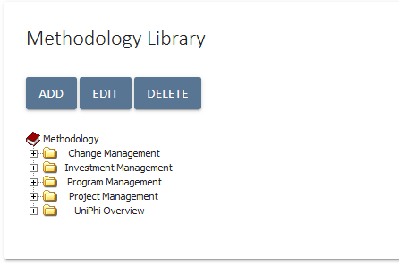
- Click on the Add toolbar icon 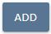
- You will see a drop down list with three content options; Folder, Flowchart and Library Page: Select Folder
- Enter a title for your new Folder
- Select 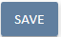
- Your new folder will appear at the end of the current folder list.
You have successfully added a folder

To edit a Folder:
- Click on the folder you wish to edit
- Select the 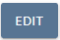 icon
- You have three edit options; you can edit the name, move the folder up in position or move the folder down in position. To edit the name, double click on the folder name and type the new name. You can move the folder up and down using the buttons: 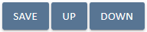.
You can use drag and drop functionality to move items around the tree structure. You can delete the folder by selecting it and clicking on the 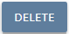 icon in the Methodology > Library view

You have successfully edited a folder

Create a Flowchart in the Library

Flowcharts need to be created in a third party application such as Visio. Visio will allow you to export the chart as a GIF or JPEG picture. You will need to have completed this work before completing this activity.
- Click on the Methodology > Library tabs
- Click on the icon
- Select flowchart from the drop down list. The following screen will be displayed:
- Enter the title of your flowchart
- Browse to the image of the flowchart that you have created and select it and click open
- Select
You have successfully added a flowchart

Create and Map Library Pages

We need to be able to map library pages to the steps in the flowchart. Our end goal is to have users click on a step in the flowchart and be taken to a library page for that step. The first step in this process is to create the library pages.
To create a library pages:
- Click on the Methodology > Library tabs
- Select the flowchart for which you wish to add library pages
- Click on the Add toolbar icon
- Select Library from the drop down list
- Enter the title of the library page (try to be consistent with the name of the step in the flowchart), make sure you create the library pages in a relevant order as each library page will be represented under each other in the tree (remember though, you can move things around at a later date, it's just quicker to get things right the first time).
- You will now see a three-panelled screen of information. You can enter information into this screen. You may prefer to add all the library pages for the flowchart first and then add the content later.
- Information relating to the step is entered in the main title box. There is a rich text box displayed allowing you to do most of the formatting as per MS Word. On the right hand side there is a smaller text box option to enter who actions this step and why.
- Underneath this box is a section that allows you to add templates that might be relevant for this step. As we have not created any templates yet, we will come back to this functionality later in the course.
- Select the button in the main central box to save all the work displayed on the screen.
The best way to edit a lot of rich text in the main window is to click on the full screen icon. This displays just that box in the full screen rather than in the small box that is provided by default

You have successfully created library pages

We now need to map these library pages to the flowchart. Before being able to do this activity you will need to have mapped the hotspots of the flowchart using an HTML editor like Dreamweaver, or GIMP. This will provide you with the library co-ordinates in between the open <map> and closed </map> tags.
To map library pages to flowcharts:
- Click on the Methodology > Library tabs
- Select the flowchart for which the mapping will be undertaken
- Select the edit button above the flowchart image (not the edit button at the top of the library tree)
- Scroll to the bottom of the image. You will see a box with space available to paste the HTML code pertaining to the map tags referenced earlier. Copy the HTML code from your editor (e.g. Dreamweaver) and paste it into the box.
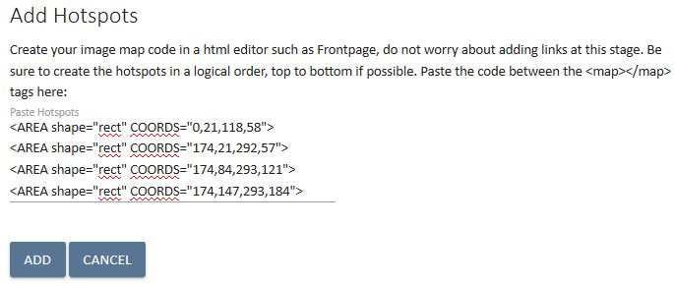
- Click on the add icon to add the image map to the system.
- A list of shape IDs will be presented below for you to then map to a library page in the drop down list to the right.
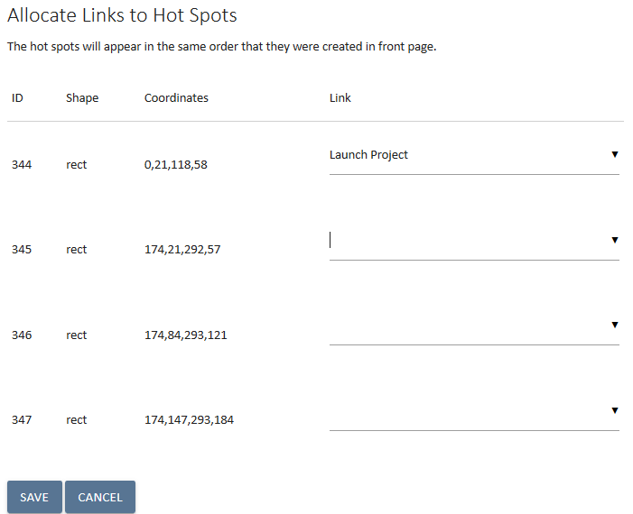
If the hotspots were created in the same order as the library pages then this should be a sequential process of selecting the next library page in the list as you move down the hotspots. Otherwise, some trial and error may be required.
- Click the save button
- Test that the mappings are correct by clicking on each of the flowchart steps and checking if the correct library page is displayed.
You have successfully mapped library pages to flowcharts

Create a Prioritisation Framework

Based on an organisation’s own methodology, UniPhi allows for the creation of a prioritisation framework to help prioritise their portfolio of projects. The framework consists of a series of questions and answers, set up by the administrator, which when completed by end users results in a score that helps identify high to low priority projects.

The framework can be completed when a new project is added by a user and is found by scrolling down on the Portfolio > Summary > New Project page.

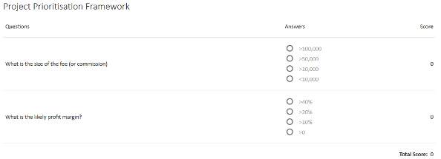

Once completed a final score is applied to the project. This score gives the project a rank of importance and helps determine which daily activities resource pool should work on - critical activities. Projects can also be killed when they're no longer valuable, freeing resources for other more critical tasks.

Critical Projects are given a higher ranking (highlighted in red) helping to focus the efforts of the project team:

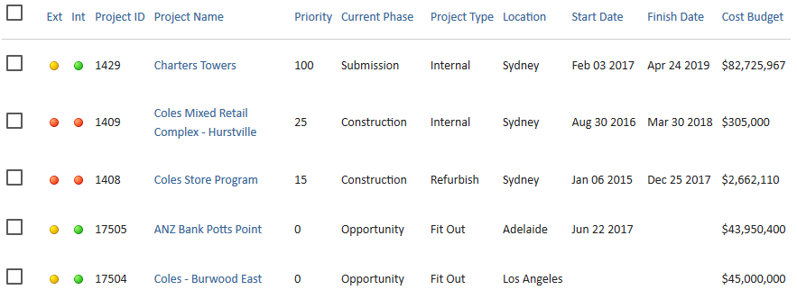
To establish a Prioritisation Framework:
- Go to the Configuration > Prioritisation tabs:
- Click the 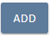 bottom to start building your framework
- Enter in the first question and order:
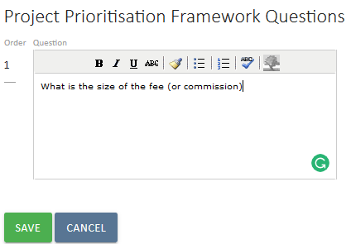
The default answers are Yes and No. You can now edit the answers and/or add more by clicking the icon.
- Click to save the question and commence entering possible answers and scores:
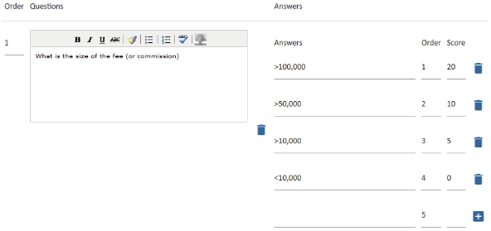
- Amend (if required) the answers to match your organisation’s methodology and enter a score against each answer.
You know how to create a prioritisation framework

Exporting Documents from UniPhi
Within the Admin tab, Administrators are able to export document from the system. This may be required at the end of a project and once UniPhi is no longer required, or to satisfy legal or audit inspections.
  - Go to the Configuration / Document Export tab
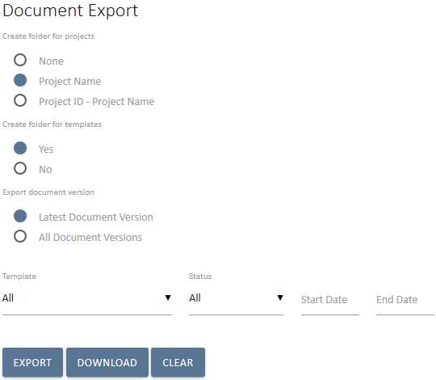

  - The export document panel presents all available options for exporting documents from UniPhi. The configurable options available include:

- Create folder for projects – allows you to specify the name of your output folder structure. If project ID and name are important for future reference, you will choose Project ID – Project Name
- Create folder for templates – will group all documents within a folder per template. Your structure would therefore appear as:
Project XYX
- Template A
- Template B
- Template C, etc.
- Template – Allows for a single template selection which will extract all document produced by the selected template, or you may choose to select all templates which will naturally extract all documents that have been created
- Status – Allows you to specify the status of the document(s) that you are extracting. You may only require signed off documents, or you may require documents regardless of their status (private, draft, open for review, awaiting sign off, signed off, and closed)
- Start Date / End Date – Allows you to specify a date range of document that you would like to export

3. Once you have determined your export requirements, UniPhi will export your documents into a PDF format. The entire extract will be provided to your local PC in a compressed zip file format. You may then extract and save your UniPhi documents to another location.

APPENDIX

Current Document Controls
The following pages present examples of both the template design view, configurable options, and the resulting output document view for each input object in the UniPhi system. Document Templates are simply a combination of one or more of these Input Objects that allow for presentation of project and portfolio data.
In most cases the Template Input Objects are referencing a project and will therefore present data in the context of that project.
Where the project is nominated as a parent project and “child” projects are present some of the Template Input Objects will display rolled-up information for the total of all child and the parent project.
Some Template Input Objects provide allow for a Portfolio view to be selected, e.g. Issues Detailed & Issues Summary.

Accounting Costs
This object will present periodic financial information for the project.

Source of Data
The source of the data is the UniPhi Costs system for the project. Accounting Costs reflect financial periods selected for the month and financial year. The Phasing view will provide the monthly detail while the whole of project and financial year values are shown in various views within the Costs system.

Template Object
Allows for a defined chart of accounts to be selected. For a chart of accounts which has several levels of information, you may specify the depth level that the user will be presented as a default. The Code Format drop down allows you to specify the presentation of the chart of accounts structure. You may choose to display the only the description, only the code, or a combination of code and description. Within the template design, it is also possible to modify the output format of the table; column headings may be re-labelled, and individual columns may be shown, or hidden from view. In each of the above settings, the end user will be able change the defaults within their document, if necessary.
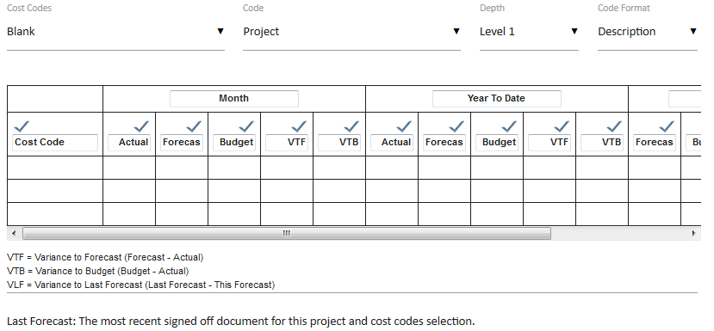
The resulting document will present to the author the accounting costs for the project for the period selected.

Document Edit View
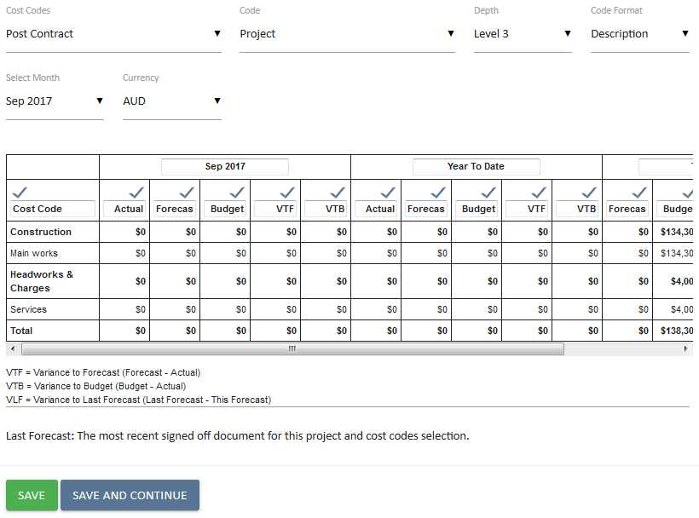
The document author selects the appropriate month and cost code chart for the appropriate data. The default page orientation is Landscape to cater for the width of the chart.

Document Output View
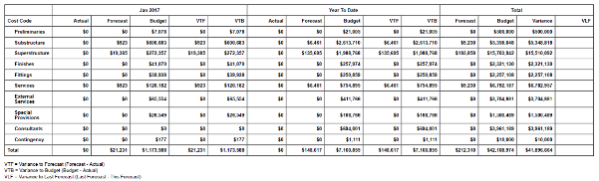
The output view is taken from the on screen HTML view of the document. The PDF output will vary depending on the selection of style sheet and the applicable styles.

Auto Number
This creates an automated number. Depending on the settings the auto number may be a sequential number, or a unique number. The auto number may be used for Variations, Requests for Information, Defects, etc. where having a unique reference and sequence is required.

Source of Data
The source of this data field is from within the document itself. This will be either on document creation or sign-off depending on the option selected.

Template View
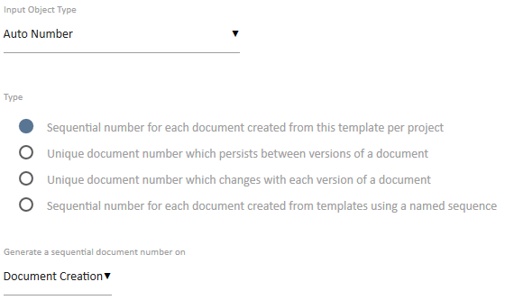
The first option simply creates a sequential number each time the template is used.
Option two allocates a number to a document. Importantly that number does not change as and when the version of the document is changed
Option three allocates a number to a document, and that number changes each time the document is modified.
In all of the above options you may choose to generate the automatic number when the document is created, or when it is signed off.
Note that by default the document auto number will commence at 1, and then progress to 2, 3, 4, etc. sequentially. If you require the sequence to start at a specific number you may enter in the next number in the sequence that you require. All subsequent documents will follow the number sequence that you set

Document Edit View
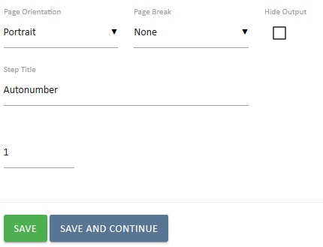
In the resulting document the Auto Number step will appear. Note, it may be edited.
Generating the number sequence on Document Sign-off is used where the document or record is not included in the sequence until it is approved or accepted. Progress Claims are an example of numbering on sign-off.
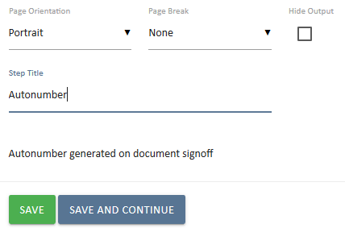
In the resulting document the Auto Number value will not be shown until after sign-off.

Document Output View
If the step is not hidden, which it can be if it is purely for an internal numbering reference, then it will appear similar to this.
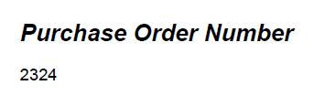
As with any of the input objects the heading size and presentation can be modified in the Document Edit view.
The auto number can also be displayed in a rich text object using a standard template variable $document.autonumber

Benchmark
The Benchmark control is used to associate your project data with data that has been captured against other projects. This is useful for comparative purposes, and can be configured to compare all projects, or those which meet specific comparable criteria.

Source of Data
Benchmark data is drawn from a number of sources, and encompasses your current project, and the data of other projects which have been completed. By default, the data is drawn from like for like comparable projects, e.g. those which belong to the same Sector, Project Type, Sector, and those which use the same chart of accounts for budgeting). Project Custom Fields and Metrics may also be used to help narrow down the number of projects presented for benchmark comparison.

Template View
The template view has no selections made by default. This will simply present the document author with a list of projects that matches the project that they are benchmarking. Typically this default setting will be the simplest option, though you may select options such as Metrics Chart of Accounts, if you intend creating numerous benchmark templates, per chart of accounts.
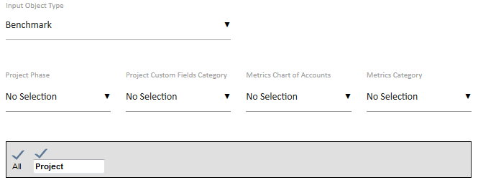

Document Edit View
The document author may choose to selectively show or hide specific projects. In the example below, two projects have been removed from view as they do not have relevant data. The author may also edit the column heading – e.g. they may rename NLA to be Net Lettable Area. Different, or multiple selections can be made to draw on more extensive metrics, charts of account, custom categories, etc.

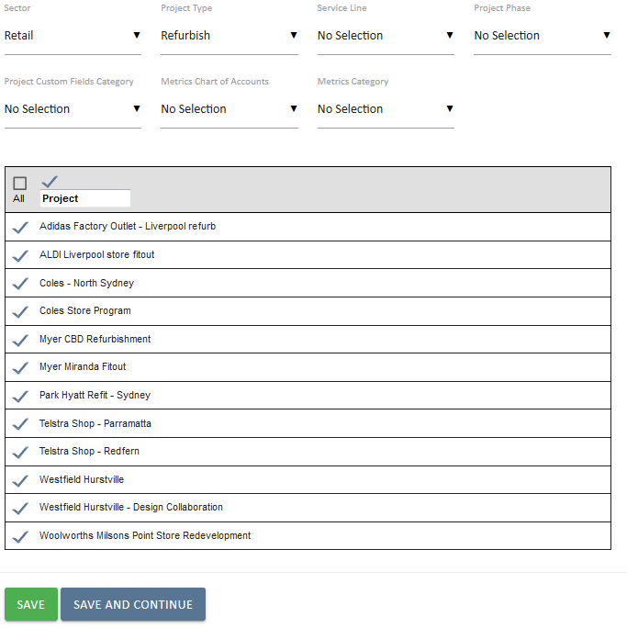

Budget
The Budget object is used to display varying levels of financial information as relevant to your project

Source of Data
Data comes from entries made in your Costs Tab, and entered via the Project Budget section.

Template View
When preparing your template to use the Budget control, you may choose to display costs at the Project, or Portfolio level, by selecting the desired option from the Template Mode drop down box. You may also choose to select the level of financial information to be a high level (Level 1), or a more granular and detailed breakdown (level 3, 4, 5, etc.). In the event that you have numerous Charts of Accounts (CoA), you may selectively choose the correct CoA for your project. Your template may also be configured so that the budget for a project is locked in as being an “Original” budget , an ”Approved” budget, or as being both “Original and Approved”
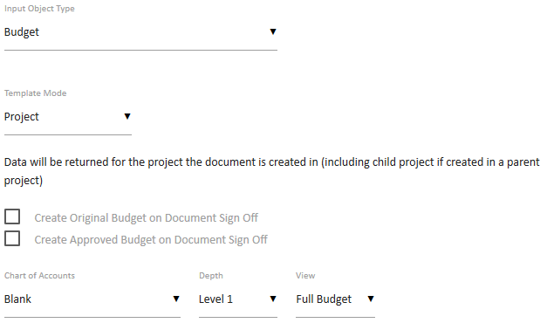

Document Edit View
Depending on the desired level of financial information you wish to present in your output document, you may display the project information at a high level summary, through to a more detailed and granular level

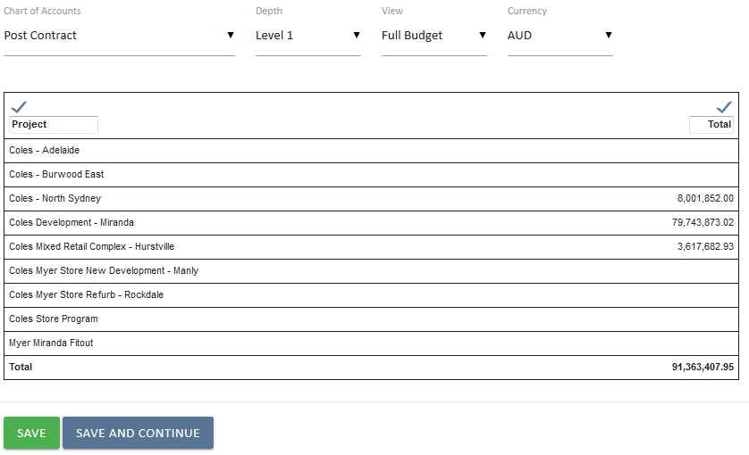

As more detailed views are selected, you will be able to present variance analysis, whereby your current budget is displayed alongside any previous budget versions. This can be useful in comparing project budgets throughout the project lifecycle.

Cashflow
Presents project level phased cashflow details from either cost of fees tabs.

Source of Data
The cashflow data is presented in three columns; Budget, Forecast, and Actual. The budget information comes from your phased project budget, and will be presented according the date range to which is has been phased. Forecast is also drawn from your phased forecast to complete. Actual values come from actual claims/invoices which have been raised and signed off

Template View
The template allows you to specify the chart of accounts that your cashflow relates to.
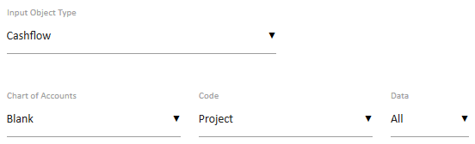

Document Edit View
When creating your document, you may choose to change the chart of accounts and currency. All columns can be selectively shown or hidden, and column titles may also be changed if necessary.
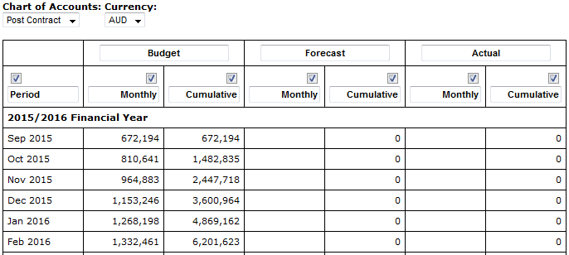

Document Output View
The document output largely matches the document template control.

Contract Deliverables
The contract deliverables object is used to display line item details of a contract for the project.
This is useful in reporting for Cost contracts and in preparation of proposals for Revenue contracts.

Source of Data
The data source for this object is the Contracts system for the project.

Template View
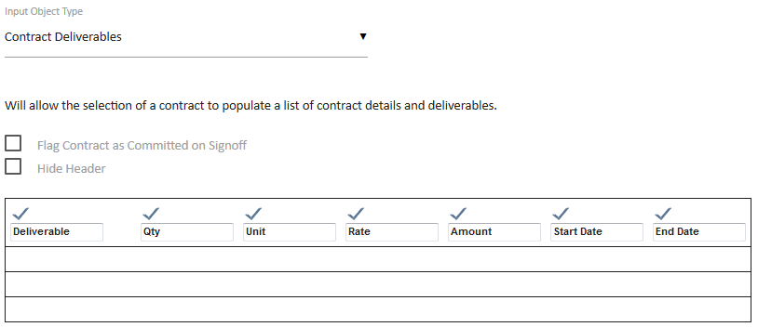
Check the box for Include Schedule Dates if you would like the schedule dates to be displayed from the details entered within the contracts tab
Checking the box to Flag Contract as Committed on Sign-off will only show your contract as being committed when the document is signed off. If you require the document to leave the contract in an uncommitted state after sign off, then un-tick this box.

Document Edit View

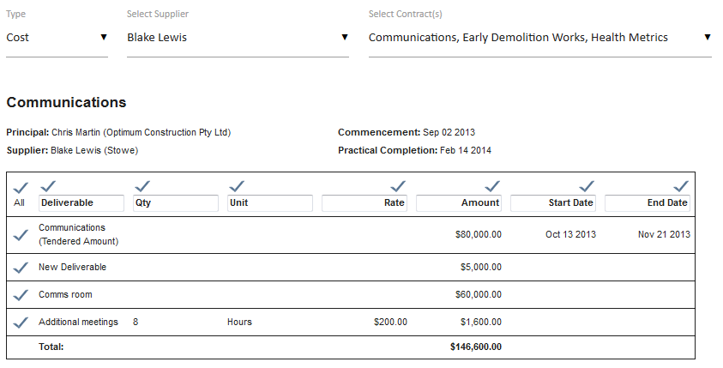
In the resulting document the contract can be selected and can be displayed with or without the schedule. Individual deliverable items from the contract can be selectively shown or hidden as required.

Document Output View
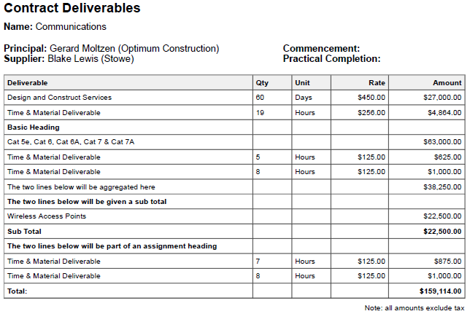

Contract Details
The Contract Details object is a contract selector to associate a document with a contract. This also allows for contract oriented template variables to be used in any Rich Text box in the document.

Source of Data
The data source for this object is the Contracts system for the project.

Template View
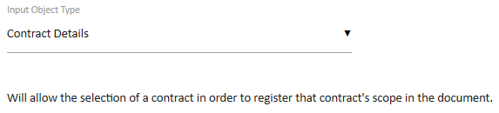
There are no configurable options for the Contract Details object.

Document Edit View
Similarly, in the resulting document there are no options for this object. Simply select a contract from the selector list.
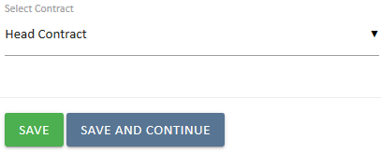

Document Output View
There is no output for the Contract Details Input Object as it is assumed that the selection of the contract is evidenced from other information in the document. However, the document is linked to the Contracts system as a result of this object being used in the document. The selection of a contract links the document to the contracts system and depending on the other details in the document will appear in the Related Documents Register on the Contract View screen.
Use this with the Issue Selector object to prepare documents that link between Issues, Contracts, & Documents to provide a complete record of contract related issues.

Contract EOT
The Contract Extension of Time (EOT) object provides for preparing a document that supports a record of an approval process for an extension of time on a project Cost contract schedule.

Source of Data
The data source for this object is the Contract Extension of Time listing for a Cost contract in the Contracts system for the project.
Add the extension of time claim to the contract for it to be accessible by the document.
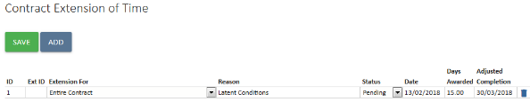

Template View
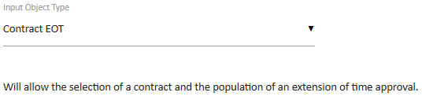
There are no configurable options for the Contract EOT object.

Document Edit View
In the document select the relevant contract.
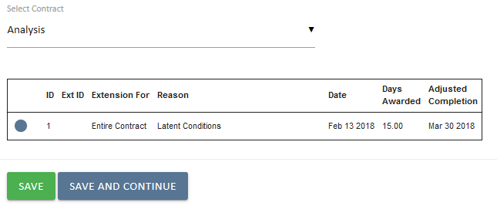
The list of extension of time claims for the contract will be displayed. If there are more then one EOT on the contract, you can use the radio button to the left to select which EoT is relevant for the document.

Document Output View
The document output includes a summary of the impact of the extension on the schedule of all the EoT’s approved.

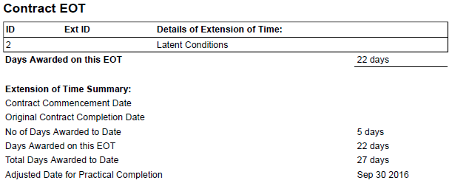

Contract Registers
The Contract Registers object provides for listing variations, progress claims, extensions of time and requests for information that relate to a contract. It is used for documents that report on contract progress.

Source of Data
The data source for this object is the Contract related documents and data entry from the Contract summary view.

Template View
There are no options for the Contract Registers object.

Document Edit View
You will be presented with 2 drop down selection items. The first is the Register type, and allows you to select the type of contract item that you wish to view. The second list displays the names of suppliers for each contract that has been created within the selected project.
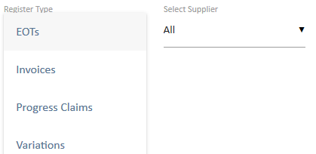
Depending on the selection made, UniPhi will present each of the contract related items. UniPhi will also inform you that no items exist. In the example below you can see that the Construction contract has not had any progress claims.
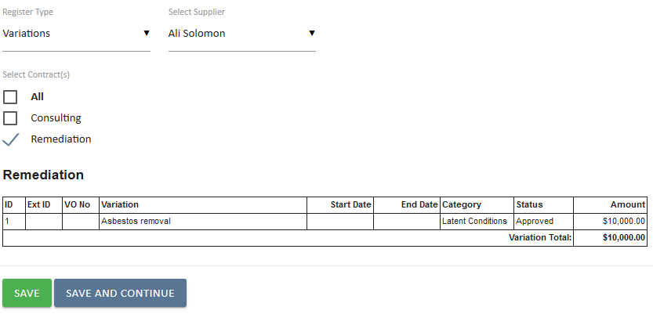

Document Output View
The resulting document output will display the selected listing.
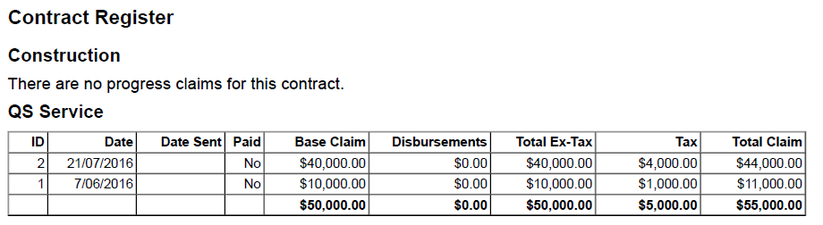

Contract Variations
The Contract Variations object displays the details of variations that relate to a contract within a project. It is used for documents that approve variations that are flagged as Pending (Pending Approval).

Source of Data
The data source for this object is the Variations entered in the selected Contract claim view.

Template View
Notice that the document control allows for the selection of variation categories. Your organisation can create specific variation categories. Once created, they can be set within your document template.
The document control column headings are configurable. You may choose to show or hide particular columns, and even re-name default column headings as required
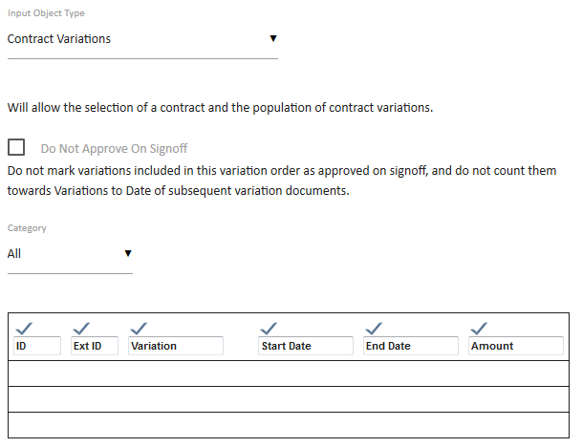

Document Edit View
In the document select the relevant supplier and contract.
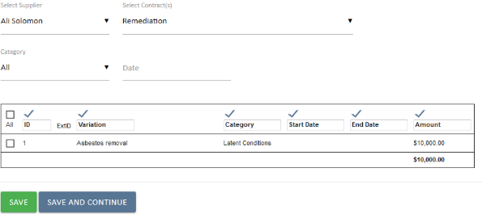

This displays the variations listing. Pending Variations are identified by the check box to the left of the item. You may choose to show or hide previous variations.
The Certification Date is a mandatory field while it is also expected that at least one variation will be checked for inclusion. If no variation is checked then a $0 value document will be generated.
The Approved and Possible Variations are listed for reference purposes, while any Rejected Variations are not listed.

Document Output View
The resulting document output presents the Variations selected and a summary of the contract value based on the approval of this Variation Approval document.

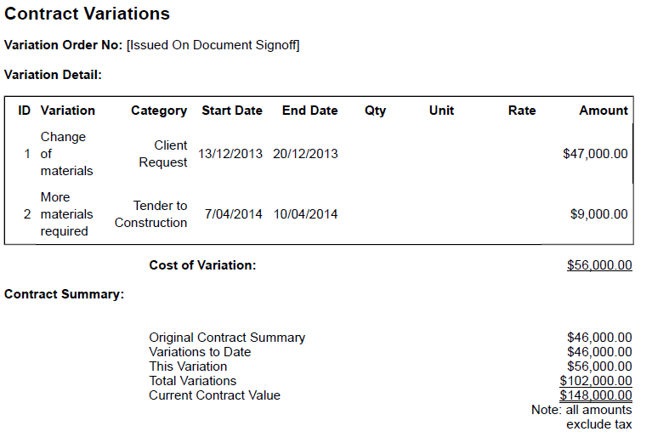

Signing off the Variation Approval document commits the Variation value to the contract, changing the status of the Variation to Approved and increasing the agreed contract value. In the summary view of the contract the Adjusted Contract value will increase by the value of the newly approved variation while the Potential Variation column value will decrease by the same value.

Custom Check List & Custom Drop Down List
Custom lists are used to provide selection options that are fully configurable and specific to your organisation. The content of the lists are added by a UniPhi administrator.

Source of Data
Both of these input objects are configured in the Configuration > Custom Lists tab. A Custom Drop Down list is a selection list that caters for one selection from many options. A Custom Check List provides for presenting a selection of options in the resulting document that can be checked, for the items that are applicable.
In the above examples some custom lists have been created. Use the add icon to create a new list.

Template View
The Custom Check List provides a number of options for the output format in the Document Edit view and resulting Document Output.
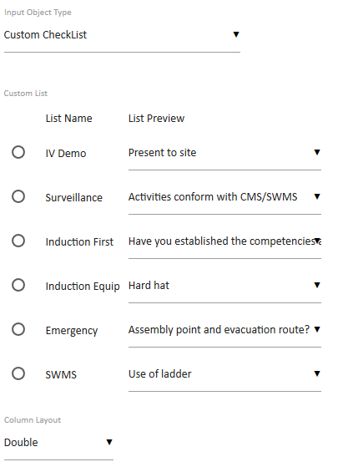
Select the relevant Check List and the preferred Column Layout option.
The Custom Dropdown Lists are presented in a similar manner. Select the relevant Dropdown List. There are no presentation options for this object.
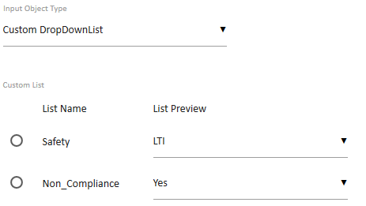

Document Edit View

For the Custom Check List select the relevant items by checking the appropriate box. In the example below we have used the single column with comments options in the template, so when using the checklist we can enter any related commentary
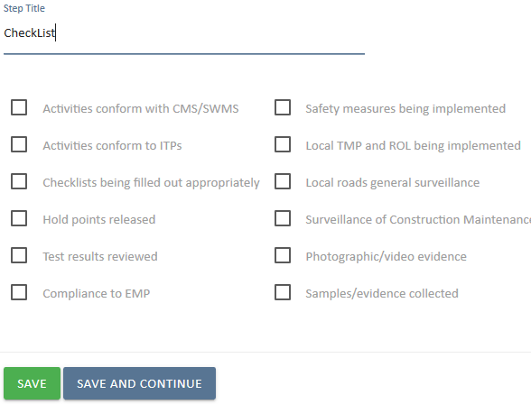

And for the Custom Drop Down list, simply select the relevant option from the Dropdown List.
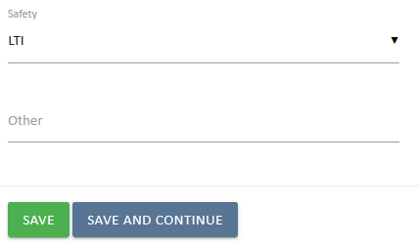

The Custom Dropdown List also provides for a manual entry if the list does not provide an appropriate option for the specific document. Entering data in this field is recorded for this document only.

Document Output View
The custom lists present the selected options from the document edit view.

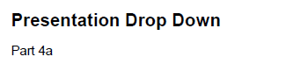

Date Selector
The Date Selector input object provides for either manual entry or a calendar selector.

Source of Data
The source of the data is the document creation/edit process. This date is not linked to any existing data and is relevant to the presentation in the document output.

Template View
The template Input Object includes options for various date formats.
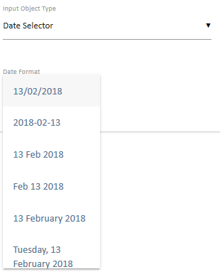
The date format is set from the template and cannot be modified in the document.

Document Edit View
In the Document Edit View the date selector is a simple entry field. Dates can be keyed manually.
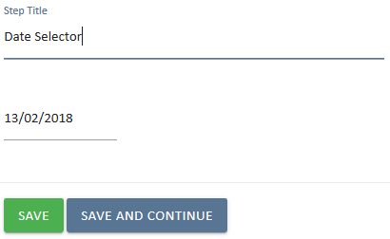
Dates can also be selected with the calendar tool.

Document Output View
The date selector field can be made visible within the output document.
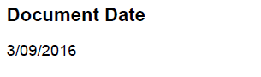
As an alternative, the step may be hidden from output, and then referred to in subsequent sections of your document via the use $document.date template variable.
For example selecting a date within the document date step;.
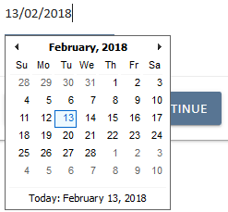
Then using the template variable of $document.date to automatically populate that field from the Date Selector.

Distribution List
A distribution list is used to validate the transmittal records for specific documents. While transmittal records are automatically maintained for documents emailed from UniPhi the use of a distribution list provides for standard roles to be nominated for inclusion as defaults for specific document types.

Source of Data
The source of the data is the resources that have been assigned to a project.

Template View
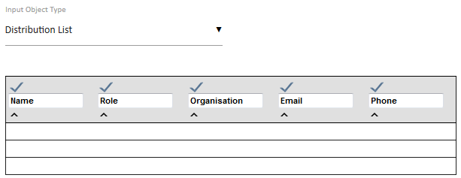
The template control can be configured to show or hide individual columns of information. It is also possible to change the column headings, if required

Document Edit View
The document edit view displays the list with check boxes for the team members that are to be included in the distribution list.
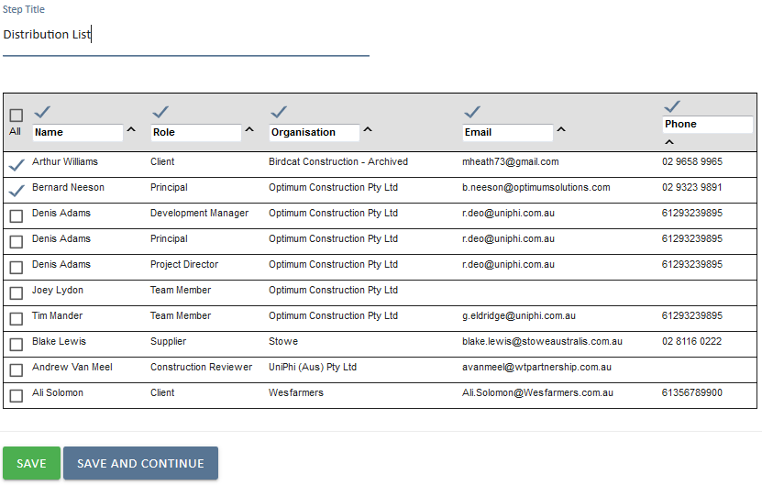
The document author may choose to select or de-select individual contact resources, and to show, hide, or even relabel column headings. It is also possible to “sort by” any of the columns into alphabetical or numerical order.

Document Output View
The listing is a simple output with the team members name, role and organisation name if it is in the system.
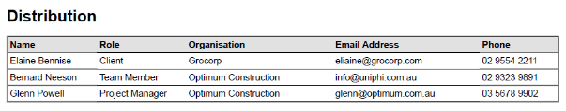

Document Selector
The Document Selector allows you to attach an existing UniPhi document into your template. Note: the document(s) that you wish to attach must be “Signed Off” status to be included as an attached document.

Source of Data
The signed off documents within the same project.

Template View
The Document Selector provides a default template filter option when preparing a template.
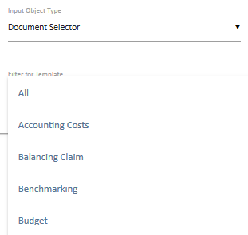
The selected filter can be overridden at the document edit view.

Document Edit View
The document edit view provides for filtering for a specific template type and then selecting a document from the Select Document list.
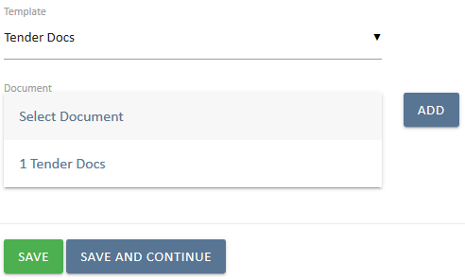
Any document template may be selected as the default.
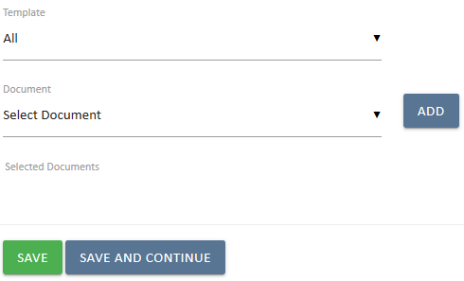

The default Template can be overridden during document editing. Selecting an existing document is completed using the Select Document listing and the add icon.

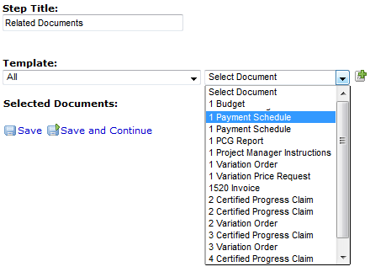
Having selected a document click the Add Selected Document icon

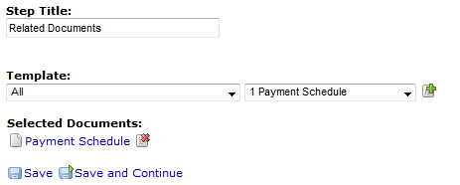

Once added the attached document is shown as a link within UniPhi.

The document will be displayed under a heading of selected documents.
Additional documents can be added by selecting a second or subsequent document and using the Add Selected Document icon.
Removing an incorrectly selected document is done by clicking the remove icon.

Document Output View
There are two different outputs for this object.
In the on screen view for a team member with access to UniPhi the ‘attached document’ is shown as a link within UniPhi.
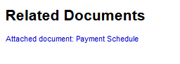
The PDF output however is different as the PDF must be universal and all recipients of the PDF output may not have access to the UniPhi system directly and therefore the ‘attached’ document appears as an attachment rather than a link when the document output is sent to a PDF format.
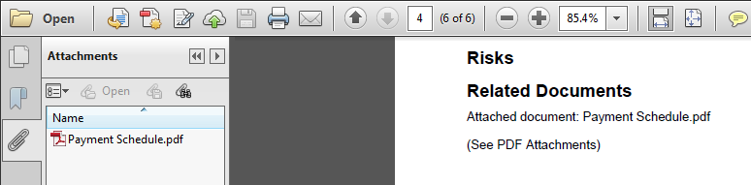

Document Version History
The document history object provides a listing of all the edit sessions for the document.

Source of Data
The source of this is the document version history. This is not visible anywhere else in UniPhi.

Template View
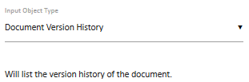
There are no options for the Document Version History object.

Document Edit View

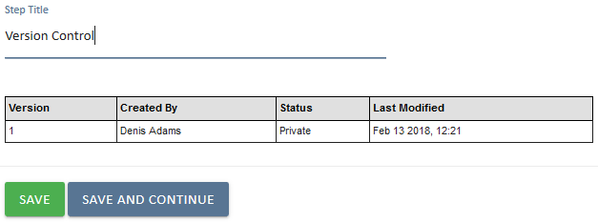
Documents that are in private mode are not version controlled and will always appear as version 1.
While documents are in Draft, Open for Review, or Awaiting Sign-off the version number will increment. If a document is set to Draft status when first saved then that status will appear against version 1.
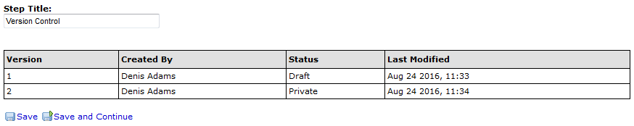
Once a document is signed off this object is completed and any further revisions will be noted against a new document copied from the original.

Document Output View
The document output is a simple table reflecting the same data.

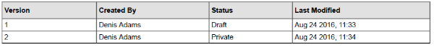

Embedded Document
Allows you to embed a previously prepared document into the document that you are generating.

Source of Data
The selection of a document to embed can be made from any document within your project, so long as the document you are selecting has been signed of (draft documents may not be embedded).
The selection of documents to embed can be made at the project level, or across the entire portfolio of documents

Template View
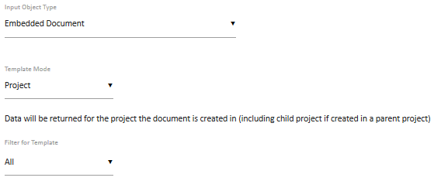

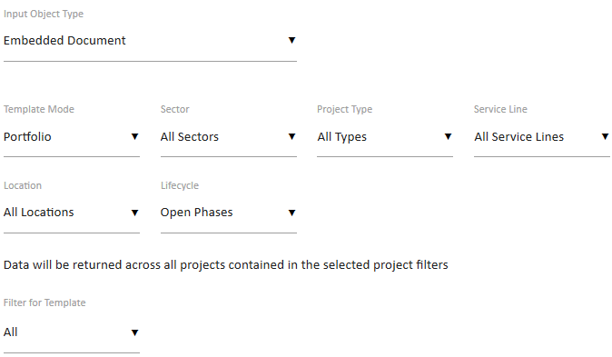

Document Edit View
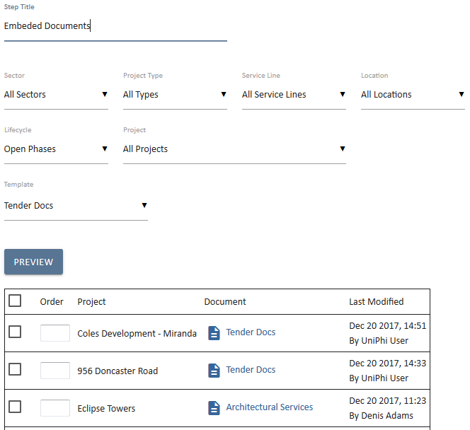

Document Output View
Each of the selected documents will appear within the document you are creating. All style sheet information will be removed so that the resulting output document has a consistent look and feel.

External Comments
External Comments are an extension of UniPhi issues. The design of this control is to simply include comments (issues) which have been raised for discussion/action. It is essentially a summary of communications which need to be presented to stakeholders external to your UniPhi deployment.

Source of Data
Data is sourced from issue actions that have been logged within the issues tab.

Template View
External comments may be configured to present project issues comments, or those across the entire portfolio. The template is configurable to draw all comments, or to limit the comments to those that align to project specific sectors, project types, service lines, locations, or lifecycle stages. Comments can also be defined according to issue settings such as category, escalation, status, and rating.
If you have defined issue custom fields, these fields will also appear, and allow you to select them
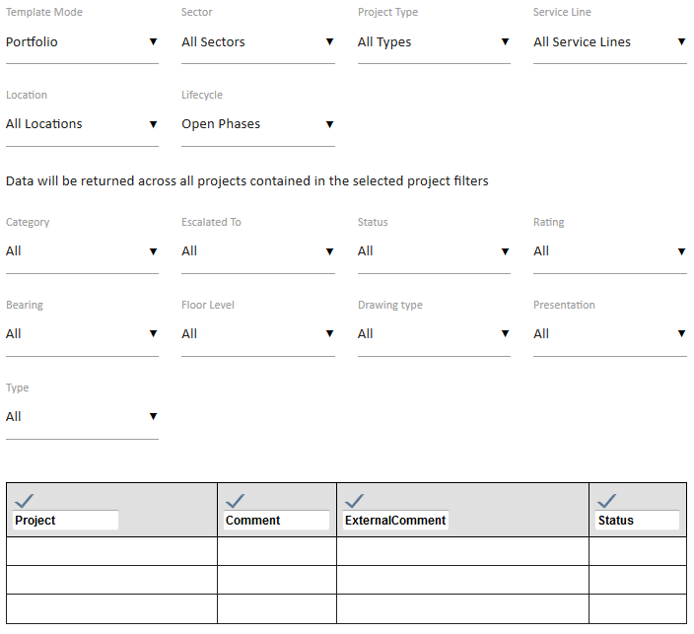

Document Edit View

The document author has a number of drop down menu items that they can adjust if necessary to present the correct view of external comments. Specific issues can be selected or de-selected, and column headings may be re-named.
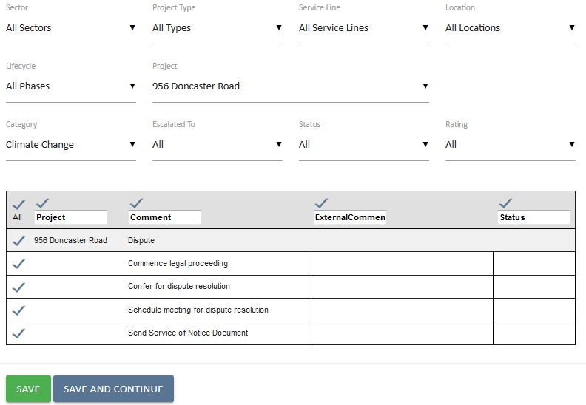

Document Output View
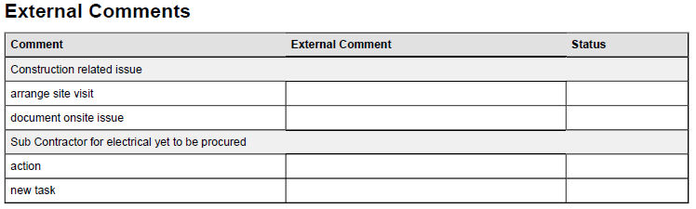

File Upload / File Upload (Multi)
The file upload control allows you to attach any file into your UniPhi document. Files may be uploaded regardless of their file format. This object provides for a single file to be uploaded in the step. For multiple file uploads use the next object File Upload (Multi). The difference is that more than one file can be uploaded by using the Ctrl click or Shift click options as with a normal Windows selection process.

Source of Data
The document authors local or network accessible file storage drives.

Template View
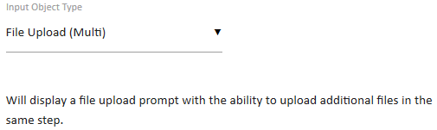
The document template view provides for attaching a default document. This can be used to distribute a standard form or file with the document prepared from this template.

Document Edit View
The document edit view displays an option to browse to the authors file storage i.e. C:\ or a networked drive using a standard browse window.
The selected the file will be uploaded from the local storage to the UniPhi server and a file description can also be entered by the author.

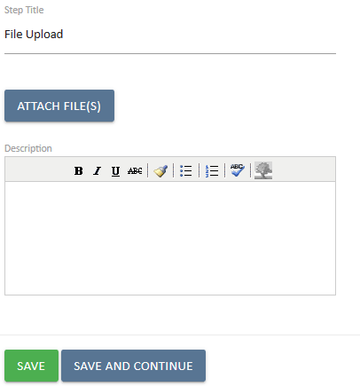
The file is uploaded after a Save or Save & Continue option is selected.
The document is shown as already attached. If a new document is selected the existing one will be dropped from the list and the new one will replace it. This is a single attachment option.

Each file has an individual description field for cases where the file name is ambiguous or not descriptive of the content of the file. If the file names are indicative and sufficiently unique for the intended audience of the output document then these descriptions may be left blank.
When editing an existing document with a File Upload (Multi) object the view will appear. If additional files are added to the document or existing files are removed the changes will be displayed within the document as a version control record.

Document Output View
The uploaded file is displayed as a link in the on-screen view or as an attachment in a PDF.

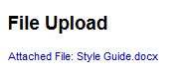

Graph Selector
The Graph Selector provides for the inclusion of various charts and graphs based on the data within the UniPhi system. Similar to the charts found on the dashboard screens this object caters for including these charts within documents.

Source of Data
The source of this data is from the statistical and financial information for projects and portfolios in UniPhi.

Template View
There are several graphs available. Each draws on information stored within UniPhi. UniPhi graphs have some common features throughout. For example it is possible in most graphs specify the output size as being 50% or 100%, and to include text box commentary. In some cases the graphs are configured as being project specific, while others allow data to be drawn from the entire portfolio. Financial graphs allow you to specify the Chart of Accounts, and whether the graph should display as curency value or as percentages.
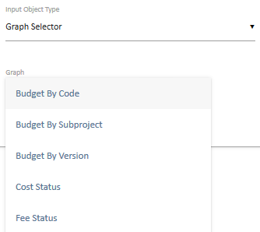
Once you have selected your required graph(s), and press the Add button, your graph will appear. You may add numerous graphs into a single document template step if necessary. Note that the view of the graph at this point is only indicative, and will not reflect the actual graph, or any underlying data from UniPhi.
As your graph options are selected, it is important to press the Update 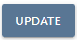 button to commit your changes.

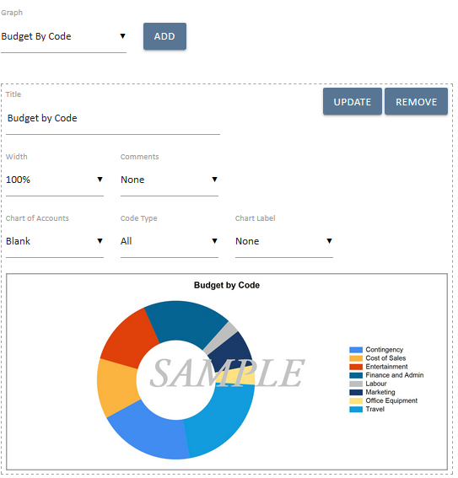
Budget by Code – draws information specific to a single project and per project budget chart of accounts
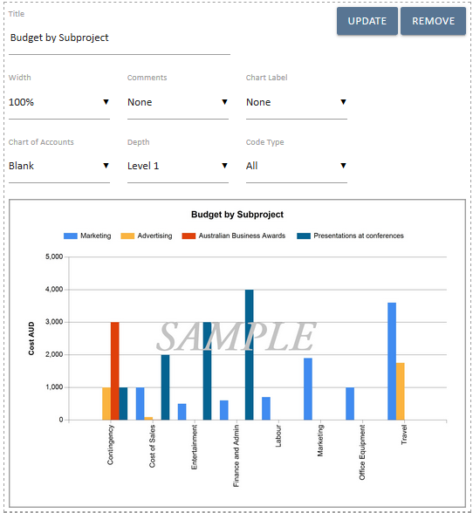

Budget by Subproject – is only used at a parent project level, where sub project (or child projects) have been created. Data is drawn from the budget information which has been captured as a budget “snapshot”.

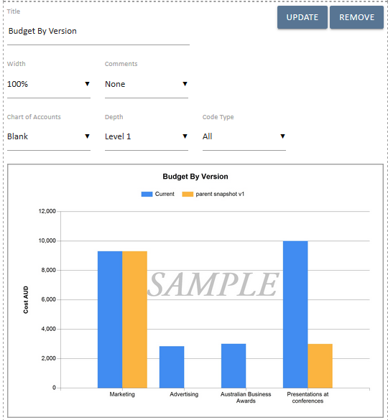
Budget By Version – is used to compare budget snapshot versions.

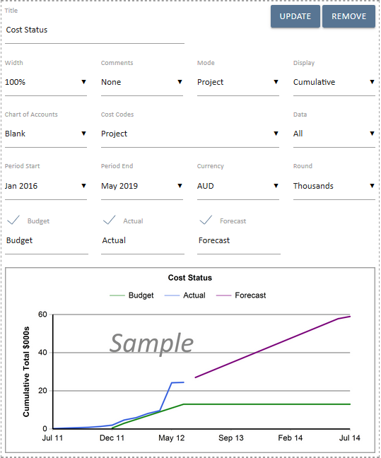
Cost Status – Draws on cost budget, actual spend, and forecasted cost information
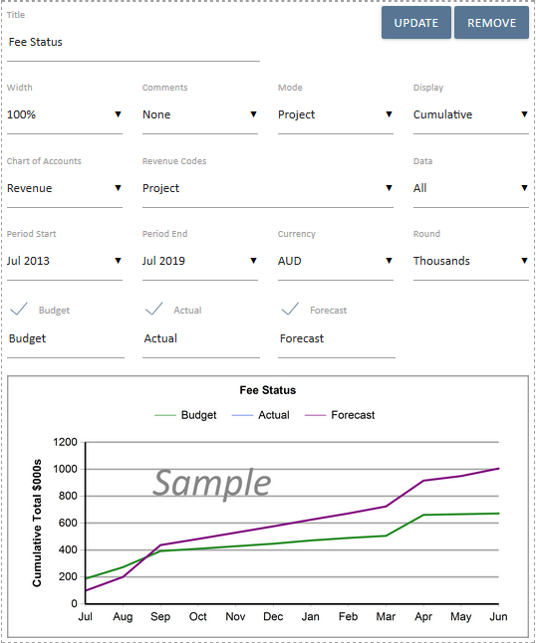
Fee Status - Draws on fee budget, actual income, and forecasted fee information
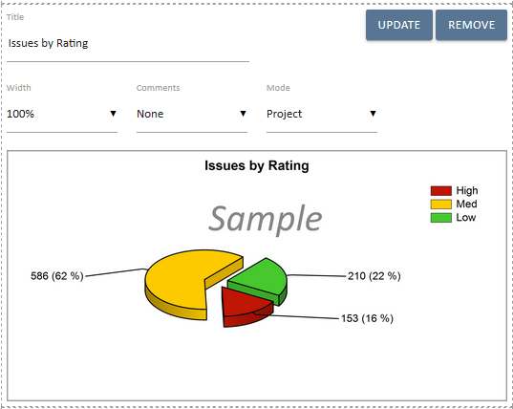
Issue by Rating – Draws on issues data such as the High / Medium / Low rating of risks according a single project, or across the entire portfolio

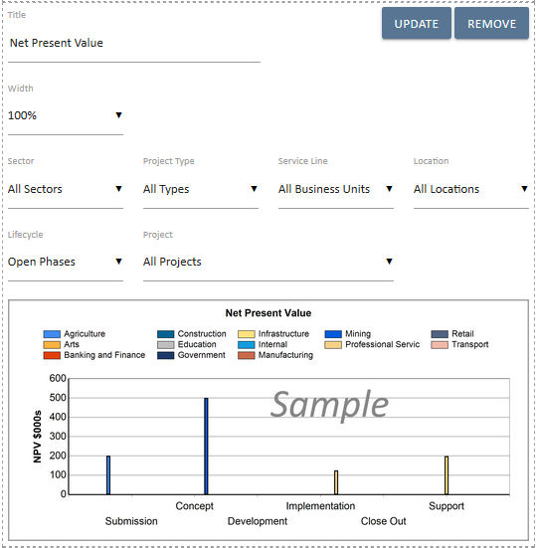
Net Present Value – displays NPV information per the project selected

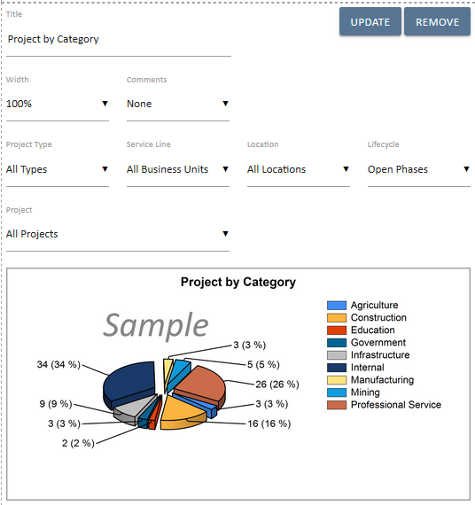
Project by Category – Is a portfolio level graph which displays the percentage of projects per category.
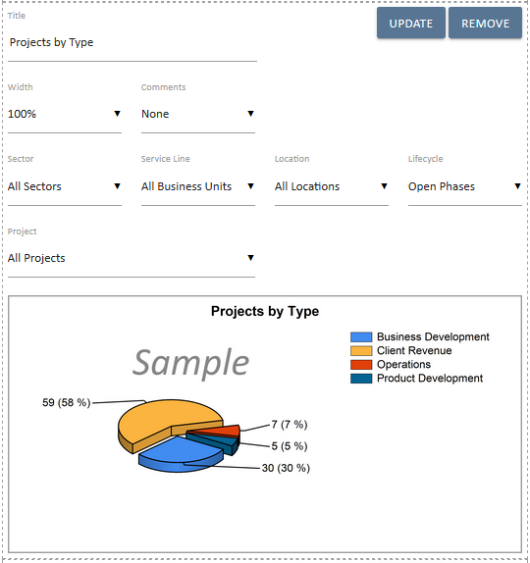
Projects by Type – shows the percentage breakup of projects across the portfolio according to their specific type
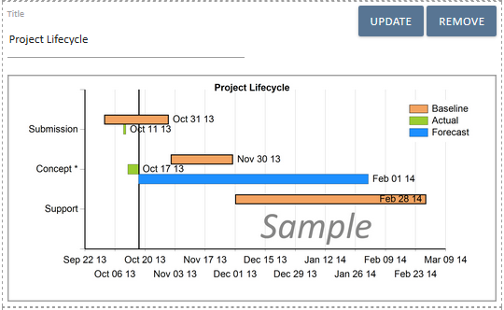
Project Lifecycle – displays at a portfolio level, all projects according to their current lifecycle phase.
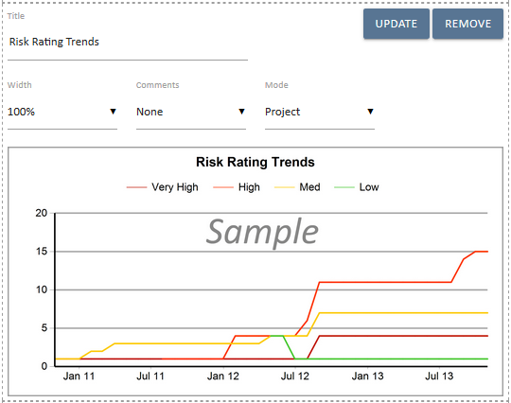
Risk Rating Trends – displays at a project or portfolio level the changes to risk status. It allows for analysis at a glance as to how risk ratings are increasing or decreasing in severity
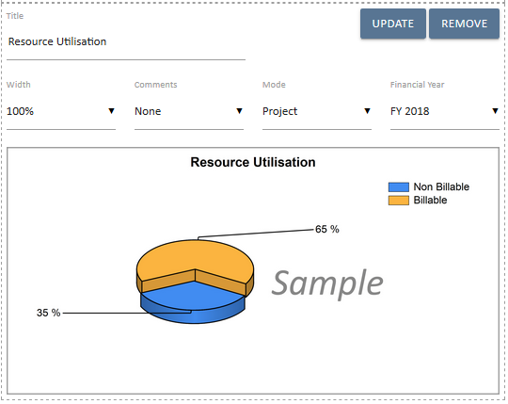
Resource Utilisation – Displays the amount of time entered into the timesheet system for all resources. The information is displayed according to the configuration of your timesheets (e.g. billable versus non-billable)

Removing a graph can be done with the red delete icon to the right of the graph placement area.

Document Edit View
The user experience will differ depending on the graph that is being displayed. In all cases though the title of the graph can be changed, comments made, and sized changed from 50% to 100%. It is also possible for the author to add new graphs by simply pressing the Add button.

Document Output View
Again, depending on the particular graph that has been selected, and the configuration potions which have been specified, the output graph will differ. It is possible to view your graphs in both html view and as a PDF document.
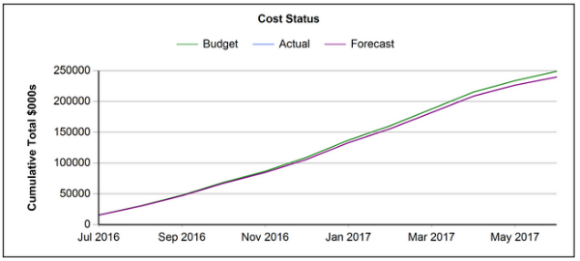

Invoice
The Invoice object is used with Revenue contracts to generate a client invoice.
Balancing Invoices are also prepared using this object and are used where the invoice is not required to be sent to your accounting software.

Source of Data
The source of this is the Contract Claim values and principal resource information for a Revenue Contract on a project.

Template View
When preparing an invoice template there are several configuration options available.
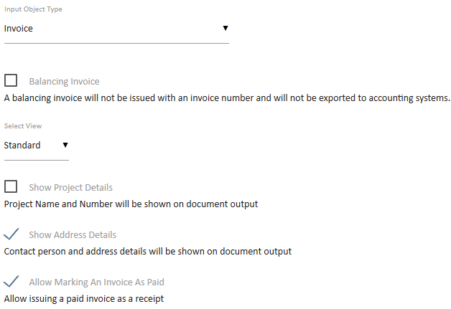
Balancing Invoice - As the explanatory text states, a balancing invoice will not be issued with an invoice number and will not be exported via the accounting system interface (if one is used). The purpose of a balancing invoice is to align the values in the UniPhi system with the relevant finance system.
Select View – Two view options are available. The Standard view presents a tabular format of all deliverable and claim values. The Expanded view shows the same table as the standard view but also provides summary additional information such as disbursement values, original contract sum, and adjusted contract values.
Show Address Details – UniPhi will detect the address details of the Principal on the contract and include this information on the output document
Allow Marking An Invoice As Paid – Allows the document author to specify that the invoice they are creating has already been paid

Document Edit View
When editing an invoice document it is generally launched from the Contract Claim screen and there is an expectation that the claim information has already been prepared on that screen and saved.
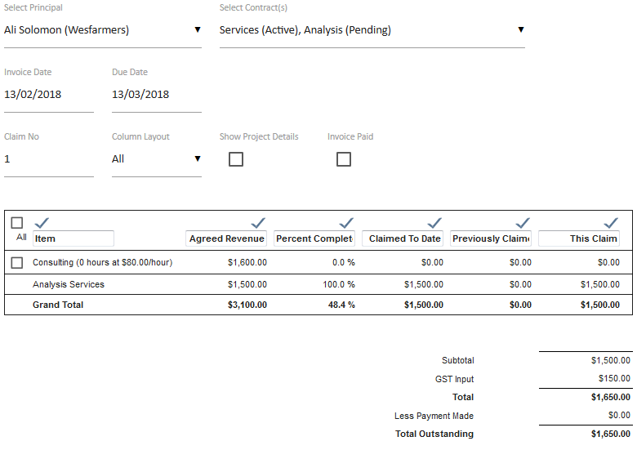
The default contract selection will be based on the contract that the document was started from.
Tax is automatically calculated based on the Tax Rates set in the system.
The Invoice Date is a mandatory field. The Due Date is automatically calculated based on the Contract header Payment Terms field. Both of these fields can be adjusted via the calendar tool or by manually entering a date to the field.
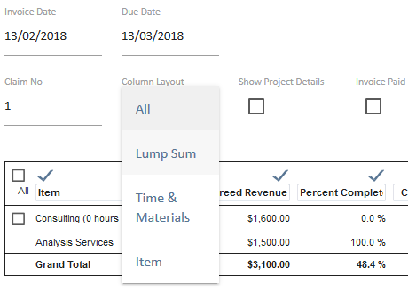
The Column Layout provides options for the display of the line items and will default to the most appropriate for the data being presented. However this can be changed to another layout if desired.
The Invoice Paid option used where the client has already made the payment and this document is being processed for documentation purposes. The balance of the invoice is assumed to have been paid and the Total Outstanding is reduced to zero.
Individual deliverable items can be shown of removed from view. Each column heading may also be renamed, and removed from view.

Document Output View
Outputs can be viewed as html, or PDF. Their appearance will resemble the example below.
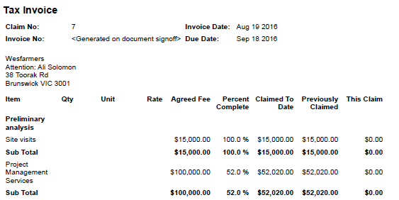

Invoice numbers are only ever added after the invoice document is signed-off in UniPhi.
The number sequence should be consistent with the Invoice numbering system in the finance system if it is interfaced with UniPhi and all invoices should be issued from UniPhi.

Issue Details
The Issue Details object provides for a listing of filtered issues for the project or portfolio including listing the Actions within the Issues and assignment details. Parent and Child projects can be ‘rolled-up’ with this object.

Source of Data
The source of this data is the Issues system for the project or portfolio.

Template View
The Template Mode option can be set to cover a single project, or the entire portfolio. In the example below the Issue Details will display only issues for the relevant project. Note that available filters will allow you to specify which project issues are displayed, according to your defined issues categories, escalation, their status, rating, and action status.
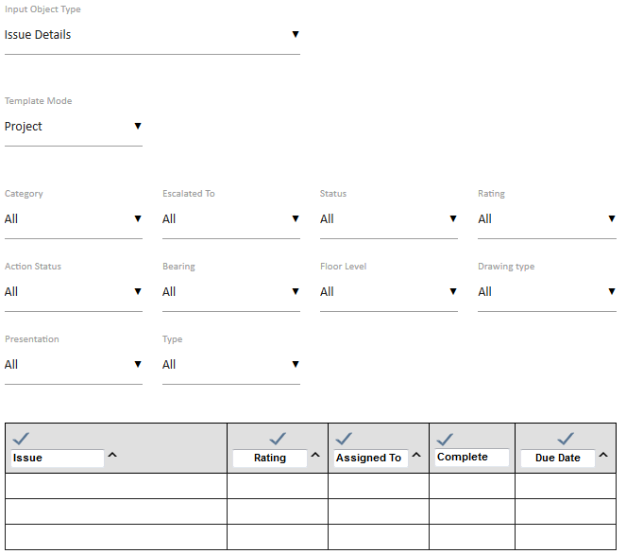
When viewing Issue Details at the portfolio level, the available filters are expanded so as to allow you to select project criteria such as sector, type, service line, and location.
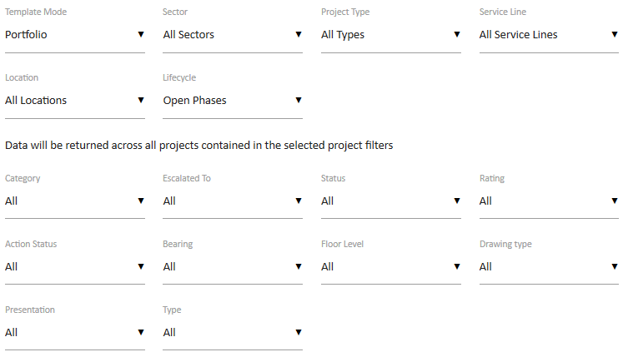

Document Edit View
When creating a document with the Issues Detail object the filters can be used as per the template setting or adjusted to suit the audience.
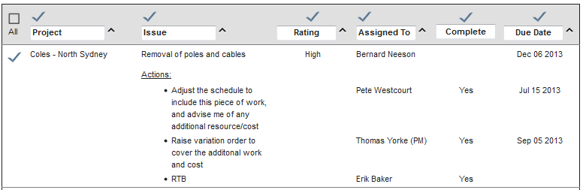
The Column headings of Issue, Rating, Assigned To, Completed and Due Date can be modified, and also clicked to change the sort order of the listing.
The check boxes to the left can be used to include or exclude particular issues.

Document Output View
The on-screen and PDF views of the Issue Details list including the Actions

Issue Selector
The Issue Selector provides for the selection of a single issue. It is used to connect a document with an Issue so that record management, particularly of Issue responses, is completed with visibility of the associated documents listed in the Issue details.

Source of Data
The source of this data is the Issues system for the project or portfolio.

Template View
The Issue Selector objects provides two filter options that can be set in the template but overridden in the document if required.
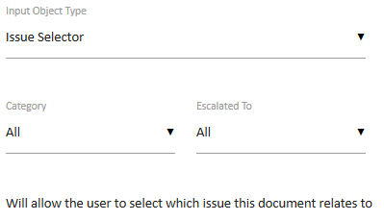

Document Edit View
This step will present all issues within the relevant project displayed according to the filter category and escalation settings
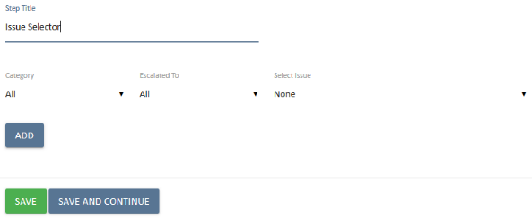

Clicking on an Issue in the Select Issue dropdown will link this document to that Issue in the Related Documents panel.
Clicking the add button will launch the UniPhi Issue creation pop up and allow you to create a new issue from within the document template. Once created, the issue and the document will be linked to each other.

Document Output View
The output view is the Issue description which is also a link to the issue. When opening the issue by clicking the link, you will notice the document appears as a “related document”
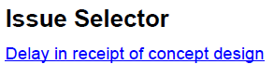
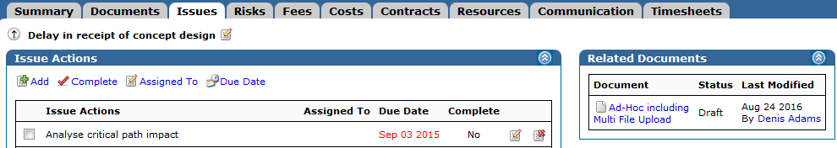

Issue Summary
The Issue Summary object provides for a listing of filtered issues for the project or portfolio as a high level summary. Unlike the Issue Details object the Summary excludes listing the Actions within the Issues. Parent and Child projects can be ‘rolled-up’ with this object.

Source of Data
The source of this data is the Issues system for the project or portfolio.

Template View
There are two views based on the Template Mode option.
This example is set for the Project view of the options.
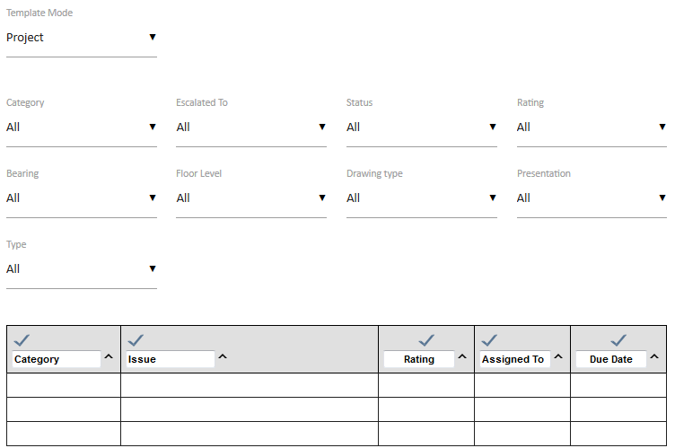
While the Portfolio view is selected in this example.
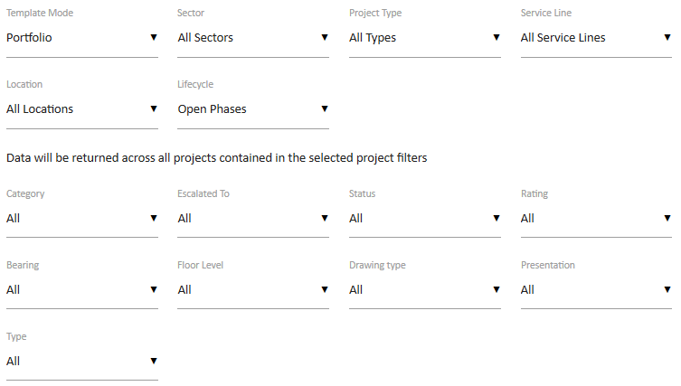
The primary difference is that the Portfolio view presents the Portfolio filter selection options as well as the Issue filters.

Document Edit View
When creating a document with the Issues Detail object the filters can be used as per the template setting or adjusted to suit the audience.
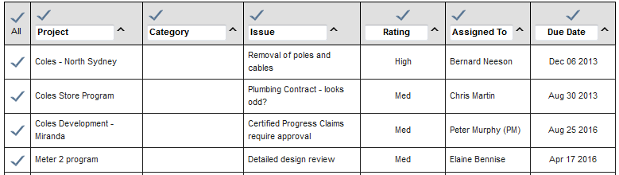
The Column headings of Issue, Rating, Assigned To, Completed and Due Date can be clicked to change the sort order of the listing.
The check boxes to the left can be un-checked to exclude a particular issue.

Document Output View
The on-screen and PDF views of the Issue Summary list is a simpler format than the Issues Details listing as it does not present the issue action information.
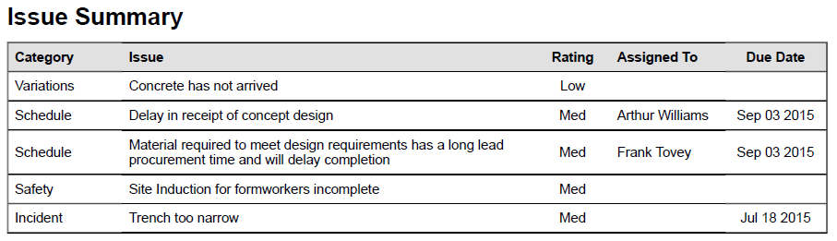

Metrics
Metrics are used to present budget calculations based on the metrics defined by your organisation.

Source of Data
Metrics data is drawn from the metrics and metrics categories which are defined within the budget of your projects. Metrics are linked to chart of accounts so as to provide a standard structure for metric calculation. In the example below, two categories have been created, and several metric calculations have also been created. When a project budget is created, these defined metrics appear beneath the budget details.

Template View
The template allows you to select the chart of accounts where your metrics calculations have been defined, and the specific metrics that you wish to include in you document. Note that multiple metric categories may be selected
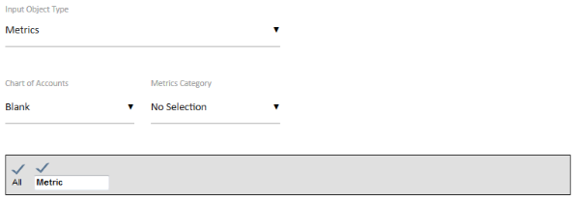

Document Edit View
The document author is presented with each of the metrics which have been defined within the budget, and selected in the template design. Additional metrics may be selected, and budget versions can be added for comparison purposes. Metrics may be selectively shown of hidden, and column headings may be changed if necessary.
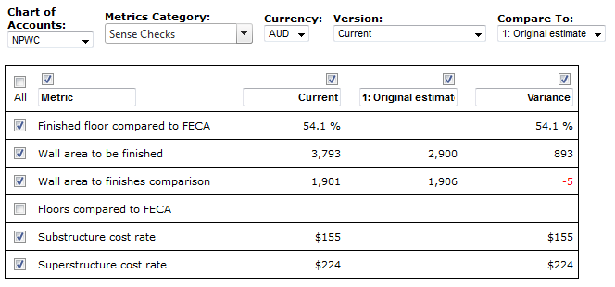

Document Output View
The output document closely resembles the view displayed when the document is being created. Note that column headings have been amended, and the metrics which were removed from view are not displayed in the output document.

Net Budget
In instances where your project is responsible for cost and revenue budgets, it is convenient to be able to view the net budget position in a reportable format.

Source of Data
Net budget relies on budget information from both the Cost and Fees tabs. If you have created budget snapshots, you may compare cost and fee per budget snapshot versions.

Template View
The template allows you to select the focus on being at a per project, or portfolio level. The template also allows you to determine which Chart of accounts is to be used by default, and the depth level that will be displayed.
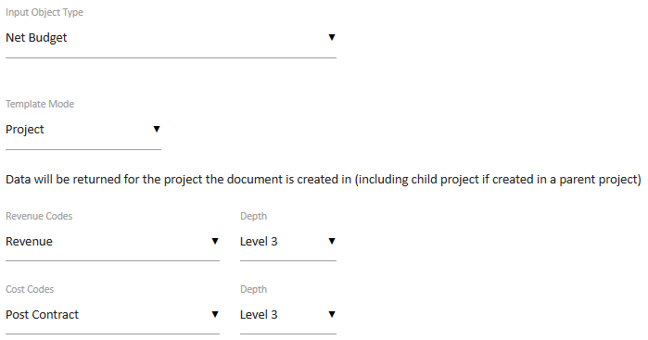

Document Edit View
The document author is presented with similar options to the template designer. IE, they can choose the change the chart of accounts, and the depth level displayed. They can also choose budget versions to use for comparison purposes, and can change the column headings if required.
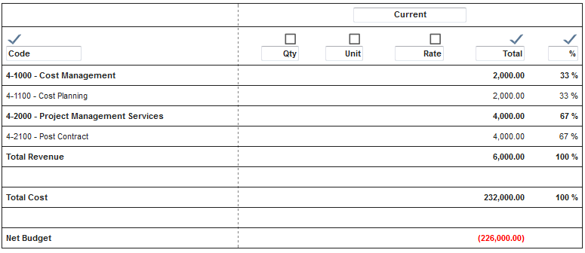

Document Output View
The document output will correspond with the settings made during the document creation.
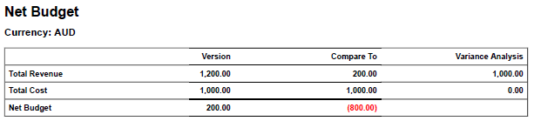

Periodic Custom Fields
Periodic Custom Fields are used to display custom field data over a monthly period, and cumulatively throughout the project duration. This object provides for reporting on the statistics recorded in those fields.

Source of Data
Project Custom fields are configurable according to your organisation, and your industry. Custom fields are added via the Methodology -> Projects settings area of UniPhi.
Periodic Custom Field values for a project are then entered and updated via the Project Summary screen. The values are recorded throughout the course of the project.

Template View
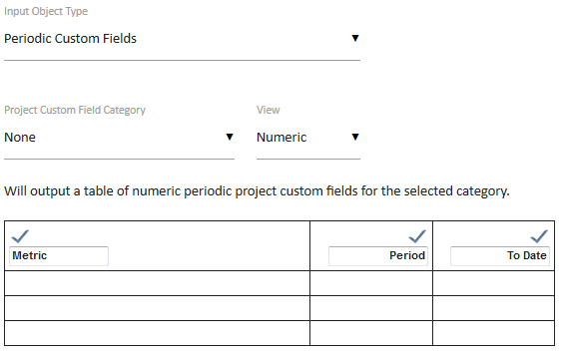

Where there are a number of different periodic custom fields, i.e. Safety or Financial, they can be filtered by the appropriate Category.

Document Edit View
When editing a document with a Periodic Custom Fields object, any relevant numeric field will be included in the listing. The listing includes the selected period and the accumulated whole of project values. Note that the To Date column heading assumes that the report is prepared within the relevant period and reflects the total for the life of the project to the end of the selected period.
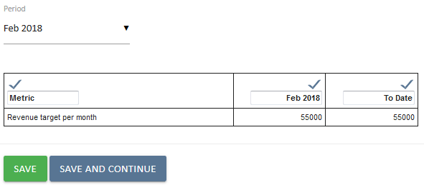

Document Output View
The resulting table is simply displayed with the step heading
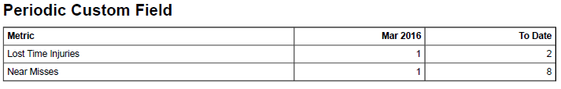

Retrospective reporting will only show the To Date value for the selected period.

Using this object immediately before or after a Rich Text object will allow for providing some descriptive text relevant to the statistics. Setting the step heading option to ‘None’ will present the results as if the heading, description and statistics were a single section in the document.

Periodic Issue Count
This object provides statistical information relating to Issues for the selected period, and as a cumulative total covering the duration of the project.

Source of Data
The source of this data is the Issues system for the project or portfolio. More specifically, it is the issue category selections which appear within the individual issues per project. Issue categories are created according to the needs of each organisation within the Methodology/Issues tab.

Template View
There are two views for this object when preparing a template, and will be used depending on the scope of your requirements. You may view issues at the project level, or across the portfolio. When the Template Mode set to Project you will be presented with the option of filtering on the Issue Category as a default filter for the document edit process.
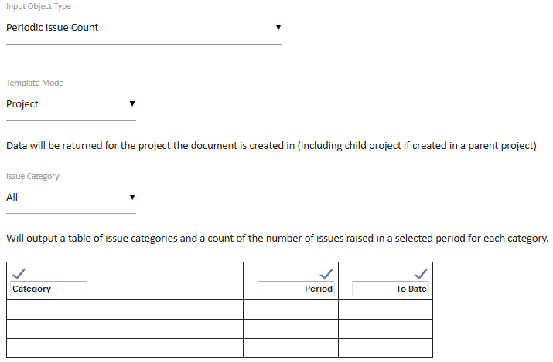
When the Portfolio Template Mode is selected, the filters for the broader portfolios are made available for setting as defaults.
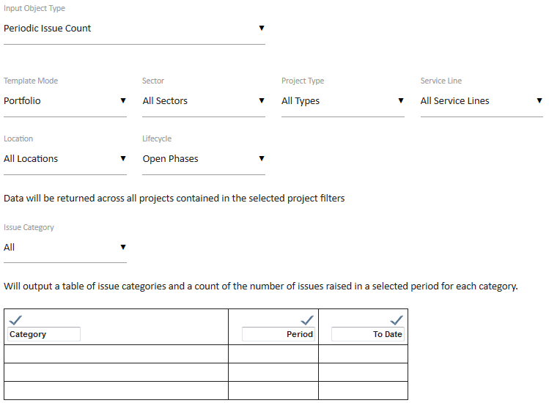

Document Edit View
When editing a document that includes this object, the view will vary dependant on the selections and the configuration of the Issue Custom Fields and Custom Field categories.
The Periodic Issue Count object defaults to Issue Category of All and will display the current relevant financial period.
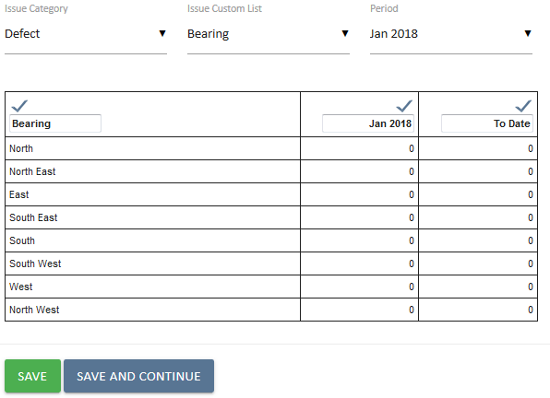
The data is presented for the period selected, and for the whole of project to the end of the selected period. Selecting a specific category changes the view to include any Custom List fields.

Document Output View
The resulting document output is simply the table as viewed in the document creation phase.
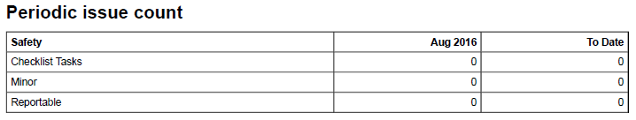

Progress Claim
The Progress Claim object provides for documenting and processing of Cost Contracts with Simple Claims set for a project.

Source of Data
The source of this is the Contract supplier information for a Cost Contract on a project, and the amount being claimed against specific contract deliverables.

Template View
The template view provides only for the selection of the Progress Claim object. There are a number of configurable settings which can be applied to this control.
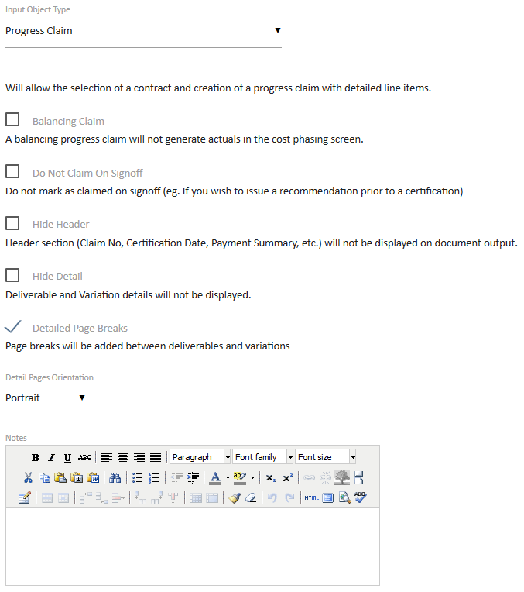

Document Edit View
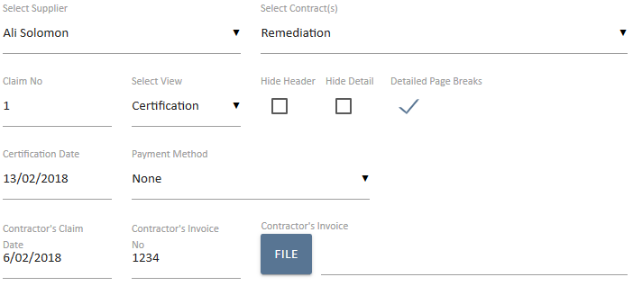
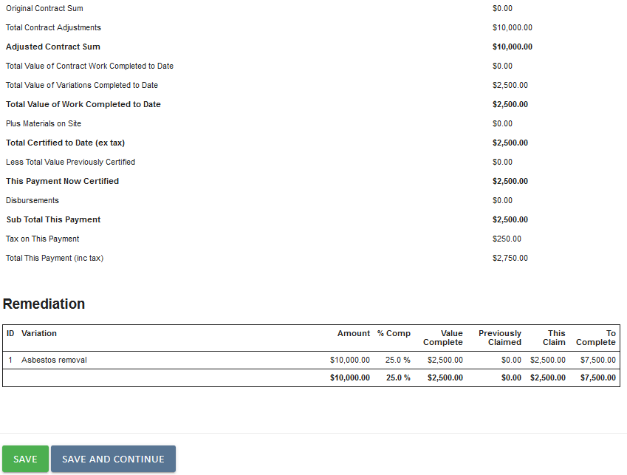
The Select Contract option allows for selection of the relevant contract. The Certification date, and Contractors Claim date are both mandatory fields. The Tax value is automatically calculated based on the Tax settings in the Admin area and should not be changed without administration approval.

Document Output View
The output view includes an auto-incremented Claim number and the details as set in the document creation phase.

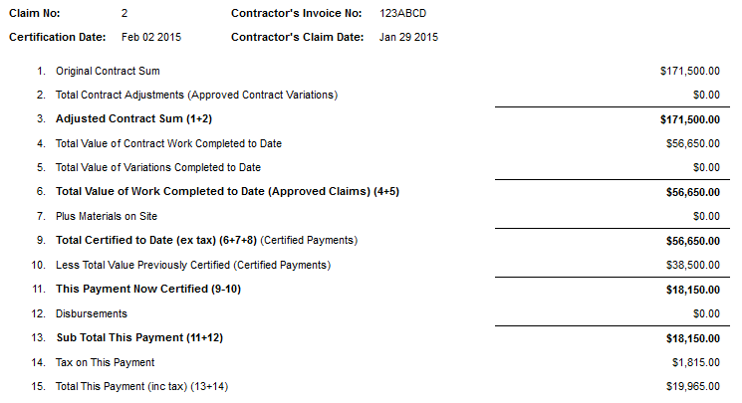

The Claim No: value is controlled by the number of documents issued within the selected project. If documents are created but left in private mode the claim number will still be allocated to that document and any claim should be validated for the correct issuing sequence before sign-off.

A template that uses the Progress Claim object will automatically appear in the Related Templates panel within the contract

Project Costs
The Project Costs object is designed simply as a data presentation tool.

Source of Data
The data source is the Cost system values for the relevant project.
Details are changed within the relevant Cost Project Budget screens before inclusion in a document.

Template View
The object control features numerous columns, and is designed to allow you full control and configurability over the desired output that you require. Each of the columns can be selectively shown or hidden by default when the template is used. Column headings may also be changed if required. The control also allows you to specify the default chart of accounts structure and depth level. Finally, you can also choose to display the costs as code, description, or code-description.
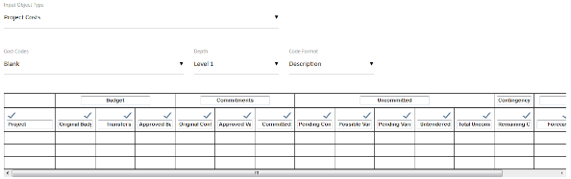

Document Edit View
By default, each of the selection options will be set at the template level by the administrator. If for any reason these selection options need to change, the document creator can make any necessary adjustments
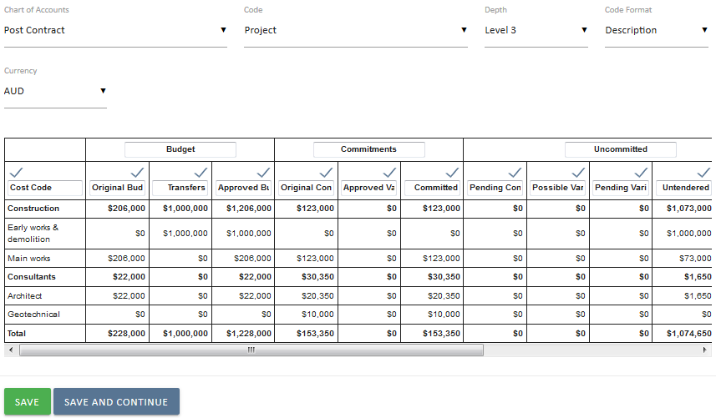

Document Output View
The output document will reflect document edit view, based on the selections that were made.
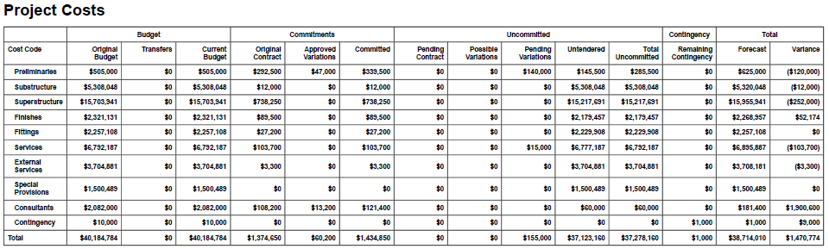

Project Milestones
Displays project specific milestones, along with their planned and current forecast achievement dates.

Source of Data
Project milestones are sourced from the Project Milestones panel which is found within the summary details of an individual project.

Template View
The template can be configured to display milestones according to the required period, and to display upcoming, completed, or all milestones
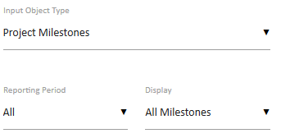

Document Edit View
Specific milestones may be included, or removed from view, and the scope of milestones may be changed.
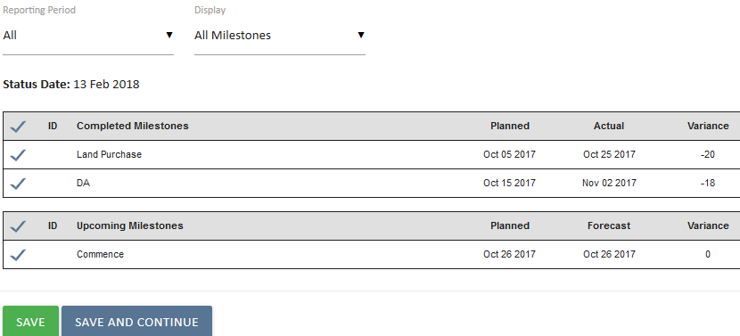

Document Output View
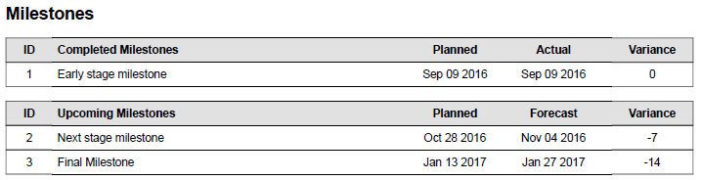

Risk Details
This object provides for a filtered listing of Risks for the project.

Source of Data
The source of this data is the Risks system for the project.

Template View
The template creation phase allows for a number of options to be selected.
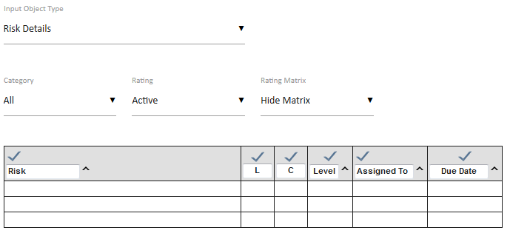
These options provide the default settings for the resulting documents but the selections may be changed during the document creation phase.

Document Edit View
The main screen is a table of the Risks listed based on the selected filters.
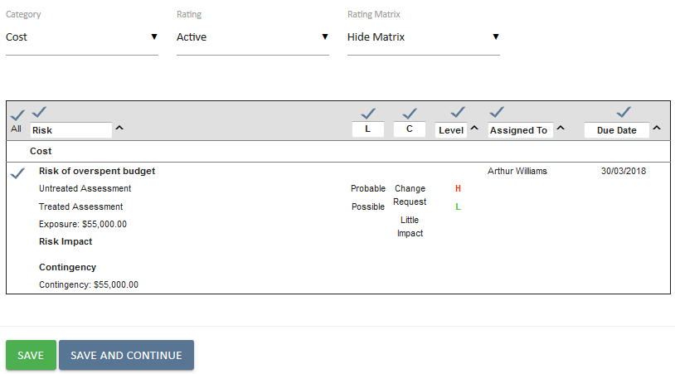

The column headings in the table provide for sorting, using the directional arrows to sort in ascending order while a second click will change to descending order.
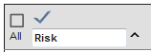

While the default settings for the presentation are set in the template they can be changed in the document preparation phase like the option for adding the matrix or not.

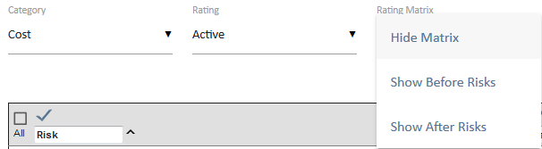

Document Output View
The output is the resulting table based on the filters and sort sequences selected in the document preparation phase.
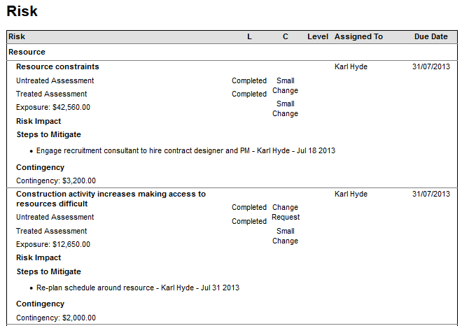

Risk Summary
This object provides for a summary listing of Risks for the project

Source of Data
The source of this data is the Risks system for the project, as seen above for Risk Details.

Template View
The template creation phase allows for a number of options to be selected.
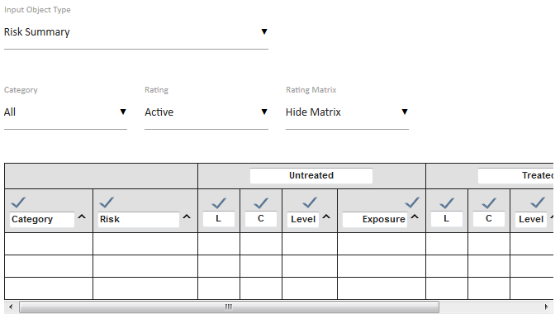

These options provide the default settings for the resulting documents but the selections may be changed during the document creation phase.

Document Edit View
The main screen is a table of the Risks listed based on the selected filters.
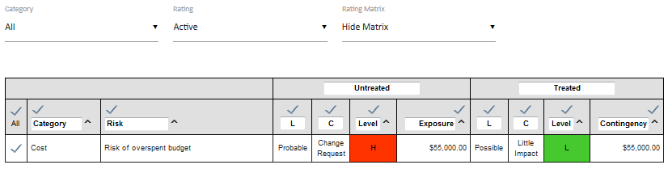
In the example the Risk Matrix has been selected for display. This matrix is the same for both the Risk Summary and Risk Detailed template objects.

Document Output View
The output is the resulting table based on the filters and sort sequences selected in the document preparation phase.
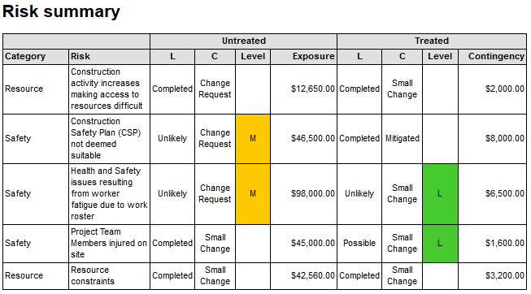

Team Selector
The Team Selector option allows for selection of multiple Team Members from the Internal Resource Pool and assigning them to a specific role for the project.

Source of Data
The Internal Resource Pool for the UniPhi system. Generally this is all the internal organisation team members.

Template View

Document Edit View
When editing the document simply place a tick against the team members to be added to the document

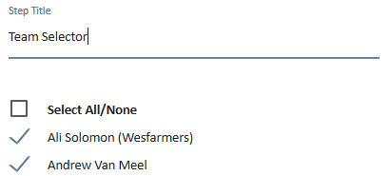

Document Output View
In this example three team members have been selected.
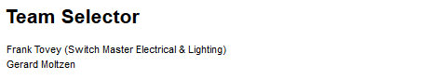

Team Selector (Single)
The Team Selector (Single) option allows for selection of a single Team Member from the Resource Pool.

Source of Data
The Resource Pool for the UniPhi system.

Template View
The template object selector only provides one option to select the role that will be assigned to the selected resources during document creation.

Document Edit View
When creating a document the selection of a team member will include them in that role.
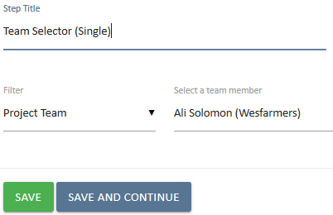

Document Output View
In this example the selected resource will appear in the output document.
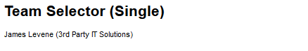

Textbox (Multi Line)
This field is a larger text box providing for descriptive information to be recorded. Similar to the Textbox (Single Line) except that it provides a larger field size.

Source of Data
The data source for this is the author during document creation.

Template View
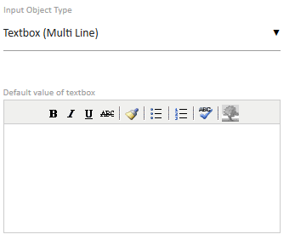
There are no options for this object other than providing for some default text to be displayed.

Document Edit View
There is a minimal set of controls for the text formatting in this object.
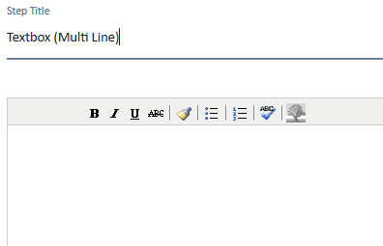

Document Output View
The entered text is displayed in multiple lines as formatted.

Textbox (Single Line)
This is a field that is a single line of text that can include numbers. It is useful where there is a piece of information such as a short description or a value collected from an ad hoc source to be inserted into the document.

Source of Data
The data source for this object is the author during document creation.

Template View
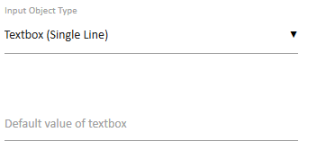
There are no options for this object other than providing for some default text to be displayed.

Document Edit View
Enter a single line of text or as a simple data entry field for a name or numeric data.
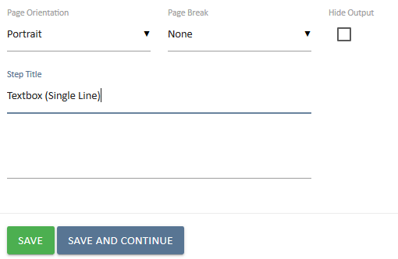

Document Output View
The entered text is displayed as a single line.

Textbox (Rich)
The Rich Text Editor is the main control used in UniPhi documents. The details of this are covered in the Document Management Manual but the use of this object in the template provides additional features that are not available during document preparation.

Source of Data
The initial source of the data is any text entered during the template preparation and the values of any Template Variables embedded in that text. Supplemental data source is the author during document preparation.

Template View
There are no specific options for the Rich Text box object but the controls in the toolbars in the template view are slightly different from the document edit view.
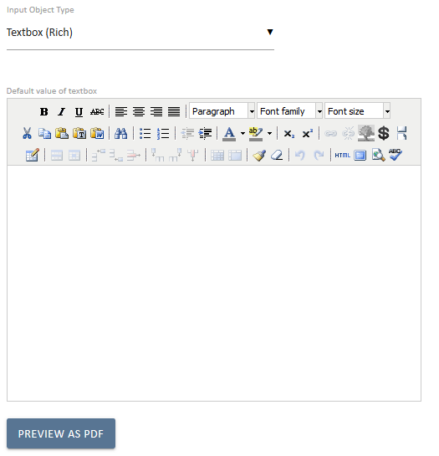
The variable icon provides for adding template variables to the document in the Rich Text box.
The available variables will depend on the other objects in the template. For example Contract related variables will only be available if a Contract selector object is also present as that object would determine the relevant contract to be used with the variables.

Document Edit View
The document edit view provides for all the standard controls.
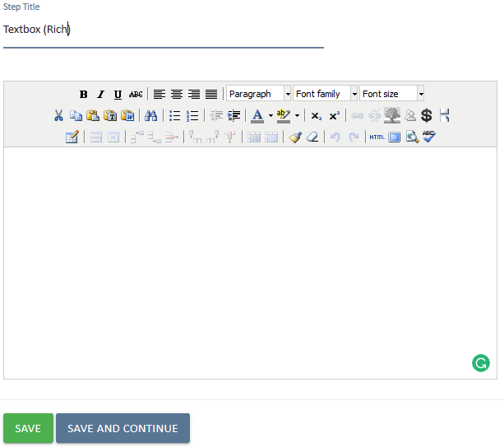
The template variables added in the template default text are converted to the values found in the UniPhi database for the project context. The invalid template variable $project.naem (should have been spelt as $project.name) appears as black text indicating that it is being treated as plain text due to not be recognised.
The red text for the $Resource.Email indicates that the variable is valid but that the database does not have a value for the requested variable. A complete list of text box formatting controls is included in the Document Management Manual.
A complete list of template variables is included as an appendix to this manual.

Document Output View
The output of the document will display as text formatted by the organisation style sheet information.
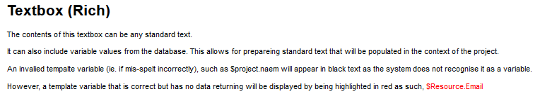

Template Variables
The Template Variables are configured in the Configuration > Template Variables section of UniPhi.
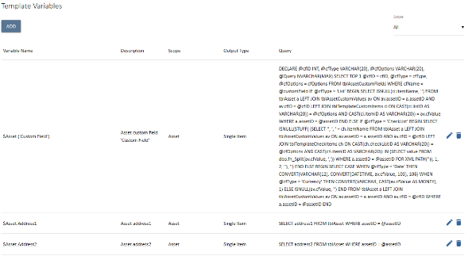
The Scope option to the right provides for filtering on relevant context for the variables like Resources, or Contracts.

A variable can be added if the administrator has sufficient understanding of SQL and the UniPhi or related databases. Note that if any database on the same server can provide input for template variables. This should be discussed with UniPhi support for the specific installation before doing so.

